**Run A2 - 10.0km** **Christies, O’sullivan’s Beach & Port Noarlunga run**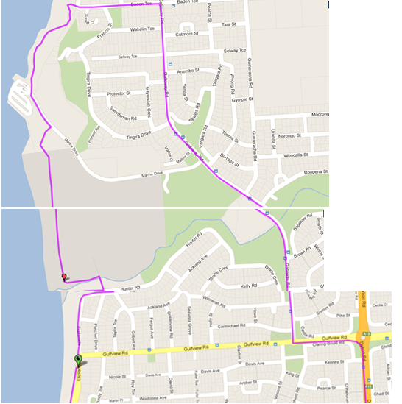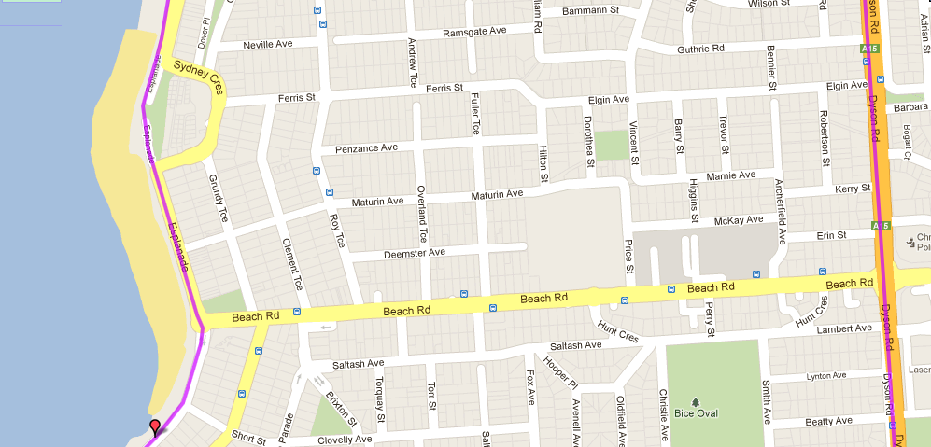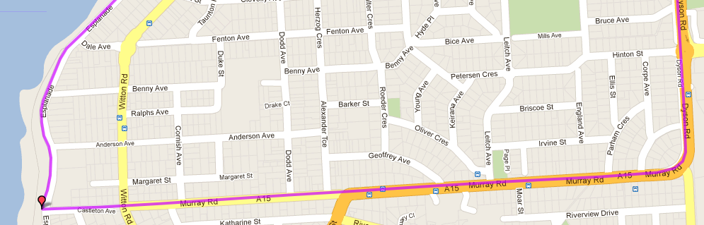

**11**

**10**

**9**

**8**

**7**

**6**

**4**

**5**

**2**

**3**

**1**

START / FINISH

1. Follow coastal track for 500 metres up the hill (till parking area) then cross carpark onto Baden Tce.
2. Take 3rd right into Galloway rd
3. Follow Galloway Rd for 1.8km till roundabout at Gulfview Rd IGA
4. Turn left to Major Roundabout at Dyson Rd and take right turn down hill
5. Follow Dyson Rd across Beach Rd until it swings to right down Murray Rd and follow
6. Continue down Murray Rd all the way to the beach (straight ahead). Don’t follow road when it swings left
7. Turn right and follow the Esplanade all the way back to the Start

Directions (*Starts at Christies Beach*):

1. Head north from Christies, past Surf club & Gulfview Rd
2. Follow the road to the right then turn left across the bridge (to the SA water gates)
3. Take left side track and follow for 1km till Marine Dr (above Marina)
4. Turn left down road towards Marina. Near the building, take the track out of the carpark almost straight ahead & to the right.

**Run A2 - 5.2km Christies Beach & Port Noarlunga run**

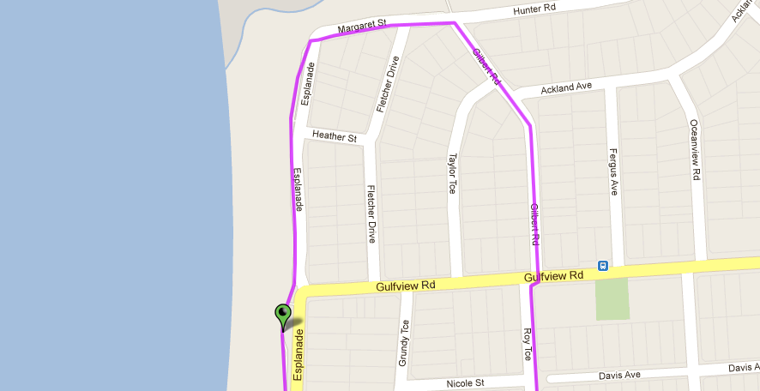 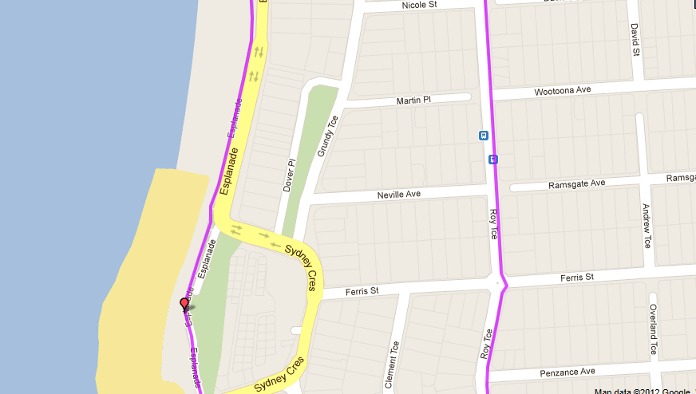 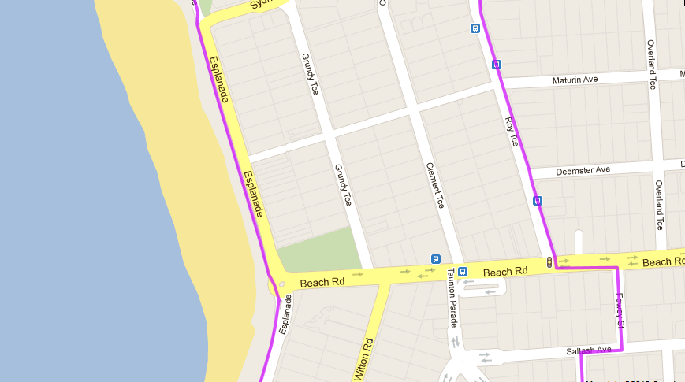 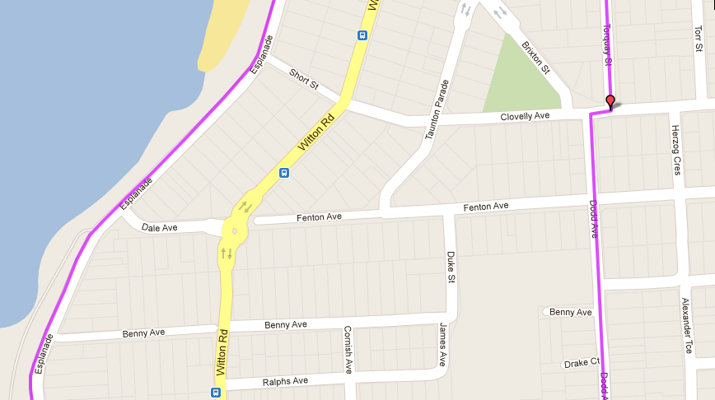 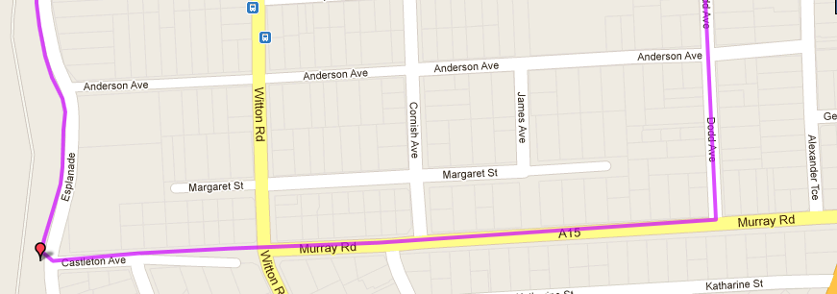

START / FINISH

**1**

**2**

**3**

**4**

**5**

**6**

**7**

**8**

**9**

Directions:

1. Head north from Christies, past Surf club & Gulfview Rd, all the way till the end
2. Follow the road to the right then turn right into Gilbert Rd (opposite driveway to SA Water plant)
3. At Gulfview Rd take ‘Dogleg’ (right & left) into Roy Tce
4. Follow Roy Terrace until ‘T-Section’ with Beach Rd. Cross Road and turn left
5. Take next right into Fowey St
6. Turn right into Saltash Ave then left into Torquay St.
7. Turn right and then left into Dodd Ave and follow till T section at Murray Rd
8. Turn right into Murray road and go straight ahead (across nature strip) until the Esplanade (overlooking Pt Noarlunga)
9. Turn right and follow the Esplanade all the way back to the Start

**Run A2 - 20.0km** **Christies, O’Sullivan’s Beach & Port Noarlunga run**

**Directions (*Starts at Christies Beach*):**

1. From Christies beach run up Beach road until Brixton St (2nd right) then turn left at the roundabout into Saltash Ave
2. Turn right into Christie Ave (near football ground) and run until the end
3. At Murray road, turn right and continue until the Port Noarlunga roundabout (following Murray road as it swings to the left (changing to Gawler St, then Gray St)
4. Continue across Saltfleet bridge, and at the next roundabout go straight ahead onto Commercial road

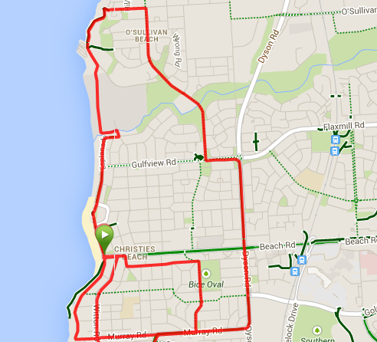 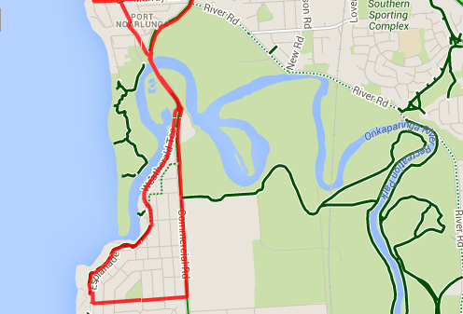

1. Follow the road to the right then turn left across the bridge (to the SA water gates)
2. Take left side track and follow for 1km till Marine Dr (above Marina)
3. Turn left down road towards Marina. Near the building, take the track out of the carpark almost straight ahead & to the right.
4. Follow coastal track for 500 metres up the hill (till parking area) then cross carpark onto Baden Tce.
5. Take 3rd right into Galloway rd
6. Follow Galloway Rd for 1.8km till roundabout at Gulfview Rd IGA
7. Turn left to Major Roundabout at Dyson Rd and take right turn down hill
8. Follow Dyson Rd across Beach Rd until it swings to right down Murray Rd and follow
9. Continue down Murray Rd all the way to the beach (straight ahead). Don’t follow road when it swings left
10. Turn right and follow the Esplanade all the way back to the Start
11. At approx.. 5km point, turn right into Fremantle Road until you reach the Esplanade, then cross the road and turn right – joining the coastal footpath
12. Staying on the coastal track follow the Esplanade then Weatherald St back to Port Noarlunga
13. After crossing Saltfleet bridge go left at the roundabout and then, once in Port Noarlunga turn right into Gawler St and take the first left into Wilton road – follow this back to Beach road and to the start point
14. At the beach turn right and head north from Christies, past the Surf club & Gulfview Rd