**Run 28 - 5.2km Morphett Vale loop** 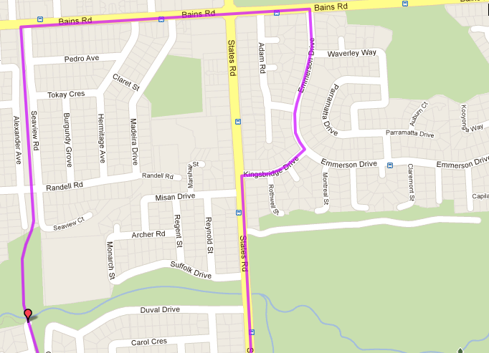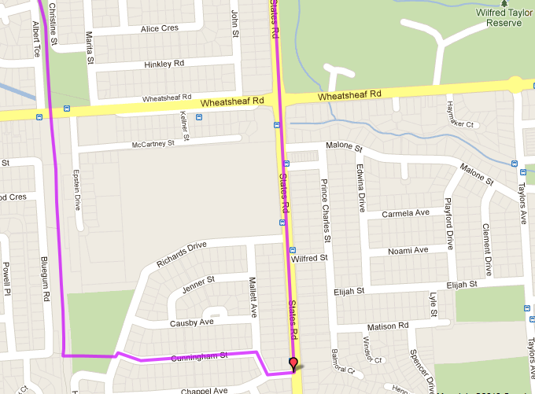

**Directions**

1. Follow track to Bains Rd and turn right
2. Cross States Rd (roundabout near shops) and take 2nd right into Emmerson Dr
3. Take 2nd right into Knightsbridge Drive then turn left onto States Rd
4. Follow States Rd, across Wheatsheaf. After sports field, take 2nd right into Chappel Ave
5. Take first right into Mallett Ave and first left into Cunningham Ave. Run till end
6. At T-Section, cross onto gravel track through car park and then turn right to join bike track and follow back to park

**4**

**3**

**2**

**1**

**Start & Finish**

**6**

**5**

**Run 28 - 10.5km Morphett Vale Loop**

**Directions:**

1. **Follow track to Bains Rd then cross and continue non until Pimpala Rd (Hungry Jacks)**
2. **Turn left and cross at lights, up the hill until next intersection (Westpac bank/GE Money)**
3. **Turn right onto Hillier Rd and follow till roundabout**
4. **Turn right into The Strand and follow round corner and then up hill until it continues along Grant Rd**
5. **Follow Grant Rd through roundabout and to Old Reynella interchange (traffic lights). Continue straight ahead**
6. **After bike track, take next right turn into Burgoyne Drive and follow till end (T-Section)**
7. **At T-Section, turn right into Concord Rd then turn Left into States Rd**
8. **Follow States Rd across Pimpala Rd and then till Woodcroft Drive. Turn Left**
9. **Follow Woodcroft Drive around loop and then turn tight into Gardenia Cres and follow to the end (Bains Rd T-Section) – Turn right**
10. **Take next left into Emmerson Dr then right into Knightsbridge Drive and left onto States Rd**
11. **Take first right into Misan Drive and follow till left turn and then to T-Section**
12. **Turn left onto Archer Rd and at end (near school) follow footpath to the right of school, cross footbridge and**

**turn left to track then back to the park**

**8**

**7**

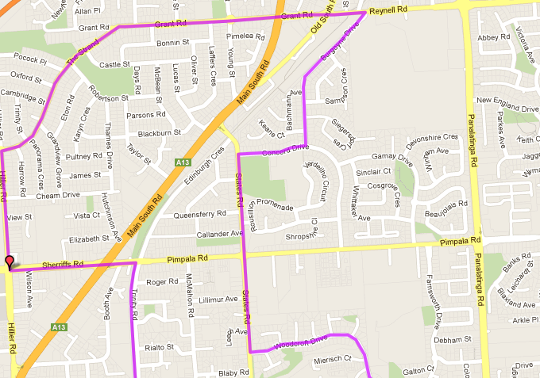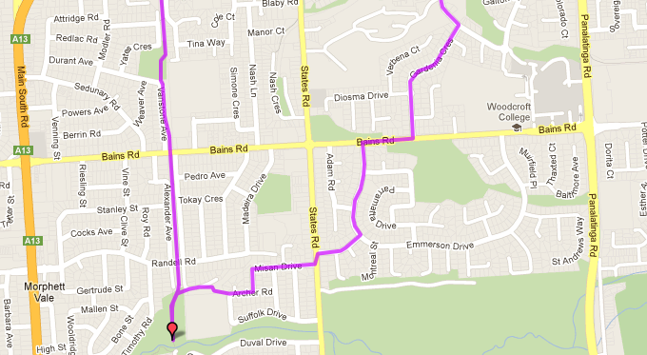

**12**

**11**

**10**

**9**

**8**

**7**

**6**

**5**

**4**

**3**

**2**

**1**

**Start & Finish**

**Run 28 – 20.4km Morphett Vale Loop**

**Directions:**

1. From the park, cross dirt hill, go down stairs and alongside the school. At the footbridge cross to the right onto Duval Drive
2. Continue along Duval Drive to States road and turn right until the roundabout then turn left into Wheatsheaf road
3. At the end turn right into Panatalinga Road, then take the next right into Kathleen St
4. At the T-Section, turn left into Taylor Ave and follow till the end (States Road)
5. Turn left into States road and continue past Doctors and Penney Hills road, until Cottage Lane and turn right
6. Take the first right into O’Halloran Lane then at the end turn left into Penney Hills road then right into Collins Pde
7. At the end of Collins Pde (Doctors Road) cross over and turn left, then turn right onto the bike track (near pedestrian traffic lights) and follow back to the park
8. Continue along the track to Bains Rd then cross and continue non until Pimpala Rd (Hungry Jacks)
9. Turn left and cross at lights, up the hill until next intersection (Westpac bank/GE Money)
10. Turn right onto Hillier Rd and follow till roundabout

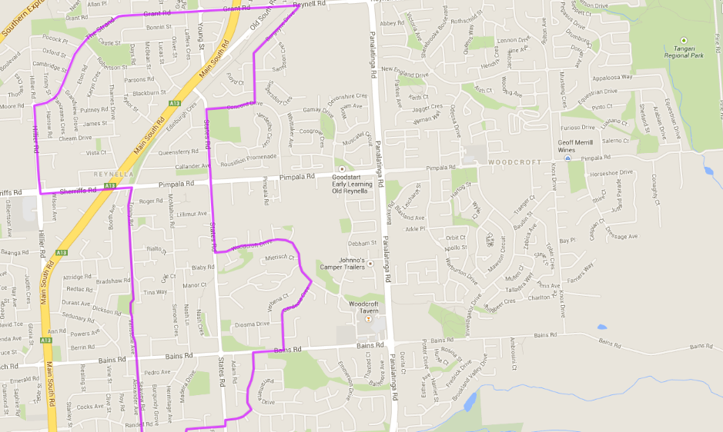 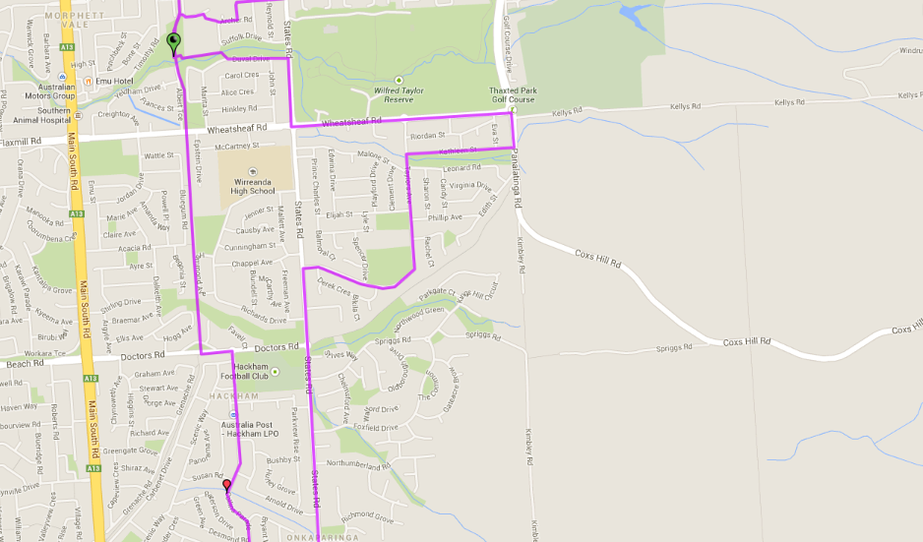 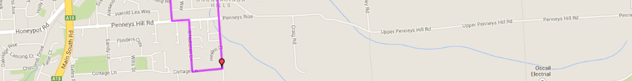

**Start & Finish**

1. Turn right into The Strand and follow round corner and then up hill until it continues along Grant Rd
2. Follow Grant Rd through roundabout and to Old Reynella interchange (traffic lights). Continue straight ahead
3. After bike track, take next right turn into Burgoyne Drive and follow till end (T-Section)
4. At T-Section, turn right into Concord Rd then turn Left into States Rd
5. Follow States Rd across Pimpala Rd and then till Woodcroft Drive. Turn Left
6. Follow Woodcroft Drive around loop and then turn tight into Gardenia Cres and follow to the end (Bains Rd T-Section) – Turn right
7. Take next left into Emmerson Dr then right into Knightsbridge Drive and left onto States Rd
8. Take first right into Misan Drive and follow till left turn and then to T-Section
9. Turn left onto Archer Rd and at end (near school) follow footpath to the right of school, cross footbridge and turn left to track then back to the park