**Run 38 – 4.9km Hackham & Morphett Vale**

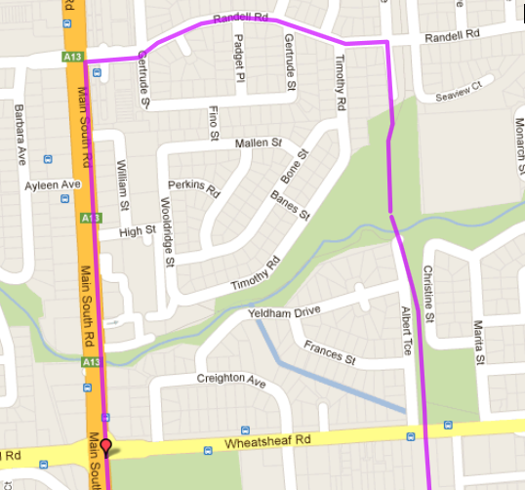 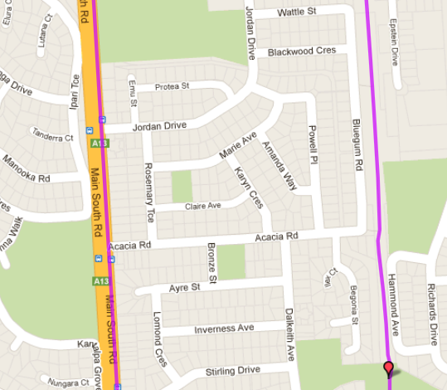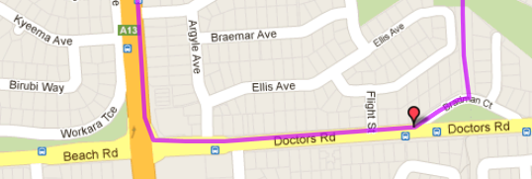

**Directions:**

1. Follow track to Wheatsheaf road and continue till Doctors road
2. Turn right and follow Doctors road until Main South Road traffic lights and turn right
3. Follow Main South Road till Wheatsheaf Road. Cross and continue past supermarket until Randell Road (near Fruit Market)
4. Turn right into Randell Road and follow till bridge crossing bike track and turn right
5. Follow road back to park

**5**

**4**

**3**

**2**

**1**

**Start & Finish**

**Start & Finish**

**Run 38 – 10.0km Hackham & Morphett Vale**

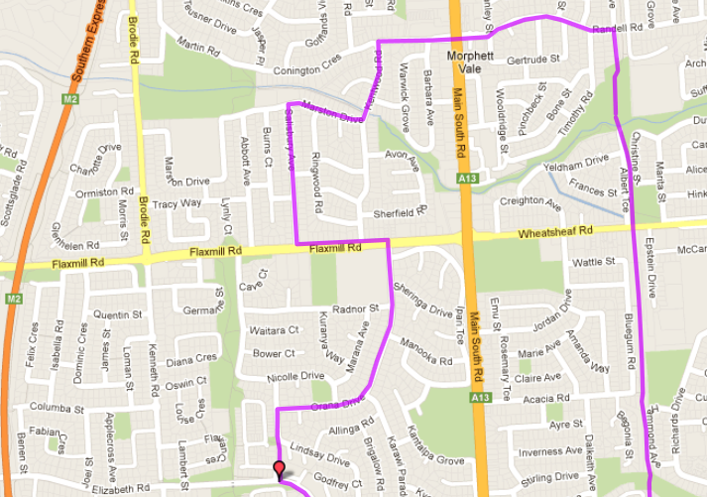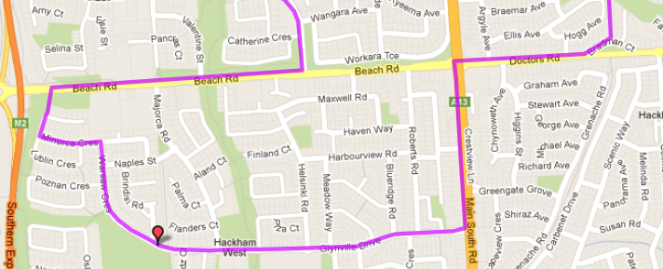

**Directions:**

1. Follow track to Wheatsheaf road and continue till Doctors road
2. Turn right and follow Doctors road until Main South Road traffic lights
3. Cross at lights and turn left, follow Main South Road over hill until Glynville Cres and turn right
4. Follow Glynville past shops and IGA then continue up hill through roundabout until T-Section
5. At IGA follow track from carpark immediately after building onto the road until Orana Drive and turn right
6. Continue along Orana Dr till T-Section at Flaxmill Road. Cross over then turn left and then 2nd right into Salisbury Ave
7. Continue till T-Section and turn tight into Marston Dr –follow into Kentwood Road
8. Follow Kentwood to the right into Connington and to MS Road lights
9. Cross and continue along Randell Rd till bike track bridge then turn right and follow back to park
10. Turn left at T-Section then right to follow road and track until Beach Road then turn Right
11. Turn left into Elizabeth Road (‘Local Shops’ sign) and continue until IGA supermarket

**Start & Finish**

**Start & Finish**

**Start & Finish**

**Run 38 – 20.2km Hackham & Morphett Vale**

**Directions:**

1. Follow track towards Bains road, then go to the right onto Seaview Road then turn right into Randell Road
2. At the end turn right, then left until States Road. Cross over States and turn left
3. Take the first right turn into Kingsbridge Drive then right into Emmerson Drive and follow till the end
4. Turn right into Bains Road and cross Panatalinga road
5. Turn left at the roundabout into Investigator drive then take the first left into Warburton Drive
6. At the end turn left into Pimpala then right onto Panatalinga road
7. Turn left at Reynell road then at the bike track turn left and follow it back to the park

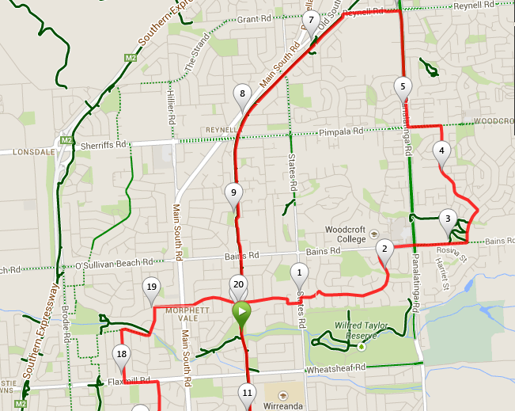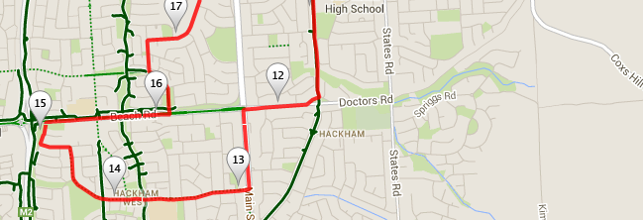

1. Continue till T-Section and turn tight into Marston Dr – follow into Kentwood Road
2. Follow Kentwood to the right into Connington and to MS Road lights
3. Cross and continue along Randell Rd till bike track bridge then turn right and follow back to park
4. At the park continue along the track to Wheatsheaf road and continue till Doctors road
5. Turn right and follow Doctors road until Main South Road traffic lights
6. Cross at lights and turn left, follow Main South Road over hill until Glynville Cres and turn right
7. Follow Glynville past shops and IGA then continue up hill until T-Section
8. Turn left at T-Section then right to follow road and track until Beach Road then turn Right
9. Turn left into Elizabeth Road (‘Local Shops’ sign) and continue until IGA supermarket
10. At IGA follow track from carpark immediately after building onto the road until Orana Drive and turn right
11. Continue along Orana Dr till T-Section at Flaxmill Road. Cross over then turn left and then 2nd right into Salisbury Ave

**Start & Finish**