Run A9 – 5.3km Seaford - Onkaparinga River 'Away' run
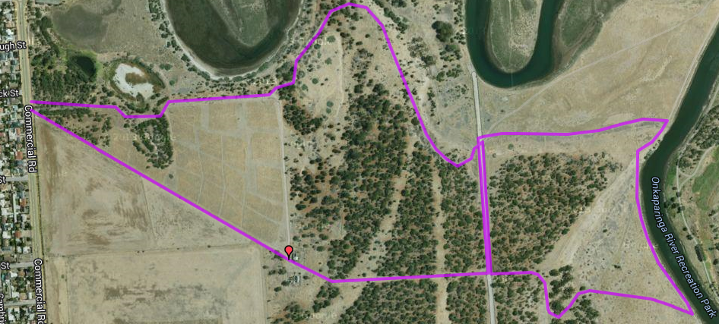
- Cross the road and continue onto the track, under the railway bridge. Continue straight ahead on the gravel track past the first bridge pillar, heading towards the river (10k runners go to the left at this point)
- When you reach the river turn right and continue to follow the track for 600 metres. As you reach the end of the airstrip, take a sharp (slightly backwards) turn to the right and follow the dirt track back towards the railway line
- Follow the dirt track until you reach the embankment then take the uphill track on the right and cross over the bark chip area to the service road and turn right, back towards the railway bridge
- At the end turn to the left and go under the railway bridge, across the road and back through the park gate. Follow the main gravel park (looping to the right then back to the left) all the way back to the car park
7
6
5
4
3
2
1
Start & Finish
Directions – Start point: Onkaparinga National Park entry gate located on Commercial Road, Port Noarlunga (near Berwick St)
- From the car park take the fire trail to the right (angled) and follow for 750 metres when you will pass between old ruined houses
- Just after the ruins continue to follow the track to the left until just before you reach a gate
- Just before the gate turn left onto a single track and follow it till you reach a wide gravel track then turn right and exit onto the road
Run A9 –10.0km Seaford - Onkaparinga River 'Away' run
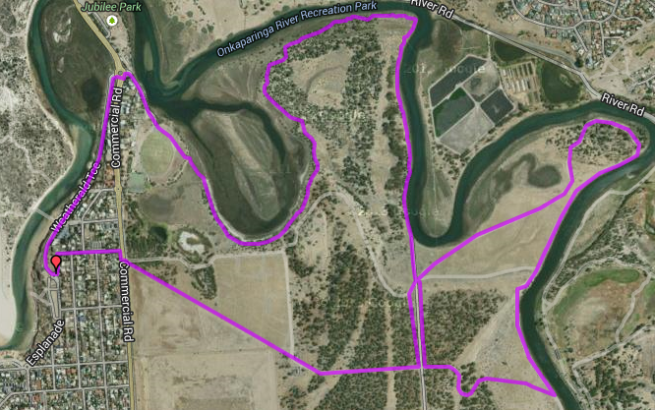
6
12
11
10
9
8
7
5
4
3
2
1
Start & Finish
Directions – Start point: Onkaparinga National Park entry gate located on Commercial Road, Port Noarlunga (near Berwick St)
- From the car park take the fire trail to the right (angled) and follow for 750 metres when you will pass between old ruined houses
- Just after the ruins continue to follow the track to the left until just before you reach a gate
- Just before the gate turn left onto a single track and follow it till you reach a wide gravel track then turn right and exit onto the road
- Cross the road and continue onto the track, under the railway bridge. Follow the gravel track to the left (near the 2nd bridge pillar), heading towards the river bend (5k runners go straight ahead at this point)
- When you reach the river continue to follow the track to the right and follow the track along the river for 1.2km. As you reach the end of the airstrip, take a sharp (slightly backwards) turn to the right and follow the dirt track back towards the railway line
- Follow the dirt track until you reach the embankment then take the uphill track on the right and cross over the bark chip area to the service road and turn right back towards the railway bridge
- At the end turn to the left and go under the railway bridge until the access gate
- Turn right onto the road and at the end join the single track along the river edge – you will follow this track for approx. 3.2km until you reach Port Noarlunga Football ground
- CONTINUE TO FOLLOW THE TRACK CLOSEST TO THE RIVER UNTIL YOU REACH A SET OF STAIRS LEADING TO THE FOOTBALL GROUND
- Once at the oval, continue towards the gate and follow the road to the roundabout
- Cross the roundabout and follow Weatherald Tce, along the river, up the hill to the roundabout at the top
- Do a sharp ‘U-Turn’ to the left into Berwick St and follow this down the hill and back to Commercial road and the car park (PLEASE CROSS THE ROAD WITH CARE)

Run A9 –20.9km Seaford - Onkaparinga River 'Away' run
Directions – Start point: Onkaparinga National Park entry gate located on Commercial Road, Port Noarlunga (near Berwick St)
- From the car park follow Commercial road Southwards for 2.1km until Seaford road and turn left
- After 900 metres, turn left onto the bike track at Seaford Meadows Railway station and follow the track until the reach the river
- Cross footbridge then turn left immediately afterwards onto the river side track. Continue along this track till River road, then joining River road continue until the end, then turn left towards Port Noarlunga
- Continue through the roundabouts then across the Saltfleet bridge and past the playground.
- Go through the roundabout onto Commercial road until you reach the car park again (Start of 10km run)
- From the car park take the fire trail to the right (angled) and follow for 750 metres when you will pass between old ruined houses
- Just after the ruins continue to follow the track to the left until just before you reach a gate
- Just before the gate turn left onto a single track and follow it till you reach a wide gravel track then turn right and exit onto the road
5
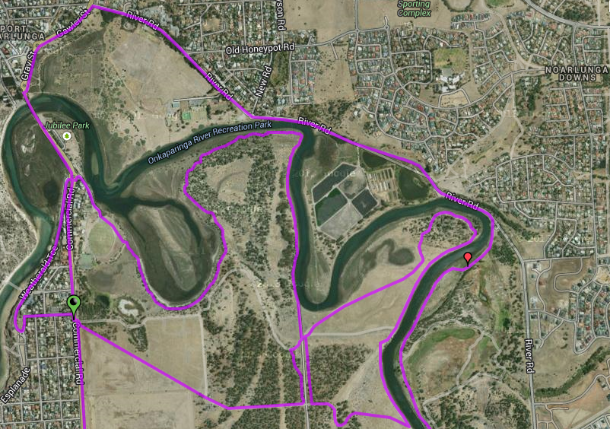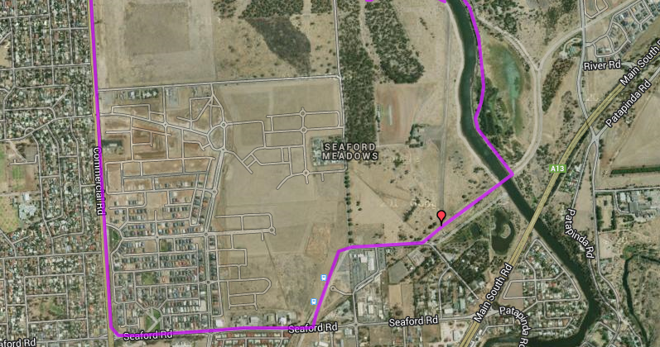
Start & Finish
- Cross the road and continue onto the track, under the railway bridge. Follow the gravel track to the left (near the 2nd bridge pillar), heading towards the river bend (5k runners go straight ahead at this point)
- When you reach the river continue to follow the track to the right and follow the track along the river for 1.2km. As you reach the end of the airstrip, take a sharp (slightly backwards) turn to the right and follow the dirt track back towards the railway line
- Follow the dirt track until you reach the embankment then take the uphill track on the right and cross over the bark chip area to the service road and turn right
- At the end turn to the left and go under the railway bridge until the access gate
- Turn right onto the road and at the end join the single track along the river edge – you will follow this track for approx. 3.2km until you reach Port Noarlunga Football ground
- CONTINUE TO FOLLOW THE TRACK CLOSEST TO THE RIVER UNTIL YOU REACH A SET OF STAIRS LEADING TO THE FOOTBALL GROUND
- Once at the oval, continue towards the gate and follow the road to the roundabout
- Cross the roundabout and follow Weatherald Tce, along the river, up the hill to the roundabout at the top
- Do a sharp ‘U-Turn’ to the left into Berwick St and follow this down the hill and back to Commercial road and the car park (PLEASE CROSS THE ROAD WITH CARE)
2

