**Run A1 – 5.0km Onkaparinga River**

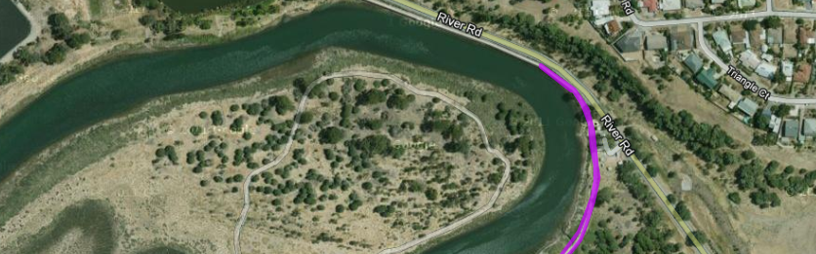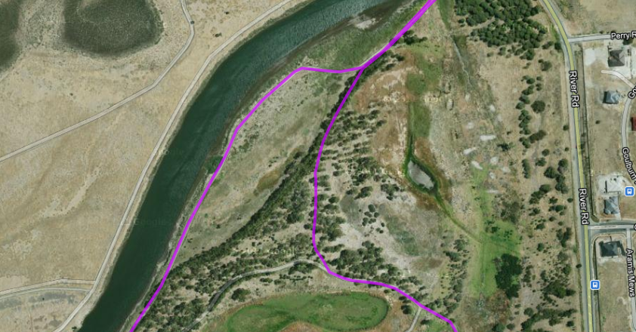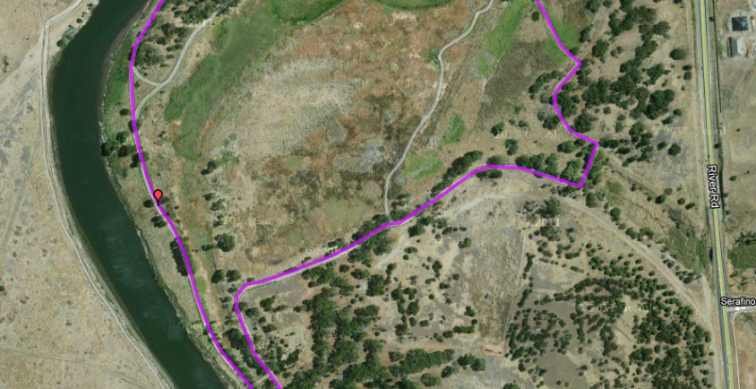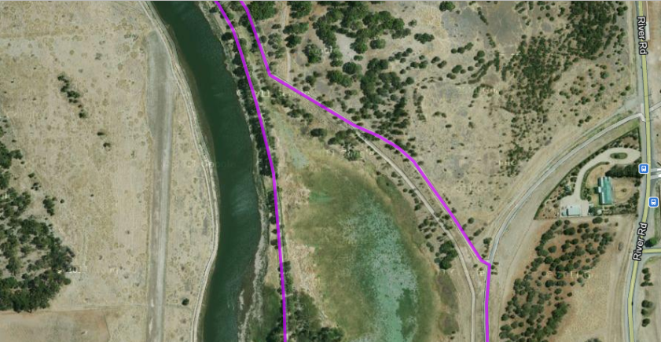 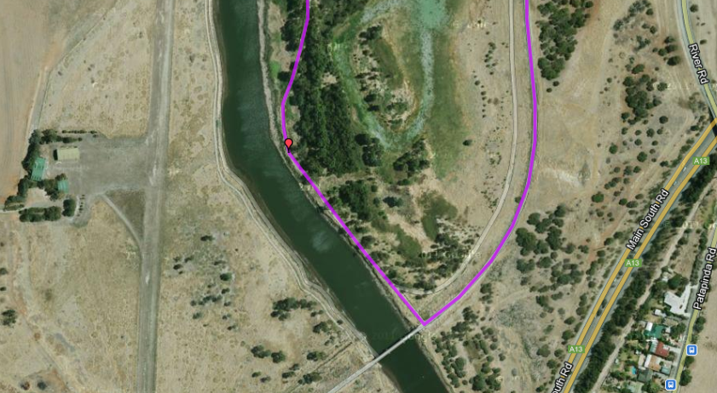

***Start & Finish 50metres along wooden bridge to make it 5km***

**Follow the trail along the river edge, all the way back to the park**

**Down the track then turn right back onto the trail – Just before the bridge**

**Keep following the trail and stay to the left. Follow the trail up the hill (all the way to the asphalt bike track)**

**Cross the footbridge then turn to the right**

**Past the boardwalk and just ahead, turn to the right (up the small slope)**

**Take Left Track and left again**

**Run A1 - 10.2km River & Old Noarlunga**

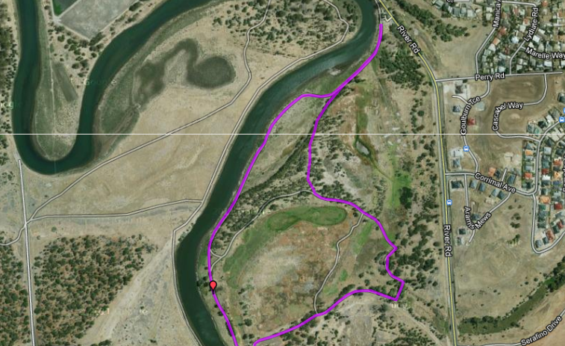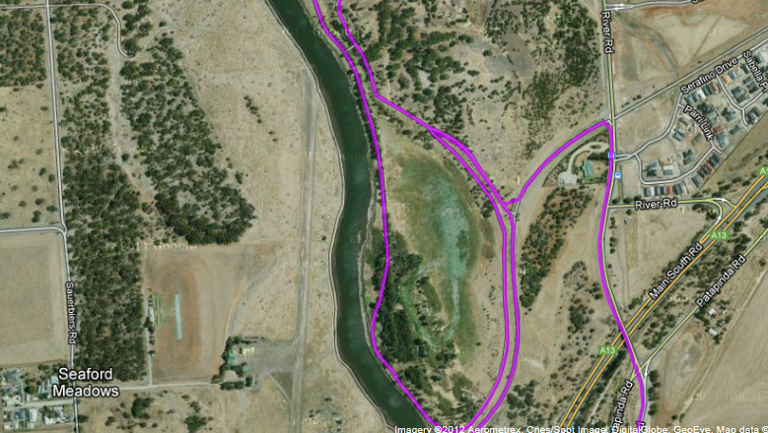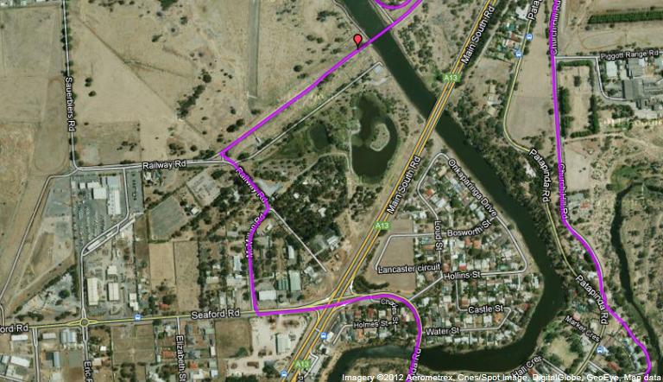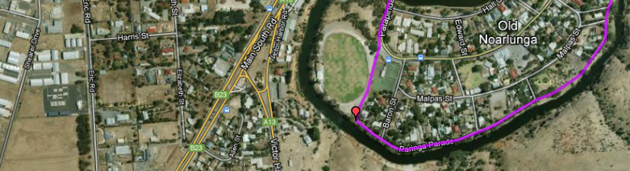

1. Take left track to wetland lagoon and then left again past boardwalk
2. Follow main trail across small footbridge then around wetlands
3. Follow Left trail up hill to Asphalt bike trail – Turn left
4. *Turn right at River road and follow until Intersection – straight ahead and to the right*
5. *Down hill past church then left at park (bottom of hill along river)*
6. *Follow track till football oval then out gate and follow road to traffic lights*
7. *Cross intersection then take first right and follow back to Bike track*
8. *Right at bike track till bridge. Up hill to original trail and turn left*
9. *After 200mtrs, switchback onto down hill track to bridge*
10. *Turn right onto trail and follow river edge back to park*

**Run A1 – 19.4km River & Old Noarlunga**

**Directions:**

1. From the carpark turn right along the boardwalk/bridge and join River Road
2. After 200 metres, cross River road and follow bike track into park opposite wetlands – stay on left side track alongside houses
3. When the track swings to the right at the top of the hill follow path through the tunnel and continue up the hill to the back of Cardign college
4. Continue to follow track until you go through another tunnel and reach Colonnades shopping centre car park
5. Turn to right and follow service road (past petrol station) to the end then follow it around to the left
6. Follow road until T-Section near Noarlunga Hospital then cross over and go through Centrelink Carpark to Beach road
7. Continue across Beach road and follow Morton Road until roundabout
8. Turn left into Elizabeth road and follow till T-Section with Flaxmill road
9. Turn left at Flaxmill then after 200 metres turn left at next large roundabout into Dyson road
10. Follow Dyson road past Police Station and McDonalds then through next roundabout until the road swings to the right (Murray Road). On the corner, take the left turn (continuation of Dyson Road) down the hill
11. Turn right at the bottom (Old Honeypot road) and follow until roundabout T-Section at River Road
12. Turn left into River road and follow back to the back (start area) – Approx 1.8km
13. Continue onto wetlands track - Take left track to wetland lagoon and then left again past boardwalk
14. Follow main trail across small footbridge then around wetlands
15. Follow Left trail up hill to Asphalt bike trail – Turn left
16. Turn right at River road and follow until Intersection – straight ahead and to the right
17. Down hill past church then left at park (bottom of hill along river)
18. Follow track till football oval then out gate and follow road to traffic lights
19. Cross intersection then take first right and follow back to Bike track
20. Right at bike track till bridge. Up hill to original trail and turn left
21. After 200mtrs, switchback onto down hill track to bridge
22. Turn right onto trail and follow river edge back to park

