**Run 15 –** 5.2km Morphett Vale loop

**11**

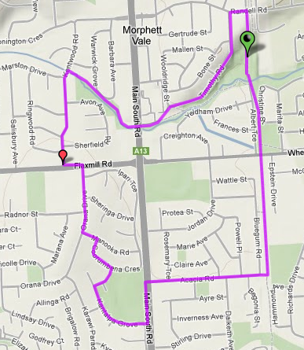

**Directions**

1. Follow track to Wheatsheaf road and continue towards Beach Rd
2. Pass Car park and club on left side continue till end of parkland and car park, Turn right along Bluegum Rd till MS Road – Cross Road
3. Turn left along MS Rd until first road alongside of oval – turn right and follow road around oval
4. Take first right (end of oval) into Kilimna Walk until end T-Section
5. Left into Coorumena Cres until end T Section
6. Left into Manooka Rd then Right into Orana Drive
7. At end, cross Flaxmill Rd and turn left then right into Kentwood Rd

**10**

**7**

**3**

**1**

8. Continue along Kentwood till Christies Creek trail (just after Marston Dr) and turn right onto track

9. Follow trail till MS Rd underpass (Tunnel) and Emu hotel

10. Cross hotel car park diagonally and follow Timothy Rd up hill

11. At end, turn right onto Randell Rd then next right onto Alexander Ave and follow back to park

**Run 15** – 10.2km Morphett Vale Loop

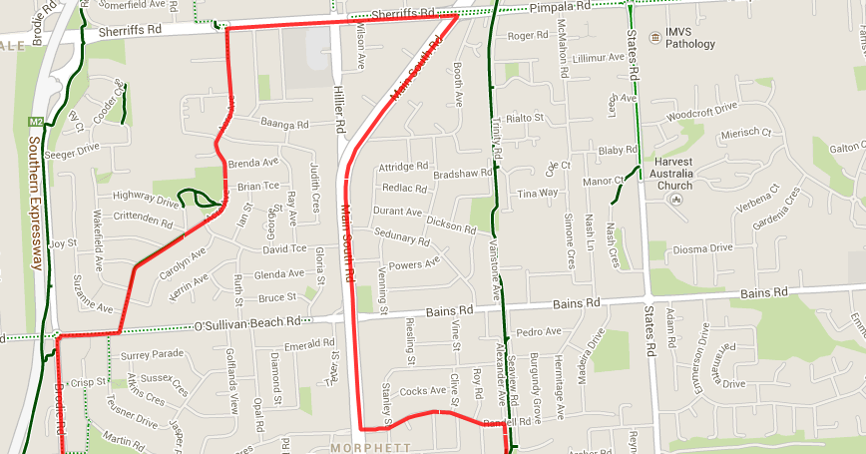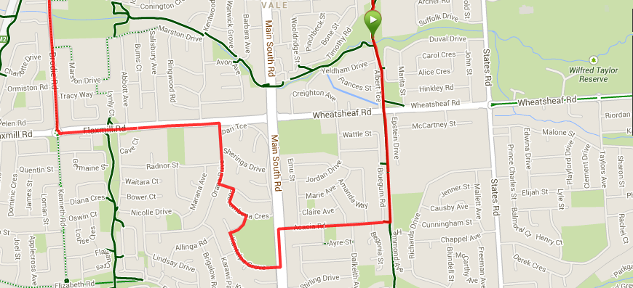

**9**

**11**

**10**

**8**

**7**

**6**

**4**

**5**

**3**

**2**

**1**

**Directions**

1. Follow track to Wheatsheaf road and continue towards Beach Rd
2. Pass Car park and club on left side continue till end of parkland and car park, Turn right along Bluegum Rd till MS Road – Cross Road
3. Turn left along MS Rd until first road alongside of oval – turn right and follow road around oval
4. Take first right (end of oval) into Kilimna Walk until end T-Section
5. Left into Coorumena Cres until end T Section
6. Left into Manooka Rd then Right into Orana Drive
7. At end, cross Flaxmill Rd and turn left until the roundabout
8. Turn right into Brodie Road until O’Sullivan’s Beach road roundabout and turn right
9. Turn Left into Acre Ave and follow to Sheriffs road then turn right

10. Follow Sheriffs Rd till MS Road (McDonalds – Cross over and turn right, following MS road until Randell Road (near old coffee shop)

1. Follow Randell Road till the bridge which crosses the bike track, turning left just before the bridge and follow the road and track back to the park

**Run 15** – 20.8km Morphett Vale Loop

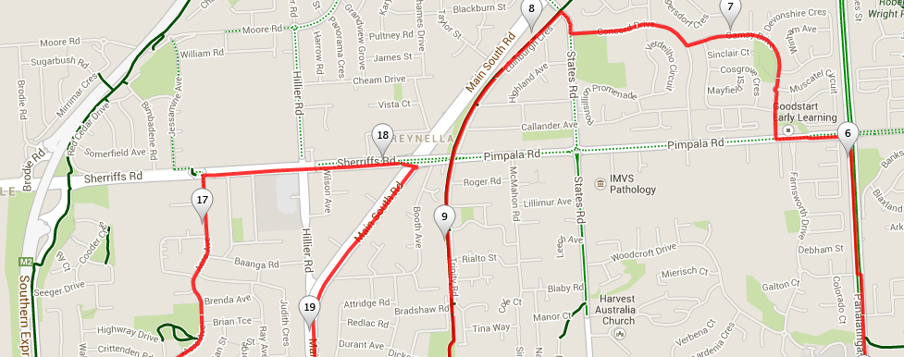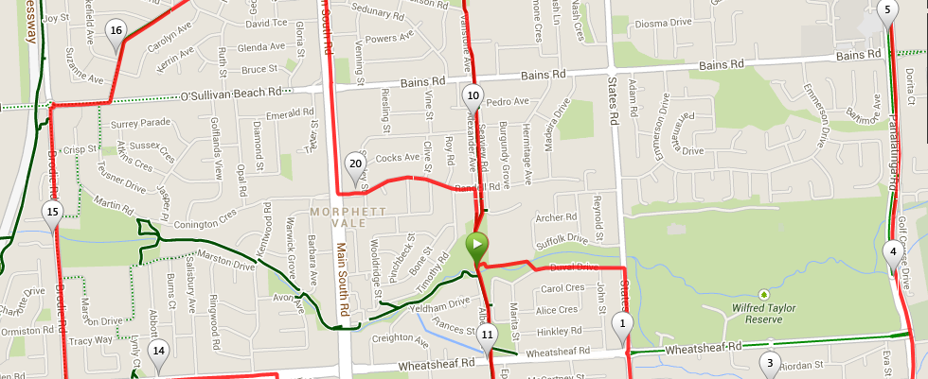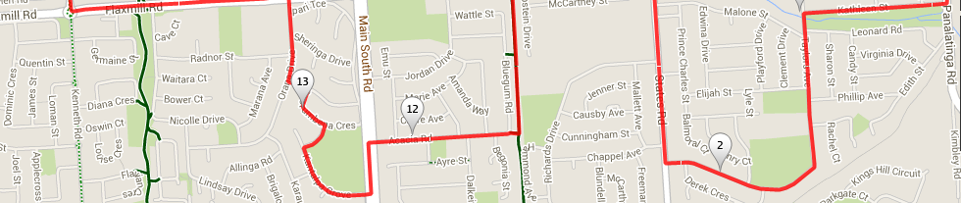

6. Follow Gamay Dr till T-Section then turn right into Concord dr and follow till the end (States Rd)

1. Turn right, then when you reach the bike track turn left and follow back to the park
2. Continue along track to Wheatsheaf road and continue towards Beach Rd
3. Pass Car park and club on left side continue till end of parkland and car park, Turn right along Bluegum Rd till MS Road – Cross Road
4. Turn left along MS Rd until first road alongside of oval – turn right and follow road around oval
5. Take first right (end of oval) into Kilimna Walk until end T-Section
6. Left into Coorumena Cres until end T Section
7. Left into Manooka Rd then Right into Orana Drive
8. At end, cross Flaxmill Rd and turn left until the roundabout
9. Turn right into Brodie Road until O’Sullivan’s Beach road roundabout and turn right
10. Turn Left into Acre Ave and follow to Sheriffs road then turn right
11. Follow Sheriffs Rd till MS Road (McDonalds – Cross over and turn right, following MS road until Randell Road (near old coffee shop)
12. Follow Randell Road till the bridge which crosses the bike track, turning left just before the bridge and follow the road and track back to the park

**Directions**

1. From the park cross over track to school and then use footbridge to Duval Drive
2. Turn right into States Road and follow till Taylor Ave, just before the shops and church
3. Follow Taylor ave till it reaches Kathleen St (before shops) and turn right
4. At Panatalinga Road turn left and follow till Pimpala Road (Opposite Gym)
5. Turn left into Pimpala then take first right into Gamay Dr