SRG # 46 - 5.1km Woodcroft & Panatalinga run
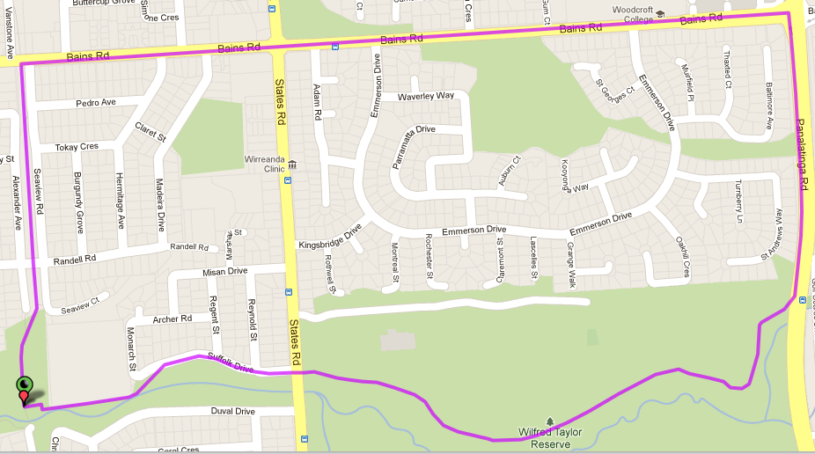
4
2
3
1
Directions
- Take track over mound and down steps to Morphett Vale East school then continue along Suffolk St until States Road
- Cross States Rd and follow track past sports fields and through Wilfred Taylor Reserve, swinging towards the left as you reach Panatalinga Road then continue along Panatalinga, towards Bains Road
- At Bains Road, Turn left and follow across States Road until you reach the bike track
- Turn left onto the bike track and follow back to the park
Start & Finish

SRG # 46 - 10.3km Woodcroft & Panatalinga run
4
Directions
- Take track over mound and down steps to Morphett Vale East school then continue along Suffolk St until States Road
- Cross States Rd and follow track past sports fields and through Wilfred Taylor Reserve, swinging towards the left as you reach Panatalinga Road then continue along Panatalinga, towards Bains Road
- At Bains Road, continue at Traffic Lights until the Petrol station then join the footpath to the left that goes down to a tunnel under Panatalinga Road – Go through tunnel
- Follow track to the right until it crosses a small footbridge then continue to the right until you reach Investigator Drive
- Turn right into Investigator Drive then right again into Bains Road and continue until Panatalinga Rd
- Turn left at Panatalinga and continue past Golf Course and Wheatsheaf Road & Edith St
- Before you go up the hill on Panatalinga, Turn right onto the track behind the houses and follow until you reach the end of Doctors Road
- Follow Doctors Road until Main South Road lights and turn right
- Continue along MS Road till Wheatsheaf Road then continue across lights until Emu Hotel
- Turn right into Emu Hotel driveway and continue along the track until the park
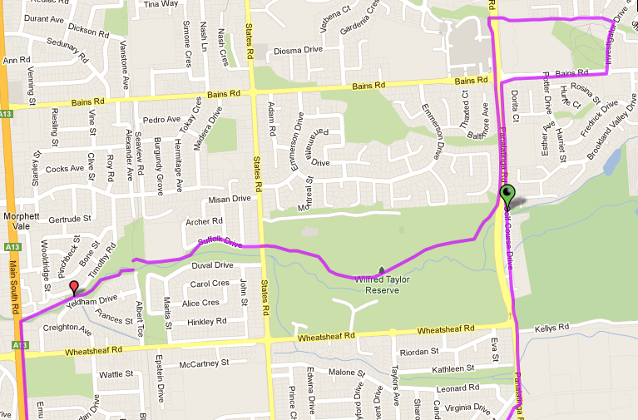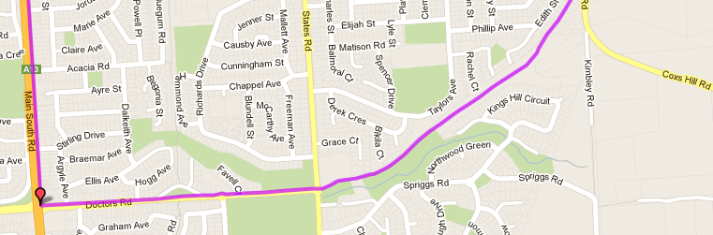
10
9
8
7
6
5
3
1
2
Start & Finish
SRG # 46 - 20.2km Woodcroft & Panatalinga run
Directions
- Take track over mound and down steps to Morphett Vale East school then continue along Suffolk St until States Road
- Cross States Rd and follow track past sports fields and through Wilfred Taylor Reserve, swinging towards the left as you reach Panatalinga Road then continue along Panatalinga, towards Bains Road
- At Bains Road, continue at Traffic Lights until the Petrol station then join the footpath to the left that goes down to a tunnel under Panatalinga Road – Go through tunnel
- Follow track to the right until it crosses a small footbridge then continue to the right until you reach Investigator Drive
- Turn left into Investigator Drive and continue until you reach Pimpala Road (shopping Centre) and turn right. Continue to the end of Pimpala Road including along service road until Tangari Park
- Turn left into Pine Road and run until Reynell Road then turn left. Follow Reynell Road until Panatalinga Rd
- Turn left at Panatalinga and continue past Golf Course and Wheatsheaf Road & Edith St
- Before you go up the hill on Panatalinga, Turn right onto the track behind the houses and follow until you reach the end of Doctors Road
- Follow Doctors Road across Main South Road lights until Elizabeth Road and turn right
- Immediately after IGA shops take the driveway and footpath to the right and through to next street. Turn left at the end then right until you reach Flaxmill Road
- Turn right into Flaxmill and follow, across MS Road until the bike track then turn left onto the bike track back to the park
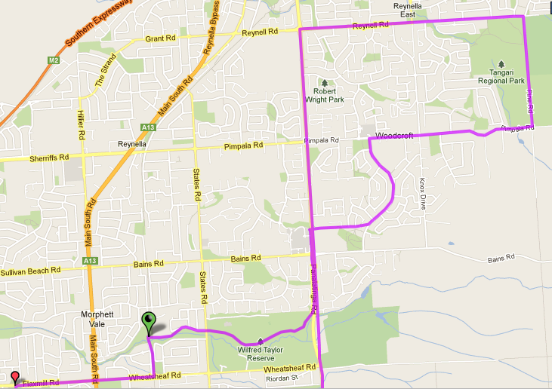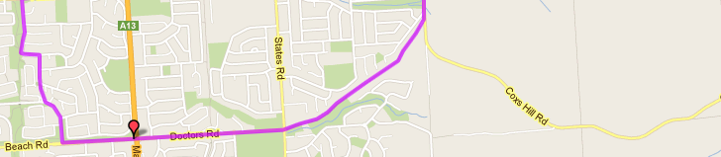
9
10
11
8
7
6
5
4
3
2
1
Start & Finish
2

