**Run 37 – 5.0km Morphett Vale Loop**

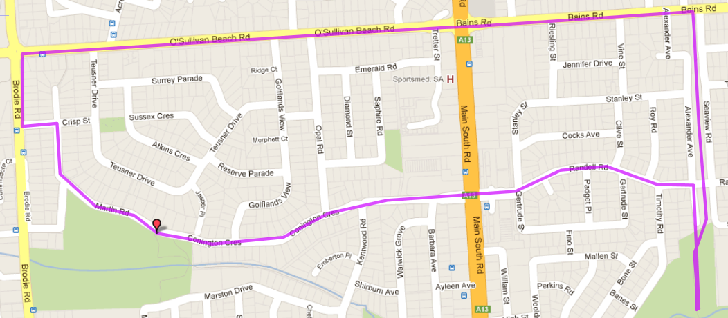

**Start & Finish**

**Directions:**

1. Follow track to Bains Rd then turn LEFT onto Bains Rd, across Main South Road until roundabout (Yes, up that hill!)
2. Turn LEFT onto Brodie Road then first LEFT into Crisp St and RIGHT into Martin Road
3. Follow Martin Road (and Connington Dr) back to Main South Road traffic lights
4. Continue straight ahead and follow Randell Road till the bridge across the bike track
5. TURN LEFT and follow road down the hill and back to the park

**6**

**5**

**4**

**3**

**2**

**1**

**Run 37 – 9.8km Morphett Vale Loop**

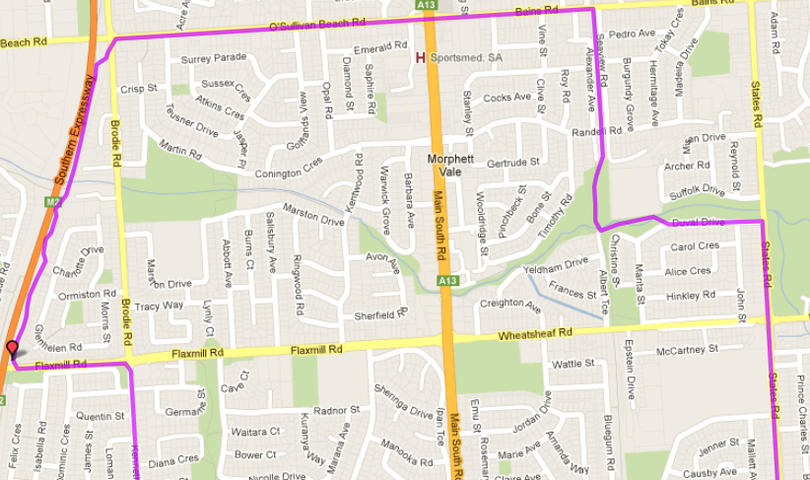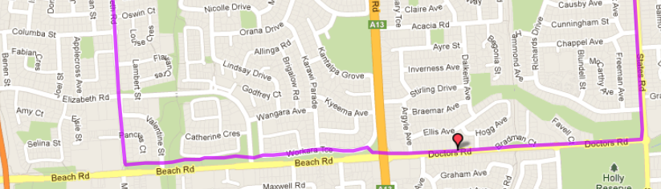

1. Turn LEFT onto bike track at Beach Road and follow till Main South Road lights. Continue straight ahead onto Doctor’s road till States Road (2nd Roundabout/T-Section)
2. Turn LEFT onto States Road until Wheatsheaf Road roundabout
3. Continue Straight ahead till Duvall Drive (Christies Creek) and turn left
4. Follow Duvall Drive till the bend then cross the foot bridge to the right and follow the track THROUGH THE TUNNEL and back to the park

**Directions**:

1. Follow track to Bains Rd then turn LEFT onto Bains Rd, across Main South Road until roundabout (Yes, up that hill!)
2. Turn LEFT onto Brodie Road then cross the road and join the expressway track.
3. Follow Expressway track (down-hill then uphill!) till Flaxmill Road exit and turn left onto the road
4. At Roundabout (Near Ambulance Station) Turn right and follow the road till Beach Road (Near Lutheran School)

**Start & Finish**

**Start & Finish**

**Start & Finish**

**Run 37 – 21.1km Morphett Vale & Hackham West Loop**

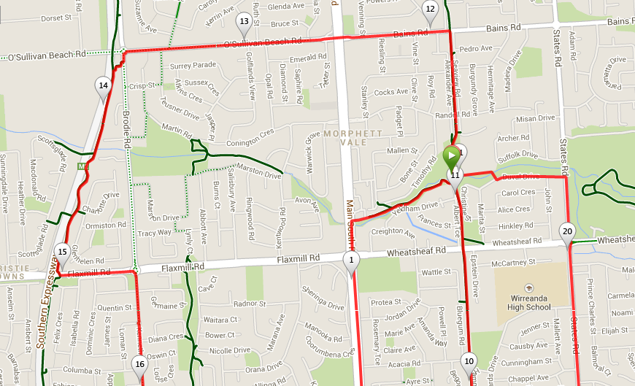 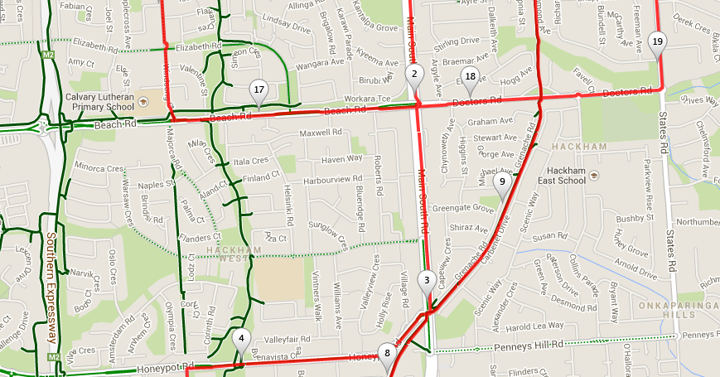 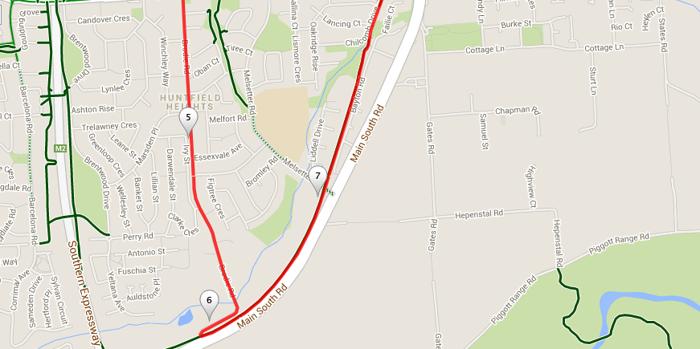

**Directions**:

1. Follow the Christies Creek track to Emu hotel then turn left onto Main South road
2. Continue along MS road across Wheatsheaf and Doctors roads, then at the next lights turn right into Honeypot road
3. Go over the first hill then through the dip until almost at the top of the next hill and turn left into Brodie Road
4. Follow Brodie Road all the way until the end when it becomes gravel and loops around to the bike track (just before main road)
5. Turn left onto the bike track and follow continue across several roads until you get back to the park
6. Continuing on from the park, follow track to Bains Rd then turn LEFT onto Bains Rd, across Main South Road until roundabout (Yes, up that hill!)
7. Turn LEFT onto Brodie Road then cross the road and join the expressway track.
8. Follow Expressway track (down-hill then uphill!) till Flaxmill Road exit and turn left onto the road
9. At Roundabout (Near Ambulance Station) Turn right and follow the road till Beach Road (Near Lutheran School)
10. Turn LEFT onto bike track at Beach Road and follow till Main South Road lights. Continue straight ahead onto Doctor’s road till States Road (2nd Roundabout/T-Section)
11. Turn LEFT onto States Road until Wheatsheaf Road roundabout
12. Continue Straight ahead till Duvall Drive (Christies Creek) and turn left
13. Follow Duvall Drive till the bend then cross the foot bridge to the right and follow the track THROUGH THE TUNNEL and back to the park

**Start & Finish**