Run A18 - Thalassa Park (Aberfoyle Park) Runs
5.1km Route - http://connect.garmin.com/course/8308187
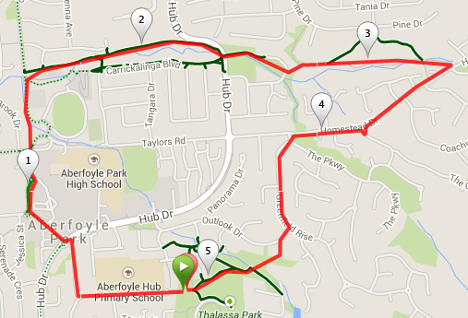
Directions:
1. Follow path through alleyway to Jeanette Crescent. Turn right into Andrews Ct and pass through alley way at the bottom onto Hub Dr.
2. Cross the road to the right of the roundabout onto Sandpiper Crescent, past the servo and turn right at the island into Park Ave.
3. Climb the hill passed Mitre 10 and go straight over the island, crossing Taylors Rd onto a footpath then dirt track turning right over the foot bridge then left.
4. Pass the Tennis courts turning right in the bowling club car park, and running down the alleyway in the left corner behind the bowling club.
5. Follow the trail which turns into a footpath and follow as it sweeps to the right. Cross Hub Dr onto the grassed area and follow the footpath then the dirt trail that bears to the right. Cross Corro St. following the alleyway between the houses.
6. Bear right and follow the trail through Pine Reserve onto Homestead Dr. Turn right and follow the road.
7. Turn left into The Parkway then immediate right into Greenfield Rise.
8. Climb the hill and turn right into Outlook Dr, then left into Shelter Court and down the grass bank into Thalassa Park.
9. Cross the foot bridge, turn right and follow the path up the hill back to the starting point.
Run A18 - Thalassa Park (Aberfoyle Park) Runs
9.9km Route - http://connect.garmin.com/course/8308197
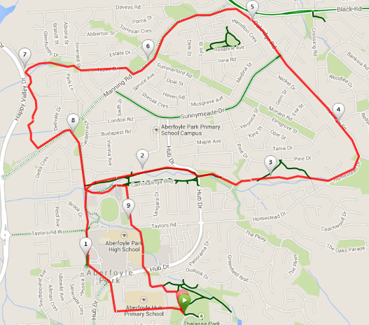
Directions:
1. Follow path through alleyway to Jeanette Crescent. Turn right into Andrews Ct and pass through alley way at the bottom onto Hub Dr.
2. Cross the road to the right of the roundabout onto Sandpiper Crescent, past the servo and turn right at the island into Park Ave.
3. Climb the hill passed Mitre 10 and go straight over the island, crossing Taylors Rd onto a footpath then dirt track turning right over the foot bridge then left.
4. Pass the Tennis courts turning right in the bowling club car park, and running down the alleyway in the left corner behind the bowling club.
5. Follow the trail which turns into a footpath and follow as it sweeps to the right. Cross Hub Dr onto the grassed area and follow the footpath then the dirt trail that bears to the right. Cross Corro St. following the alleyway between the houses.
6. Bear right and follow the trail through Pine Reserve onto Homestead Dr, then left up the hill veering left into Oakridge Rd.
7. Just before the island take a left into Oakridge Cl, following it around into Manning Rd.
8. Turn right into Topaz Drive and at the T junction cross over onto a grassed area and through the alleyway. Cross the grassed area past the play park and through the gate onto a trail.
9. Follow the 'Yellow Walk' back to Manning Rd and turn Left.
10. Just after Deborah Rd turn right onto a grassed area, up the hill behind the shops onto Canberra Dr.
11. At the end of the road go through the bollards across the bowling club car park and left before the tennis courts onto a footpath. Follow this around past the BMX track and right onto Carrickalinga Blvd.
12. At the corner of the road turn left onto Taylors Rd and cut through the gap in the wooden fence following the school fence line.
13. Go under the underpass bearing left onto Newport Cr. Follow the road around and turn right at the T junction into College Ave.
14. Turn left into Margaret Cutton Grove then Right into Burton Mews.
15. Take the path, hidden behind bushes, at the top of the road back into Thalassa Park.

Run A18 - Thalassa Park (Aberfoyle Park) Runs
23.1km Route - http://connect.garmin.com/course/8374947
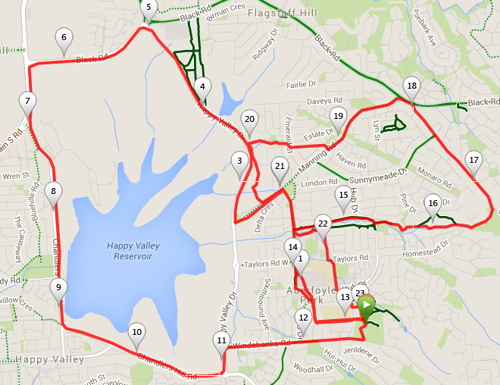

Directions:
1. Follow path through alleyway to Jeanette Crescent. Turn right into Andrews Ct and pass through alley way at the bottom onto Hub Dr.
2. Cross the road to the right of the roundabout and run across the car park to the left of Woolworths and follow between BWS and Mitre 10.
3. At the island turn right into Park Ave, crossing Taylors Rd onto a footpath then dirt track turning right over the foot bridge then left.
4. Pass the Tennis courts, following the road through the bowling club car park and bollards into Canberra Dr.
5. Bare left behind the shops at the bend in the road onto a grassed area, and left onto Manning Rd.
6. Follow until island, turning right onto Happy Valley Dr.
7. At the next island turn left onto Black Rd, then left at the T junction on to South Rd.
8. Turn left and follow Chandlers Hill Rd down then up to the crest of the hill turning right.
9. Follow Chandlers Hill Rd over one island and on reaching the second, left onto Happy Valley Dr.
10. Turn right into Windebanks Rd, straight over the island and left into Thalassa Park.
11. Follow as 10K route.....
10.3km route directions:
1. Follow path through alleyway to Jeanette Crescent. Turn right into Andrews Ct and pass through alley way at the bottom onto Hub Dr.
2. Cross the road to the right of the roundabout onto Sandpiper Crescent, past the servo and turn right at the island into Park Ave.
3. Climb the hill passed Mitre 10 and go straight over the island, crossing Taylors Rd onto a footpath then dirt track turning right over the foot bridge then left.
4. Pass the Tennis courts turning right in the bowling club car park, and running down the alleyway in the left corner behind the bowling club.
5. Follow the trail which turns into a footpath and follow as it sweeps to the right. Cross Hub Dr onto the grassed area and follow the footpath then the dirt trail that bears to the right. Cross Corro St. following the alleyway between the houses.
6. Bear right and follow the trail through Pine Reserve onto Homestead Dr, then left up the hill veering left into Oakridge Rd.
7. Just before the island take a left into Oakridge Cl, following it around into Manning Rd.
8. Turn right into Topaz Drive and at the T junction cross over onto a grassed area and through the alleyway. Cross the grassed area past the play park and through the gate onto a trail.
9. Follow the 'Yellow Walk' back to Manning Rd and turn Left.
10. Just after Deborah Rd turn right onto a grassed area, up the hill behind the shops onto Canberra Dr.
11. At the end of the road go through the bollards across the bowling club car park and left before the tennis courts onto a footpath. Follow this around past the BMX track and right onto Carrickalinga Blvd.
12. At the corner of the road turn left onto Taylors Rd and cut through the gap in the wooden fence following the school fence line.
13. Go under the underpass bearing left onto Newport Cr. Follow the road around and turn right at the T junction into College Ave.
14. Turn left into Margaret Cutton Grove then Right into Burton Mews.
15. Take the path, hidden behind bushes, at the top of the road back into Thalassa Park.

