**Run 31 - 10.0km Woodcroft run**

**4**

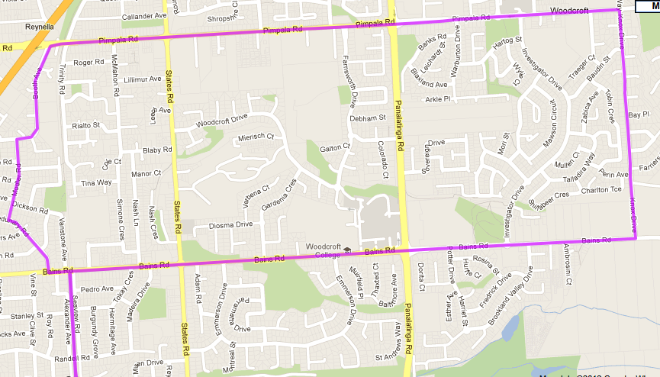 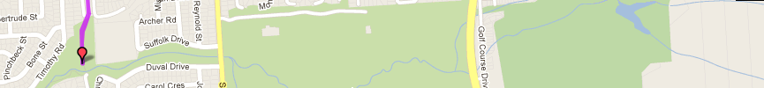

**Directions:**

1. Run up the bike track to Bains Road and turn right
2. Follow Bains Rd across States road and Panatalinga Road s then through roundabout & take next left into Knox Drive
3. Follow Knox Dr till Pimpala Rd (roundabout) and turn left
4. Follow Pimpala until Hungry Jacks and turn left immediately after into Booth Ave
5. Follow road around right turn/bend then take left into Modler Rd
6. Follow Modler Rd till end T-Section turn left into Sedundary Rd until Bains Rd
7. Turn Left until Bike track then cross Bains and follow track back to the park

**7**

**6**

**5**

**3**

**2**

**1**

**Start & Finish**

**6**

**5**

**4**

**Directions**

|  |  |  |
| --- | --- | --- |
| 1. Follow Christies Creek trail from the park towards Emu Hotel and take pathway to left of building and under Main South Rd 2. Follow track until park and continue to road then (after bridge on left) continue along creek trail – Continue across road and onto trail again | 1. Follow track around first lagoon, then turn right after lagoon and cross footbridge (just before toilet block) 2. Turn left straight after bridge and follow track along edge of lagoon and straight ahead at end until Brodie Rd – Turn left up the hill till the roundabout | 1. Turn left at Roundabout onto Flaxmill road and follow footpath down the hill to MS road – cross at lights 2. Continue along Wheatsheaf road till bike track then turn left and follow back to the park |

**1**

**6**

**5**

**Run 31 - 5.3km Woodcroft Run**

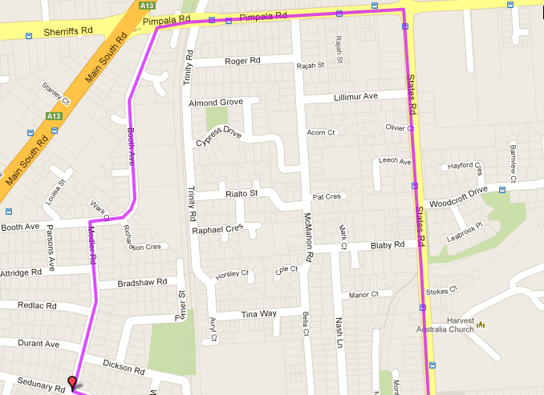 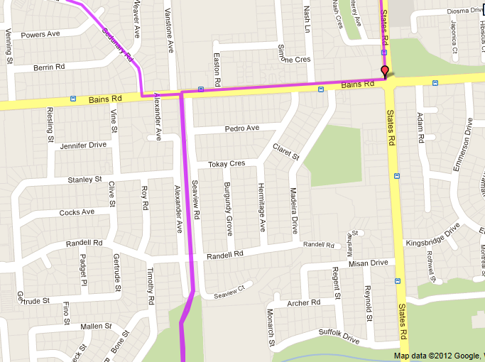

**Directions:**

1. Run up the bike track to Bains Road and turn right
2. Follow Bains Rd and turn left into States road
3. Follow States Rd till Pimpala Rd (roundabout near shops) and turn left
4. Follow Pimpala until Hungry Jacks and turn left immediately after into Booth Ave
5. Follow road around right turn/bend then take left into Modler Rd
6. Follow Modler Rd till end T-Section turn left into Sedundary Rd until Bains Rd
7. Turn Left until Bike track then cross Bains and follow track back to the park

**6**

**7**

**5**

**4**

**3**

**2**

**1**

**Start & Finish**

**Run 31 – 20.2km Woodcroft Run**

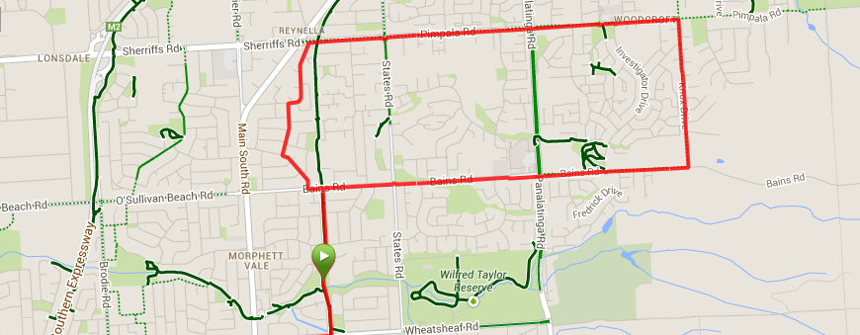 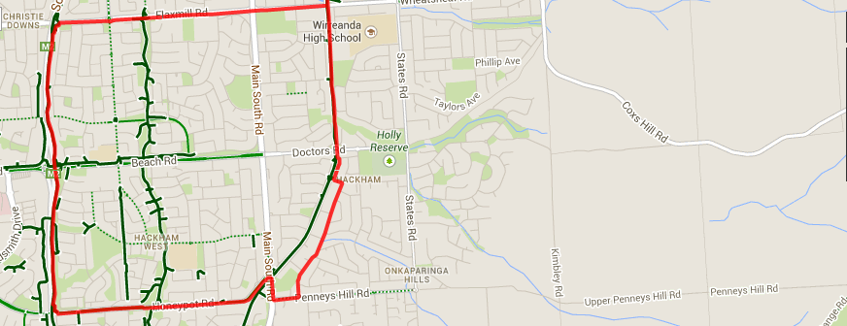

1. Follow Knox Dr till Pimpala Rd (roundabout) and turn left
2. Follow Pimpala until Hungry Jacks and turn left immediately after into Booth Ave
3. Follow road around right turn/bend then take left into Modler Rd
4. Follow Modler Rd till end T-Section turn left into Sedundary Rd until Bains Rd
5. Turn Left until Bike track then cross Bains and follow track back to the park

**Directions:**

1. From the park run South to Wheatsheaf road and turn right
2. Follow Wheatsheaf road until the expressway and turn left onto the track
3. Follow the expressway track past Elizabeth and Beach roads, until you reach Honeypot road and take the exit, turn left
4. Continue along Honeypot road until the traffic Lights (T-Section) at Main South road then turn right and left at Hungry jacks into Penney Hills road
5. Turn left into Scenic Drive and go till the end
6. Turn left into Cabernet Drive then cross over to the bike track and Beach road
7. Continue along the bike track back to the park
8. Run up the bike track to Bains Road and turn right
9. Follow Bains Rd across States road and Panatalinga Road then through roundabout & take next left into Knox Drive

**Directions:**

1. Run up the bike track to Bains Road and turn right
2. Follow Bains Rd across States road and Panatalinga Road s then through roundabout & take next left into Knox Drive
3. Follow Knox Dr till Pimpala Rd (roundabout) and turn left
4. Follow Pimpala until Hungry Jacks and turn left immediately after into Booth Ave
5. Follow road around right turn/bend then take left into Modler Rd
6. Follow Modler Rd till end T-Section turn left into Sedundary Rd until Bains Rd
7. Turn Left until Bike track then cross Bains and follow track back to the park

**Directions:**

1. Run up the bike track to Bains Road and turn right
2. Follow Bains Rd across States road and Panatalinga Road s then through roundabout & take next left into Knox Drive
3. Follow Knox Dr till Pimpala Rd (roundabout) and turn left
4. Follow Pimpala until Hungry Jacks and turn left immediately after into Booth Ave
5. Follow road around right turn/bend then take left into Modler Rd
6. Follow Modler Rd till end T-Section turn left into Sedundary Rd until Bains Rd
7. Turn Left until Bike track then cross Bains and follow track back to the park

**Directions:**

1. Run up the bike track to Bains Road and turn right
2. Follow Bains Rd across States road until Panatalinga Road (Woodcroft shopping centre) and turn right
3. Follow Panatalinga to the end of the houses on the right side then take track into parkland
4. Follow track to right and pass sports fields. Continue till you reach States Road
5. Cross States road and then follow Suffolk Road till the school – continue to the left of the school and take the steps over the mound and back to the park