**Run 33 – 5.3km Onkaparinga Hills run**

**Start & Finish**

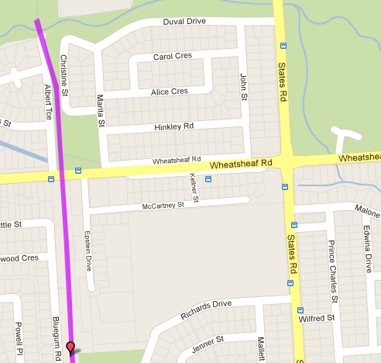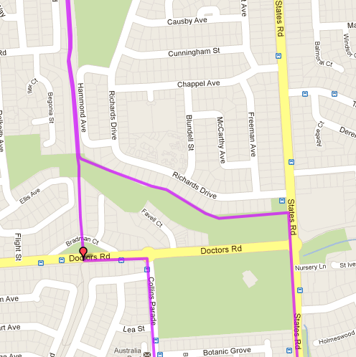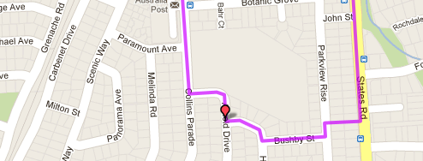

**Directions:**

1. From the park cross Wheatsheaf Rd until wooden foot bridge, take track to the left, along the back the houses to States Rd
2. Turn right at States Rd. Continue on after roundabout up the hill (almost to the top) and turn right into laneway between houses
3. Turn left into Parkview Rise and right into Bushby St.
4. Turn right at T-Section into Hurley Grove then right into Arnold Drive
5. Turn right at T-Section into Collins Parade and follow till Doctors Rd roundabout and turn left
6. At Pedestrian Traffic lights, turn right back onto the bike track and follow back to the park

**6**

**5**

**4**

**3**

**2**

**1**

**Run 33 - 10.0km Onkaparinga Hills run**

**Directions:**

1. From the park cross Wheatsheaf Rd until wooden foot bridge, take track to the left, along the back the houses to States Rd
2. Cross road & turn right at States Rd. Continue on after roundabout – cross Nursury Lane & turn left into Spriggs Rd
3. Follow Spriggs Rd till roundabout – take left turn and then first right (continuation of Spriggs Rd)
4. Continue along Spriggs Rd past houses then to the right onto Kimbley Rd (and the ‘small’ Hill)

**Start & Finish**

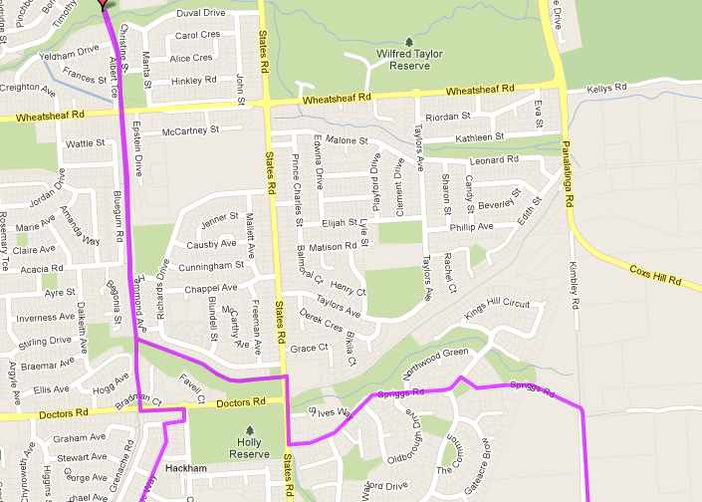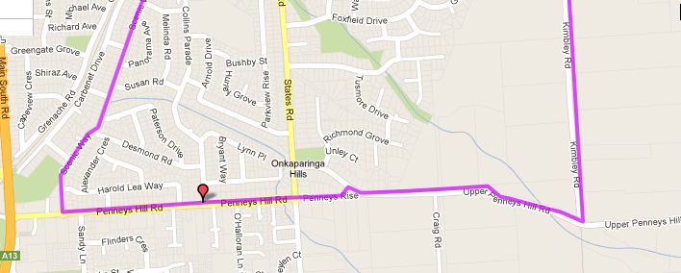

**9**

**8**

**7**

**6**

**5**

**4**

**3**

1. Follow Kimbley Rd till the end T-Section and turn right into Upper Penney Hills Rd

**###TAKE CARE ON THIS ROAD AS THERE IS NO FOOTPATH##**

1. Continue along Upper Penney Hills Road until Penneys Rise, and turn left
2. At end of Penneys Rise, continue across roundabout and along Penneys Hill Road till next Roundabout and turn right into Scenic Way
3. Follow Scenic way until the end then turn right into Cabernet Drive then left into Collins Pde to the roundabout - turn left
4. At Pedestrian Traffic lights, turn right back onto the bike track and follow back to the park

**2**

**1**

**Run 33 – 20.7km Reynella & Onkaparinga Hills run**

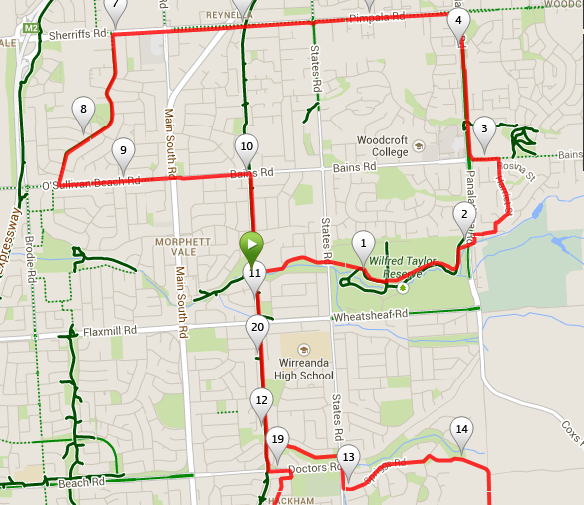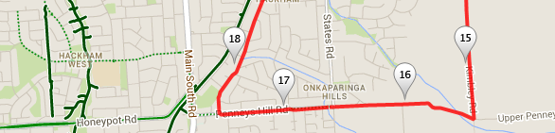

**###TAKE CARE ON THIS ROAD AS THERE IS NO FOOTPATH##**

9. Continue along Upper Penney Hills Road until Penneys Rise, and turn left

1. At end of Penneys Rise, continue across roundabout and along Penneys Hill Road till next Roundabout and turn right into Scenic Way
2. Follow Scenic way until the end then turn right into Cabernet Drive then left into Collins Pde to the roundabout - turn left
3. At Pedestrian Traffic lights, turn right back onto the bike track and follow back to the park

**Directions:**

1. From the park, cross over the mound to MV East School and Suffolk Drive until States road. Continue across States and through Wilfred Taylor reserve until Panatalinga Road – go through tunnel to other side of road
2. Turn left out of the tunnel, then take the first right and next left
3. At T-Section (Tuscany Way) turn right, then at the roundabout turn left into Harriet St and run to the end
4. Turn left onto Bains road, then right at the traffic lights onto Pantalinga Road and follow until Pimpala road
5. Turn left onto Pimpala and continue past McDonalds and Southgate shopping centre, until Acre Ave
6. Follow Acre Ave until O’Sullivan’s beach road and then turn left and follow back across MS road until the bike track and return to the park
7. Continue from the park across Wheatsheaf Rd until wooden foot bridge, take track to the left, along the back the houses to States Rd
8. Cross road & turn right at States Rd. Continue on after roundabout – cross Nursery Lane & turn left into Spriggs Rd
9. Follow Spriggs Rd till roundabout – take left turn and then first right (continuation of Spriggs Rd)
10. Continue along Spriggs Rd past houses then to the right onto Kimbley Rd (and the ‘small’ Hill)
11. Follow Kimbley Rd till the end T-Section and turn right into Upper Penney Hills Rd

**Directions:**

1. Run up the bike track to Bains Road and turn right
2. Follow Bains Rd across States road until Panatalinga Road (Woodcroft shopping centre) and turn right
3. Follow Panatalinga to the end of the houses on the right side then take track into parkland
4. Follow track to right and pass sports fields. Continue till you reach States Road
5. Cross States road and then follow Suffolk Road till the school – continue to the left of the school and take the steps over the mound and back to the park