**Run 30 – 5.0km Panatalinga Run**

**Directions:**

1. Run up the bike track to Bains Road and turn right
2. Follow Bains Rd across States road until Panatalinga Road (Woodcroft shopping centre) and turn right
3. Follow Panatalinga to the end of the houses on the right side then take track into parkland (at the bus stop)
4. Follow track to right and pass sports fields. Continue till you reach States Road
5. Cross States road and then follow Suffolk Road till the school – continue to the left of the school and take the steps over the mound and back to the park

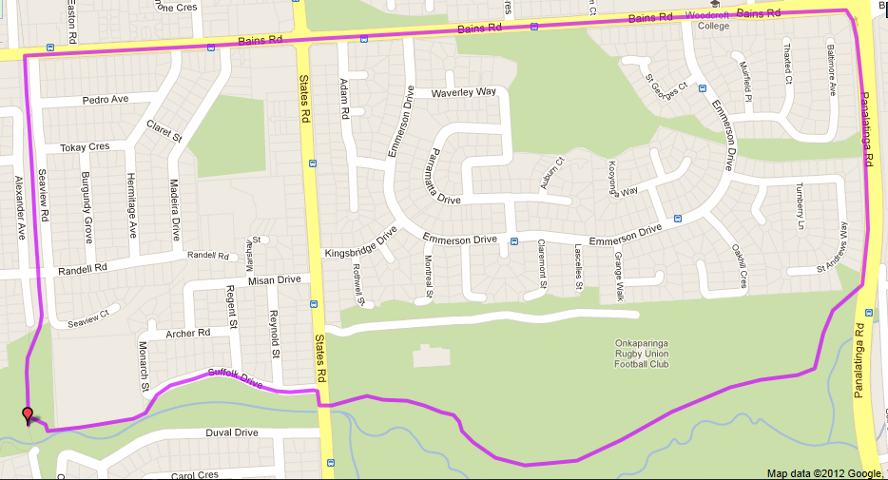

**5**

**1**

**4**

**3**

**2**

**Start & Finish**

**6**

**5**

**4**

**Directions**

|  |  |  |
| --- | --- | --- |
| 1. Follow Christies Creek trail from the park towards Emu Hotel and take pathway to left of building and under Main South Rd 2. Follow track until park and continue to road then (after bridge on left) continue along creek trail – Continue across road and onto trail again | 1. Follow track around first lagoon, then turn right after lagoon and cross footbridge (just before toilet block) 2. Turn left straight after bridge and follow track along edge of lagoon and straight ahead at end until Brodie Rd – Turn left up the hill till the roundabout | 1. Turn left at Roundabout onto Flaxmill road and follow footpath down the hill to MS road – cross at lights 2. Continue along Wheatsheaf road till bike track then turn left and follow back to the park |

**1**

**6**

**5**

**Run 30 - 10.5km Old Reynella Loop**

**Directions:**

1. Run up the bike track to Bains Road and continue past Pimpala (Hungry Jacks) and past Old Reynella Interchange until the footbridge across the creek
2. Just after the footbridge follow the track to the left until you reach Corn St and turn right up the hill until the end (T-Section)
3. Right into Oval Road and into Reynella oval – go right behind the grandstand and re-join bike track and turn right
4. Turn left at the bottom of the hill (before the foot bridge) and follow track to Panatalinga road – Turn right
5. Follow Panatalinga across Reynel Rd (Winery), Pimpala Rd (Gym) and Bains Rd (Woodcroft shops) then to the end of the houses on the right side then take track into parkland (at the bus stop)
6. Follow track to right and pass sports fields. Continue till you reach States Road
7. Cross States road and then follow Suffolk Road till the school – continue to the left of the school and take the steps over the mound and back to the park

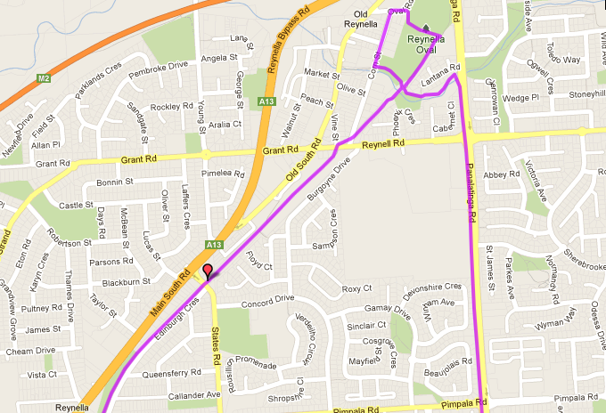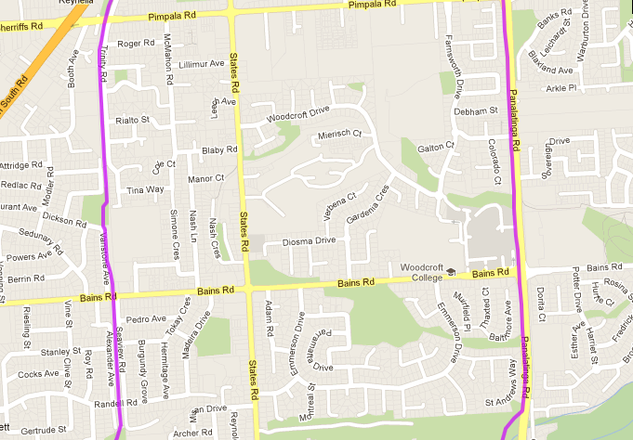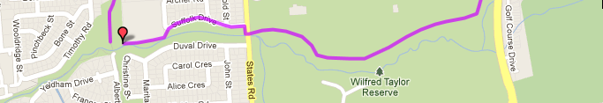

**Start & Finish**

**7**

**6**

**5**

**4**

**3**

**2**

**1**

**Directions:**

1. Run up the bike track to Bains Road and turn right
2. Follow Bains Rd across States road until Panatalinga Road (Woodcroft shopping centre) and turn right
3. Follow Panatalinga to the end of the houses on the right side then take track into parkland
4. Follow track to right and pass sports fields. Continue till you reach States Road
5. Cross States road and then follow Suffolk Road till the school – continue to the left of the school and take the steps over the mound and back to the park

**Run 30 – 20.0km Panatalinga Run**

**Directions:**

1. Take the bike track towards Wheatsheaf road and continue on until you reach Main South Road (at Honeypot road shops)
2. Continue across the lights and join Honeypot road (take side road on the right for safety)
3. Continue along Honeypot, past Williams Ave until you reach the bottom of the hill
4. Turn right onto bike track in parklands and follow track across Glynville Dr, Beach Road, Elizabeth road (tunnel)
5. Turn left at Flaxmill until Broadie road roundabout and turn right down the hill
6. Just after bridge (on right side of shops), turn right and follow dirt track to the lagoon and continue straight ahead until you reach footbridge on the right
7. Cross bridge and follow track to the left then behind houses (Christies Creek Trail)

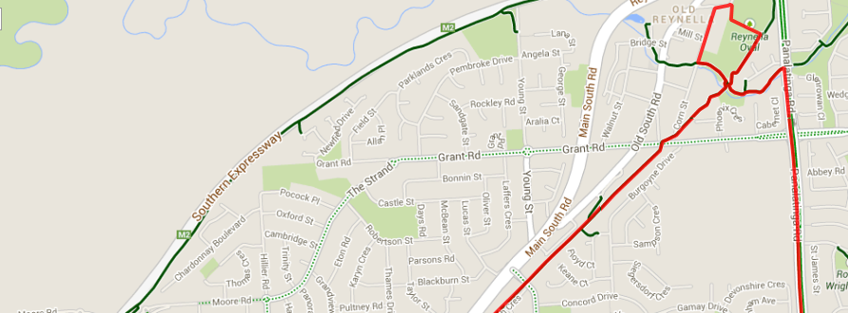 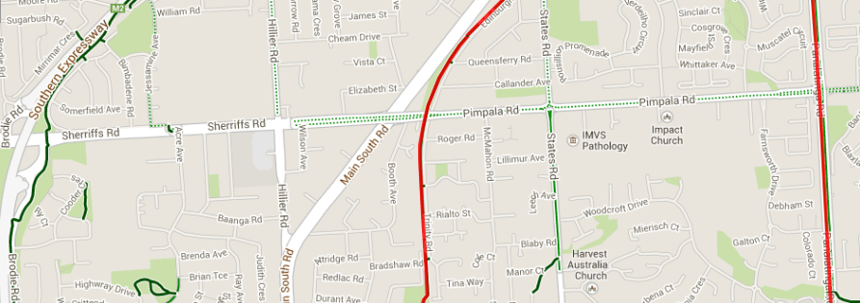 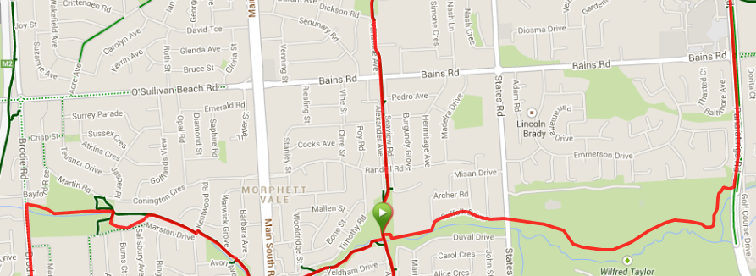 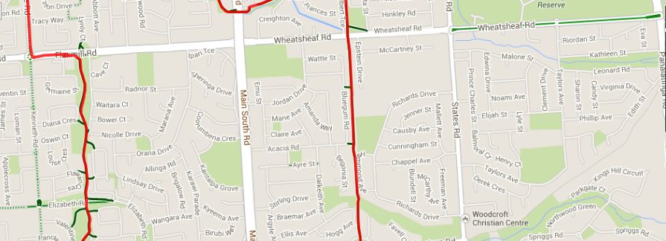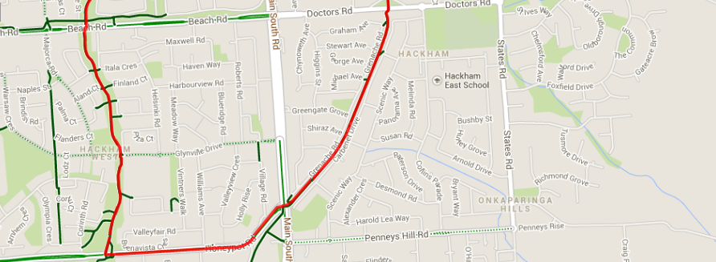

1. Continue to follow trail back to the park, via Emu Hotel car Park
2. From the park, run up the bike track to Bains Road and continue past Pimpala (Hungry Jacks) and past Old Reynella Interchange until the footbridge across the creek
3. Just after the footbridge follow the track to the left until you reach Corn St and turn right up the hill until the end (T-Section)
4. Right into Oval Road and into Reynella oval – go right behind the grandstand and re-join bike track and turn right
5. Turn left at the bottom of the hill (before the foot bridge) and follow track to Panatalinga road – Turn right
6. Follow Panatalinga across Reynel Rd (Winery), Pimpala Rd (Gym) and Bains Rd (Woodcroft shops) then to the end of the houses on the right side then take track into parkland (at the bus stop)
7. Follow track to right and pass sports fields. Continue till you reach States Road
8. Cross States road and then follow Suffolk Road till the school – continue to the left of the school and take the steps over the mound and back to the park