Exercise A.2.5
[(c) using microfluidic patterning]

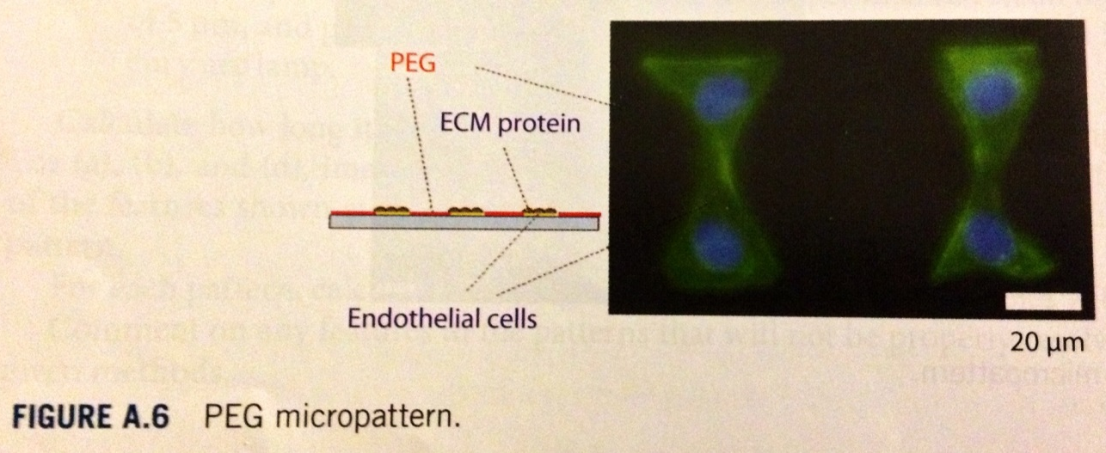

One way of using microfluidics to create the pattern shown in Figure A.6 is to use PEG interpenetrated networks, also known as PEG-IPNs. First, the PEG-IPN is chemisorbed onto a glass surface, and then the areas that are going to be plated with cells are exposed to a microfluidic channel and oxygen plasma is run through the channel, etching away the PEG-IPN layer. With the PEG-IPN layer out of the way, a fibronectin solution (extracellular matrix protein) is flowed through the microchannels where the PEG-IPN was removed. After the fibronectin coating (via physisorption), a period of incubation is allowed, followed by a PBS wash. Finally, cells are seeded onto the surface and will bind where the fibronectin has been coated.

The cells will not attach onto the PEGylated surface because PEG is a highly hydrophilic polymer that repels protein physisorption. The cells attach to the fibronectin areas because fibronectin is an ECM protein that contains RGD domains (arginine-glycine-aspartic acid) that are recognized by integrin receptors expressed by the cells. These integrins will recognize the RGD domains and will bind to them.

