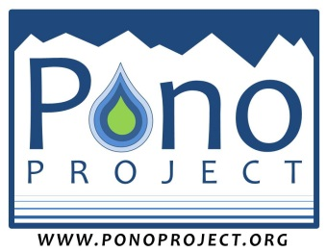
Pono Project, LLC
Paia, Hawaii
www.ponoproject.org
Phone: 808-298-2594
paula@ponoproject.org

MEDIA RELEASE

I hereby grant to the Pono Project LLC (hereinafter “Pono Project”), its affiliates and licensees and to their staff photographers, the following worldwide, irrevocable rights:
(1) To use photographs and/or video submitted to the Pono Project as a part of the grant application process in the name of Pono Project or in the name of the photographer; and
(2) To use photographs and/or video submitted to the Project as a part of the grant reporting process in the name of Pono Project or in the name of the photographer; and
(3) To use and re-use, publish and re-publish these photographs and/or video, in whole or in part, individually or in conjunction with printed matter, or in composite form, and in any medium, for editorial, commercial, promotional, and/or trade purposes.

I hereby waive my right to inspect or approve any copy that is used in connection with the above mentioned photographs and release and discharge Pono Project LLC, its affiliates and licensees, and the photographer from any and all claims arising out of use by Pono Project LLC, its affiliates and licensees, of the photographs for the purposes described above, including any claims for libel and invasion of privacy.

I have read the foregoing and fully understand its contents. If minors are present in any photos, a parent or guardian has signed on their behalf.

____________________________________________ ____________________
Signed Date

____________________________________________
Print Name

____________________________________________
Title

____________________________________________ ____________________
Organization Name Phone

Pono Project LLC Media Release

