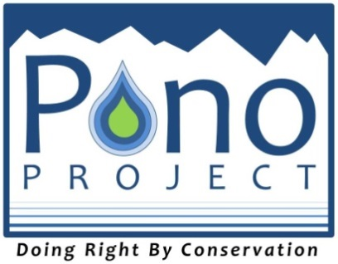
Grant Application Cover Sheet
Page 1 of 2. Please complete both pages.
Pono Project Grant Round #2 – Deadline Friday April 18, 2014, 5pm HST.

Organization Applying for Funding
Name: __________________________________________________________ Website*:__________________________________________________
Address: ________________________________________________________ Facebook*: ________________________________________________
City, State, Zip: _________________________________________________ Tel: ___________________________
*Must have one of either a web address or Facebook page

Executive director. If no ED, name chief compensated staff person.
Name: ____________________________________________ E-mail: ________________________________________________________
Title: ____________________________________________ Tel: ____________________________
Contact person for this project
Name: ___________________________________________ E-mail: _____________________________________________________
Title: ___________________________________________ Tel: ____________________________
Project
Project title:__________________________________________________________________________________________________________
Amount requested: $_______________
The purpose of this project is: (one sentence) _________________________________________________________________________________
_______________________________________________________________________________________________________________________________________
_______________________________________________________________________________________________________________________________________
Special Notes:
Sensitive information in the proposal – please contact us before posting online - _________YES ______________No

Attach all documents listed below. Incomplete applications will be returned.
- Both pages of Signed Cover Sheet as a PDF
- Proposal narrative (1 page)
- Deliverable/Budget Spreadsheet (1 page)
- Signed Media Release (signed by authorized staff person)
- 1 Digital Photo or Logo to be used during online voting session
- 1 map of project site or shapefiles of project area (optional)

Fiscal sponsor organization, if applicable
Name: ____________________________________________ Website: _________________________________________________
Address: __________________________________________ Tel: __________________________
City, State, Zip: _____________________________________ Fax: _________________________
Executive director of fiscal sponsor organization, if applicable. If no ED, name chief compensated staff person.
Name: ____________________________________________ E-mail: _______________________
Title: ____________________________________________ Tel: __________________________

Please complete both pages – continued on next page.
If a fiscal sponsor is involved, attach these additional documents: (Incomplete applications will be returned)
- Resolution by fiscal sponsor’s board of directors authorizing fiscal sponsorship of this project
- Fiscal sponsor’s Agreement form
- Fiscal sponsor’s IRS 501(c)(3) determination letter
Terms and conditions
Grants are subject to the following terms and conditions: Grantees must use the grant only for the purpose described in the grant application, subject to any additional conditions set forth in the grant award letter. Grantees must submit a final report no later than two months after the end date of the contract. Pono Project reserves the right to conduct site visits and to require interim reports. Grantees must return all unexpended funds at the end of the grant period. Grantees must notify Pono Project immediately if they cannot perform in accordance with the terms of the grant, materially change their mission or activities, or lose exemption from federal income taxes under 26 USC § 501(c)(3). In these circumstances, grantees may be required to return the grant.
Two signatures are required. Incomplete applications will be returned.
Please print out completed form and get signatures, then scan in as a PDF or JPEG to include in your application package.
We the undersigned agree to allow the Pono Project to review and post details of our proposed project on the Pono Project website and social media outlets, as specified in the above application cover sheet. All information submitted in this proposal packet is correct and up to date to the best of our knowledge. We also agree to a potential site visit by Pono Project staff to review the progress of the grant.
Executive Director: President of the Board of Directors:
______________________________________ ________________________________________
If no ED, chief compensated staff person must sign.

_______________________________________________________ __________________________________________________________________
Type or print name Date Type or print name Date
If a fiscal sponsor is involved, two additional signatures are required. Incomplete applications will be returned.
Executive Director of fiscal sponsor organization: Pres. of the Board of Directors of fiscal sponsor org:
__________________________________________________________ __________________________________________________________
If no ED, chief compensated staff person must sign.

__________________________________________________________ __________________________________________________________
Type or print name Date Type or print name Date

