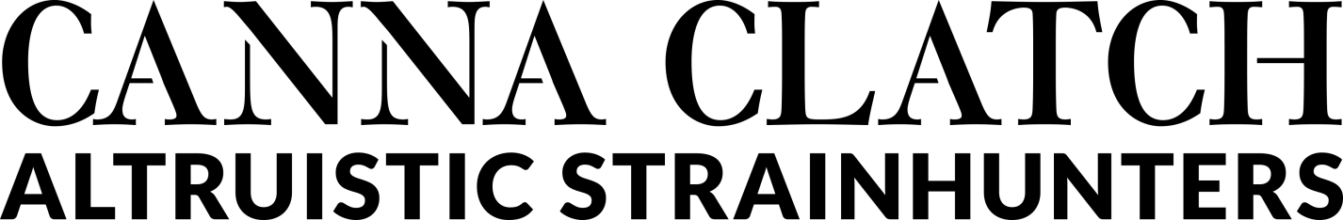

The Altruistic StrainHunters have compiled an updated list of CBD Dominant Cannabis Strains.
CBD stands for Cannabidiol and has gained huge acclaim in the last half dozen years as a cannabinoid that has tremendous medical and therapeutic value but does not have the euphorant value of THC.
Breeders have attempted to stay in front of the curve as widespread news came out of mid-America about a specific strain carrying the moniker “Wu” helped a small girl with a severe form of autism. Little by little, the rainbow of terpenes was discovered within what many revered as “industrial hemp” cultivars and the major trend of CBD Sensimilla farming launched us to where we are now.
Here is a very short list of the formal medical abilities of CBD and an updated list of known strains as of January 30th 2016
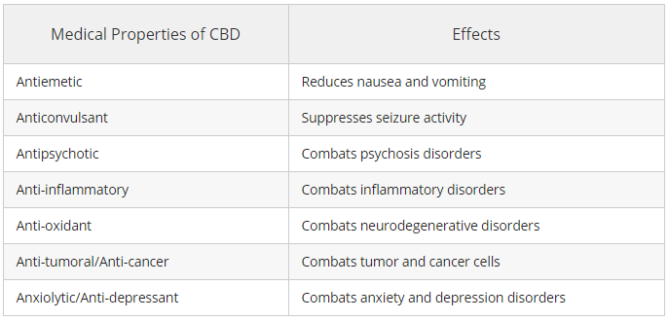

“SATIVA” aka INDICA
CBD Mango Haze
CBD Skunk Haze
Charlotte’s Web
Dance World
Harlequin
Hawaiian Dream
Island Sweet Skunk
Jamaican Lion
Johnny’s Tonic
MediHaze
Rafael
Swiss Gold

“HYBRID”
ACDC
ACDC x Good Medicine
Avi
Avi-Dekel
ATF CBD
Blue Shark
Blueberry Essence
Brainwreck
Bubba Love
Canna-Tsu
Cannatonic
Cannatonic X
CBDA5
CBD Amnesia (SSH)
CBD Lily
CBD Lullaby
CBD Cookies
CBD OG Kush
CBD Yummy
CBD Python
CBD Blue Shark
CBD Black Widow
CBD Blue Dynamite
CBD God
CBD Lavendar (AF)
CBD Diesel
CBD Kali
CBD Magma
CBD Northern (AF)
CBD Yumboldt (AF)
Channel
Cherry Kush (rare)
ComPassion
Critical Cure
Dancehall
Dance World
Dawg Star
Dieseltonic
Doctor Shiva
Durga Mata II CBD
EMT
Euphoria
Freedom Baby
Fruit Spirit
Fuck Cancer
GI001
G5 (Grace, Gayle, Gill)
Glinda’s Tonic
Good Medicine
Granny Derkle
Grape Muerto
Gravity
Harle Sin
Heaven’s Fruit
Homie OG
Hurkle
HT2
IED
Incredible Power
Jack La mota
Juanita la Lagrimosa
Kush Van Stitch
Harle-Tsu
Lost Creek
Love
Luca Brasi
Lucy’s Lion
Mary’s Healing Heart
Maui Bubble Gift
Med GOM (Grass O Matic)
Medi Bomb #1
Medical Mass
Merry Andrew
Midnight
Misty
Nebula II CBD
Nordle
OG Ringo
OmRita RX
One to One
Oracle
Orka
Otto #1
The Otto II
Painkiller XL
Pangea High CBD
Pearl
Platinum Blue
Poison OG
Polar Light #3
Project 13 (P13)
Purple Cheese
R4 (Blueberry Haze x Wu#1)
Red Rhino 10
Remedy X
Revolution
Ringo’s Gift
Royal Medic
Royal Highness High CBD
Rx Red
Ruby Slippers
Session
Shark Shock
She
Sin Tra Bajo (AF)
Soma A Plus
Sour Tsunami
Snowpack
Sugar GOM CBD (AF)
Suzy Q
Swiss Tsu
Tangelo Rapido
Tesla
The Ox
Thunderstruck
Toci (#1-12)
Tora Bora
Treasure Island
Trident
Tropimango
True Blueberry
Valentine X
VCDC
Warlock
Y Griega
Zen

“INDICA” aka AFGHANICA
Afghani CBD
CBD Rene
CBD Shark
Critical Mass
Dark Star
Devil Fruit
Digweed
Haoma
Pennywise
Remedy
Stephen Hawking Kush
Sweet and Sour Widow
Violator Kush
Z-Series
Z7
**********************END LIST***********************
WEBSITE
http://cannaclatch.info

WORDPRESS BLOG
http://cannaclatch.wordpress.com/

INSTAGRAM
http://instagram.com/cannaclatch/

TWITTER
http://twitter.com/CannaClatch

FACEBOOK
http://www.facebook.com/cannaclatch

GOOGLE PLUS
http://plus.google.com/109894551294204882146/posts

TUMBLER
http://cannaclatch.tumblr.com/

LINKEDIN GROUP
http://www.linkedin.com/groups/Canna-Clatch-Altruistic-StrainHunters-6731559/about

PAPER dot li
http://paper.li/CannaClatch/1395908453

#SevenTenPeasants #AltruisticStrainHunters #HashSapiens #OneLove #710Peasants #Soil2Oil #PatientsFirst #Altruism #710SpeakEasy #CannaSapiens #CannaClatch #CannabisCommunity #EndTheDrugWar #EmancipateHorticulture #Grow4Vets #Hash4PTSD #PlantTeacher #Mindfulness #SelfAgency #FullSpectrumResin #InalienableNature #28thAmendment4Nature #GatewayEntheogen #ConciousCommunity

