Isa Gaillard
2/13/14
Word Count: 1977

Permaculture’s Potential at the University of Michigan
The “father of permaculture” Charles “Bill” Mollison first coined the term in 1978, he defined it as, “The conscious design and maintenance of agriculturally productive ecosystems which have the biodiversity, stability, and resilience of natural ecosystems. It is the harmonious integration of landscape and people providing their food, energy, shelter and other material and non-material needs in a sustainable way. Without permaculture (permanent agriculture) there is no possibility of a stable social order (Mollison, ix). The term was later expanded to also mean “permanent culture” as it was seen that social aspects were integral to a truly sustainable system (Hemenway, 4).
The University of Michigan’s current blanket environmental program defines sustainability as an emerging field of problem-driven, interdisciplinary scholarship and practice that seeks to protect the environment and enhance quality of life for present and future generations (Planet Blue website). Unfortunately many of the university’s policies, academic disciplines, research, and consumptive activity do not act according to this practice, and where the sectors that have sought to promote sustainability have far too often based their actions on the far more common yet narrow-minded definition of sustainability. This definition comes from the Brundtland commission, but was also the term utilized in the University’s Environment 207: Sustainability and Society course, “Meeting the needs of the present without compromising the ability of future generations to meet their own needs.” Toby Hemenway unpacked the meaning behind this definition by asking, “What defines a need?” and paying close attention to the structure of the definition, “Notice the present needs come first”. He also attempted to shed light on the mediocrity of sustainability by redefining it, “Sustainability is a midpoint between degenerative activity and regenerative activity, activity that can continue indefinitely given the resources that are available”. He then provided an example that displayed this mediocrity, “When someone asks how your marriage is, if you said “it’s sustainable”, the response would likely be that of confusion or concern because they were likely expecting an answer like “great” or “better than ever” (Hemenway). However, the reality is that we as a university are not even meeting the baseline sustainability that we are currently aiming for. In this paper I will argue that we must reconsider our commitment to the environment, utilizing permaculture design and principles in the classroom, food and energy production sectors, our financial and research investments, and the broader campus culture, in order to become leaders in the environmental movement, and take a holistic approach to solving the increasingly pressing challenges our university and the greater planet are facing.
The decisions of whether or not to utilize permaculture principles are ultimately philosophical and ethical debates. Lovelock expressed an insight which links science and tribal beliefs: he sees the earth, and the universe, as a thought process, or as a self-regulating, self-constructed and reactive system, creating and preserving the conditions that make life possible, and actively adjusting to regulate disturbances. Humanity however, in its present mindlessness, may be the one disturbance that the earth cannot tolerate (Mollison, 2). The University’s firm stance on remaining invested in fossil fuels may not be mindless, it is the only feasible way to financially meet its stakeholder’s goals while still providing its promise to students of keeping costs at a reasonable rate. However these are short-sighted accomplishments that do not take into account the rapidly increasing importance of a strong environmental commitment to the University’s reputation. Additionally, the University’s lack of emphasis on systems thinking, sustainable development, and permaculture disciplines in its curriculum are strong indicators that it is falling behind in emerging educational standards that are going to be essential for its graduating student’s future aspirations, skills, and careers. The university had a mediocre score of 33.32 out of 55, and abysmal rankings in both sustainability-focused and related courses (Scavia, 31, 32). We should not ignore the ambiguous measures of sustainability learning outcomes where the university claims every student that graduates meets the sustainability learning outcomes criteria, and yet we scored a zero in sustainability literacy (Scavia, 34, 41). These measures from the university’s STARS report indicate a lack of commitment and responsibility toward ensuring an education that prepares its students for success in a society where the demand for environmental leaders will surpass that of any other discipline.
So it is evident that something must change within the current state of our university’s affairs. What is not as obvious yet, but is becoming more and more inevitable is that we as a university must not only shift our principles, but break out of the dogmatic, consequentialist, and short-term paradigm that currently dominates our campus climate and proceedings. As Donella Meadows asserted, “If no paradigm is right, you can choose whatever one will help to achieve your purpose” (Meadows, 19). In our case, the new paradigm should respond first and foremost the one law derived from nature, the law of return, which states, “Whatever we take, we must return” or in other words, “nature demands a return for every gift received” (Mollison, 13).
So how do we go about implementing and acting upon this law? To start, we must recognize the importance of non-competition, as troubles occur where large investors and short-term entrepreneurs create large areas of identical green-spaces, buildings, and practices, which are usually the result of out-of-region investment (Mollison, 425). Whether it is importing food, energy, or other campus development resources, we far too often rely on corporations and institutions that are out of region, state, and in some cases country. We also base much of our institution, construction, and academic design in linear open-loop systems that do not reflect natural patterns, creating far less efficiency and much more waste in our current practices. The solution, moving toward a far more dynamic systems thinking approach. To exemplify this concept envision a yard as a dynamic system, not an unchanging still life. By viewing our landscapes as dynamic ecosystems, rather than as static collections of inert objects, we can create gardens that inherently grow in healthy patterns and directions. This perspective allows us to transfer much of the labor of maintaining our yards and green-spaces to nature (Hemenway, 20). On our green campus spaces biodiversity could mean having a semi-wild but well-designed palette of useful plants that will attract and sustain the helpful insects, birds, and other animals we need. On and off campus there are enough vacant lots, neglected corners, parks, and flowery landscaping to nurture a lively community of small wildlife. By filling our garden with multifunctional plants, we create a dense web full of many niches for wildlife, and a rich place for humans as well: a wealth of food, flowers, and medicinal herbs; a place of beauty. 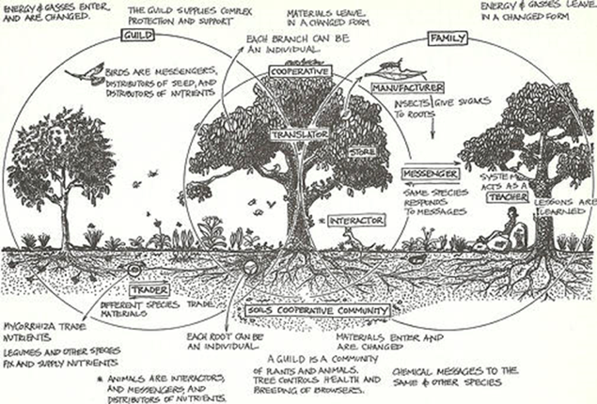(Hemenway, 22)

The University of Michigan owns much land off of campus, including areas such as the Nichols Arboretum where hilly landscapes, a variety of native and foreign plant species, a river, and many critters, birds, and insects live interpedently. Unfortunately, even in areas such as the arboretum unsustainable practices are occurring with the removal of invasive species. In my environmental ethics class we walked to the edge of the arboretum and cut down about 100 square feet of honeysuckle and buckthorn shrubs and small trees. However much of the money and energy spent clearing such exotic species is misdirected and futile (Hemenway, 10). One pro-native gardener describes what he calls “the Kudzu phenomenon, where an exotic displaces natives unless we constantly intervene” (Hemenway, 10). However it is our intervention that is the issue. We assume nature is making a mistake when it creates hybrid, fast-healing thickets, so we never allow disturbed habitat to stabilize. We can spray and cut down invasive species all we want, but they thrive in sunlit edges, and by carving forests into pieces with more edges than interior, we have created optimal habitats for these invasive species (Hemenway, 10). The only long-term hope for eliminating invasive exotics lies in avoiding soil disturbance, restoring intact forest, and shading the invaders out with other species. We need to create ecological landscapes that are more mature, and less hospitable for the invasive species (Hemenway, 10).
What does a mature forest look like, and how would we go about creating one? Permaculture research has found, tested, and formulated a seven-layer forest design that enables for “stacking” functions which is the idea that every part of a garden or forest should serve multiple simultaneous purposes. An example is a shrub, which doesn’t simply cast shade, but also feeds water-starved birds, offers shelter for insects, mulches the soil with its leaves, blocks the wind, and holds the soil with its roots (Hemenway, 26).

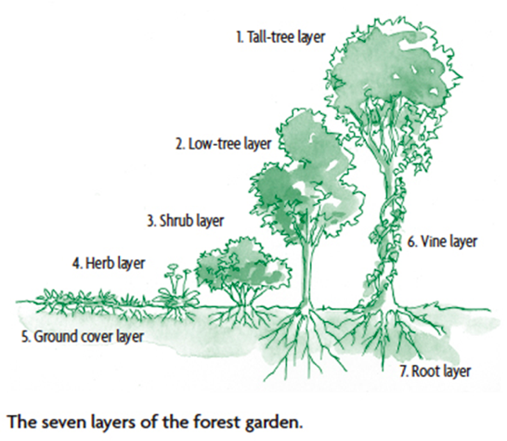 (Hemenway, 172)
A simple forest garden contains three layers: trees, shrubs, and ground plants. But for those who want to take advantage of every planting opportunity, a deluxe forest garden can contain as many as seven tiers of vegetation. From the concept of a mature multipurpose seven-layer forest stems the possibility for the university to mimic such natural systems on a broader scale, and provide for student and faculty needs (food, building supplies, fuel, fibers, etc.). We must learn to identify and work with the various functions of our natural resources. This is where the concept of the “Permaculture Guild” comes from. A guild is usually defined as an association of people working toward a common goal. In Permaculture, a guild is a grouping a plants, animals, insects, and other natural components that all work together to help ensure each other’s survival. Rather than planting gardens, Permaculture shows us how to “build guilds”. Instead of teaching about specific plants, we discover the plant’s functions. This is why Permaculture can work throughout the entire planet. It is a guide for design rather than a “how-to” type of agriculture (Hemenway, 155).
Moving beyond the use of permaculture within our land, construction, and resource generation, permaculture’s holistic principles can be applied to the larger campus decisions that are made behind closed doors, within classrooms, and in the university’s public sector. Recommended investments need to be staggered in terms of ultimate return, so that some money is always on call. To these ends, a set of loans or investments can be scattered over short to long-term enterprises (Mollison, 552). Example investments include:
· Short-term: Loans for draught-proofing, insulation, attached glasshouses, clean water tanks, also loans should be given to local enterprises with careful management and market assessment.
· Medium-term: Bee, chicken, and pig forage systems plus stock, large water catchments for aquatic culture, buying and selling farms after environmental rehabilitation; larger local industries, clean power systems.
· Long-term: Town, city, and campus reconstruction or redevelopment to more sustainable designs, fuel crop and processing, small farm development; orchard establishment, and research into new energy forms.
· Permanent: Forestry, and the purchase of natural remnant forest (shares can be traded as values increase over the long-term); wildlife reserves and rainforest restoration (Mollison, 552).
Finally, increasing campus awareness about permaculture and its applications to the many interconnected environmental movements provides a unique opportunity for innovation and collaboration. We must increase the knowledge of permaculture through education systems, with demonstrations on appropriate land in local areas. So that people can see the examples, and learn the design as a system. We should begin offering a two week design certificate course and then an opportunity to go on to take a ten week practical internship, where students can fast-track their career to go into service and help people extend these systems while we have time (Lawton). An example of a successful permaculture site in Ann Arbor is the Chiwara House. Though the transformation of this site began in 2008, remarkable yet entirely replicable results are now present throughout the property. With a lab for permaculture design at the home scale level, the ultimate goal of this site is to demonstrate solutions in net zero, fossil fuel free food, energy, water, building, transportation, and waste (Ayers).

Bibliography

Ayers, Nathan. “Locations.” About. Ann Arbor: <http://www.chiwarapermaculture.com/ Hemenway, Toby. Gaia's Garden. 1st. White River Junction: Chelsea Green Publishing Company, 2000. 4-172. Print.
Hemenway, Toby. “How Permaculture Can Save Humanity and the Earth, but Not Civilization.” Duke University. North Carolina, Durham. 12 Feb 2010. Lecture.
Lawton, Geoff. “Permaculture.” TedxAjman. Tedx. Ajman, 3 Jul 2012. Address.
Meadows, Donella. “Leverage Points: Places to Intervene in a System.” Sustainability Institute. (1999): 19. Web. 14 Feb. 2014.
Mollison, Bill. Permaculture A Designers Guide. 2nd. Tasmania: Tagari Publications, 1979. Ix 552. Print.
Newell, Josh. “Course Overview.” Lecture 1. University of Michigan. Michigan, Ann Arbor. 10 Jan 2012. Lecture.
“Overview.” Planet Blue. University of Michigan, n.d. Web. 14 Feb 2014. <http://sustainability.umich.edu/overview>.
Scavia, Don. “University of Michigan STARS REPORT.” aashe. (2012): 31-41. Web. 14 Feb. 2014.

