Environ 391 Individual Research Paper
David Milarch, Micropropagation and Wise Sustainability Funding
John Yates III

This paper will focus on a variety of topics. First, this paper will summarize the background of Archangel Ancient Tree Archive, a 501(c)3 non-profit organization that locates and propagates the world’s largest and most iconic trees, formerly known as the Champion Tree Project. Next, this paper will look at the techniques used to clone plants. Finally, it will argue that funding the Archangel Ancient Tree Archive is a worthwhile investment of limited sustainability funding, especially for sponsors with access to large capital like University of Michigan.
The story of Archangel begins with a man named David Milarch. His story is an interesting one to say the least, but his is the story of the Champion Tree Project and later the Archangel Ancient Tree Archive. A disclaimer first, his story is steeped in spirituality in the broadest sense, and this author would like to express at the start his skepticism of this story and the supernatural in general, and would guess there are ways to explain it without bringing in supernatural phenomenon. That being said, David Milarch grew up his family’s farm in Michigan and was put to work there, probably more aptly described as hard labor, by his father from an early age (Robbins, 2012). The hard work built a giant of a man, six foot three with the body of a true farm boy by the time he was twelve. Milarch realized his strength during middle school and high school and was not afraid to use, even if not for good (Robbins, 2012). He helped found the Blatz Gang and saw more than his fair share of violence. Milarch quit the gang when he was eighteen after getting “shot at, stabbed in the shoulder, and beat up bad with a rumble chain all in one year” (Robbins, 2012). After a year of college at Ferris State, Milarch dropped out and hitchhiked across the country, using his strength to win arm wrestling competitions to pay his way across the nation (Robbins, 2012). It was during this time that Milarch saw his first grove of old-growth redwoods and was dismayed to find that they were still being logged. After his travels, Milarch returned to his family’s farm, now empty, and lived there until he met his wife, Kerry, that summer. The bond was instant and two weeks after their meeting, they both left Michigan to go hitchhiking together again for a year. After they returned home from their adventures in the summer of 1977, they married and started to renew and rebuild the farm (Robbins, 2012). Sadly, though, during his gang and hitchhiking days, David Milarch developed an addiction to alcohol. It was a few years after his marriage before he decided to quit. He decided to quit after showing up drunk to his son’s softball game, rolling down the hill in his stupor and onto the first base line (Robbins, 2012). After that incident, he vowed to never embarrass his kids again, and thus began his attempt to go cold turkey.
It is also where the mysticism surrounding him and his cause begins. Milarch had a near-death experience during his withdrawal. His liver and kidneys started to fail and he was rushed to the ER (Robbins, 2012). After a thoracentesis (withdrawal of fluid from the chest) was performed, Milarch refused dialysis and returned home (Robbins, 2012). Sometime during the next few days in bed, he had a vision: he went through a tunnel of light to another realm where he felt unconditional love and saw beings of light. He was told by the beings, “You have work to do,” and they sent him back. He then sat up in bed, bewildering his wife and mother who were attending him (Robbins, 2012).
A few months later in the winter of 1992, Milarch had another vision. He was woken one winter night by a blinding light and a voice told him, “Get a pad and pen and go to your leather chair and write this down” (Robbins, 2012). He did as instructed and when he awoke later that morning in his chair, he found the plans for the Champion Tree Project outlined on the pad, a mission to reforest the Earth with clones of the oldest and largest trees (Robbins, 2012). There are other notable anecdotes of mystical and psychic experiences that Milarch has had, and he openly states that he uses this “sixth sense” of his readily during projects for Archangel (Robbins, 2012).
Whatever you take from the story, Milarch’s plan and project to clone and propagate the world’s largest trees as a means to help heal the Earth from ecological devastation stands on its own legs as an idea. Many experts have agreed it is a sound plan: Milarch was invited to give a TEDx talk to NASA, where Steve Craft, deputy director of the strategic relationships office at NASA’s Langley Research Center, said, “It’s a fantastic idea,” and has made plans to research it further (Robbins, 2012). Dr. William Libby, a professor emeritus of forestry and genetics at the University of California, Berkeley, was so intrigued by the project that he lends his services to it as needed. He still is skeptical that the “Champion Trees,” a tree that “has the highest combined score of three measurements: height, crown size, and diameter at breast height,” are the “best” trees overall. He says that many factors go into how much a tree grows, but agrees that genetics does play a large role (Robbins, 2012).
Still, the desire for clones of plants is common. Here we transition into the second part of this paper: a discussion of cloning in horticulture. In the industrial world, and in Milarch’s case, producers do not want to waste time with the progeny of a great plant specimen because sexual reproduction might have altered some of the phenotypes the producers are looking for. Plants produced by sexual reproduction are “highly heterozygous, and therefore regenerants are likely to exhibit variability” (Korrban & Sul, 2007). Clones, one the other hand, will have exactly the same phenotypes as their counterpart: “to maintain trueness-to-type of elite clones or superior genotypes of [trees] having desirable characters (e.g., resistance to diseases or insects, wood quality, or growth characteristics, among others), explants [plants chosen for cloning] chosen for micropropagation [a cloning technique] should be derived from somatic tissues of trees old enough to have demonstrated their value, and not from zygotic tissues” (Korrban & Sul, 2007). Milarch does not want to plant thousands of genetically unique trees where only a fraction of the individuals are of superb genetics; he wants to plant only the best trees as this will give us the greatest chance in combating climate change (Robbins, 2012).
So how does one clone a tree? Some plants naturally reproduce asexually, which means, technically, their offspring are clones (PNW, 2011). In horticulture, grafting is one of the oldest and most common ways to clone. The major objective of grafting is, “to multiply plants identical (true-to-type) to the parent plant” (PNW, 2011). As stated above, if there is a plant that has a specific or rare trait you are looking to replicate, cloning is your best bet to multiply that trait. Grafting is accomplished by “inserting a piece of stem containing 3 to 4 vegetative buds onto the stem of the plant that will serve as the root system for the unified plant. In nature, two closely related plants growing in proximity may establish a graft union [literally, grow their tissues together] on their own” (PNW, 2011). Milarch and his team tried this technique repeatedly in their early days attempting to clone their very large (and thus very old) trees, but to no avail (Robbins, 2012). This is because plants’ ability to develop roots declines with age (PNW, 2011).
Many critics doubted that Milarch would ever be able to clone one of his “Champion” trees due to their age (Robbins, 2012). But Milarch did what he does best: he persevered. Using micropropagation, a modern way to clone plants, he eventually succeeded in cloning Redwoods over thousands of years old (Robbins, 2012). Micropropagation is a complex process based around simulating entire new root and stem growth from tissue obtained from the meristem of the plant through the use of nutrients and hormones (Robbins, 2012; Korrban & Sul, 2007). The process starts by placing meristem tissue in a special culture where hormones and nutrients will stimulate new shoots. Each shoot is then placed in a second growth medium with more hormones and nutrients. Here they grow until they are about an inch long before they are transplanted to soil in a climate controlled greenhouse. About a year later, they will be close to six inches tall and ready to be planted in special soil mixtures (Robbins, 2012; Korrban & Sul, 2007). (Appendix 1) The meristem of a single tree can produce tens of thousands of clones through micropropagation, allowing the cloning of these trees to become economically viable (Robbins, 2012).
This brings us to the final part of this paper: why we should invest in propagating old growth trees. The Federal Government of the United States of America spent $718 billion on defense and international security assistance in 2011 alone (Plumer, 2013). Ceres, a primer environmental consulting and investing groups, estimates that we need to spend a “clean trillion” (a trillion dollars on sustainable infrastructure, energy and the like) every year for the next thirty six years if we hope to keep the average global temperature from rising about 2 degrees Celsius, the limit accepted by the majority of the world at Copenhagen (Ceres, n.d.) Ceres estimated that only $281 billion was spent on sustainability in 2012 (Ceres, n.d.). Clearly, the funds for current sustainability projects are limited, and we would have to add the entire Federal budget for the U.S. military and foreign security aid on to our current spending to consider ourselves on track for combating climate change.
What limited funding means for sustainability is that we must spend what little we have wisely. Investing in planting “Champion” Sequoia trees, Sequoiadendron giganteum, is one of the wisest actions we can take to combat climate change because they provide an estimated $162,000 in ecosystem services per tree per lifetime (Robbins, 2012). This includes services like air pollution control, carbon sinking, and soil erosion control. There could be even more benefits: planting trees near buildings helps to regulate their temperature. Dave Nowak, an expert for the U.S. Forest Service, says if a tree is planted near a building “its cooling effect can reduce heating by up to 25 percent” which would prevent 16,000 to 20,000 pounds of CO2 emissions over the tree’s lifetime (Robbins, 2012). When a single tree Milarch clones is costing only about $1000 (and this is before ramping up production which would dramatically reduce the cost of each clone) we would still have an unbelievable return on investment: over 162 times on initial value. Still, the initial cost is quite expensive, so it will take a sponsor with access to large amounts of capital to make the initial investments.
Enter the University of Michigan: being a sponsor of the require magnitude, it can easily fund Archangel while also completely offsetting its carbon emissions (if enough trees are planted). This may require convincing large donors, like Steven Ross, to invest in the sustainability side of the University instead of the athletics or the business school, but that feat is far from being Herculean. It looks even more realistic with the hiring of a new president who is married to an environmental lawyer. With climate change being one of the quintessential “wicked problems,” we need creative and innovative thinkers to help lead the way. David Milarch is one of these individuals. He has been trying to realize his goal with the scant funding he has. He was even laid off of his own cloning operation before due to lack of funding (Robbins, 2012). He has beaten the odds time and again with little more than the skin on his teeth. It is time we realize the potential of his project and started funding it more heavily as a university.

Appendix:

1.
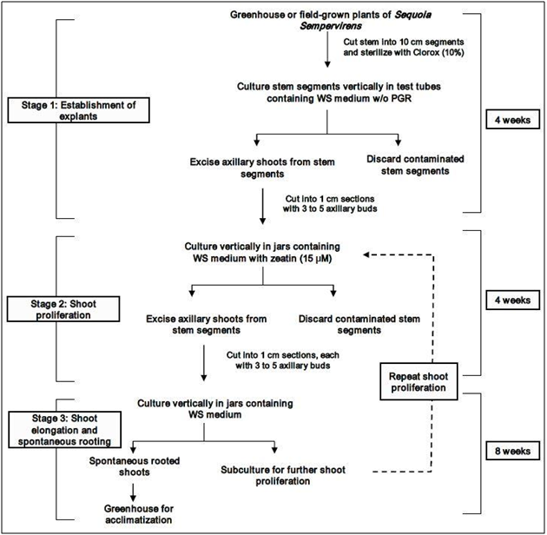
A schematic diagram of the overall micropropagation protocol for Sequoia sempervirens (Korrban & Sul, 2007).

Sources Cited:

1. Plumer, Brad. “America’s staggering defense budget, in charts.” Wonkblog: Economic and Domestic Policy, and lot’s of it. The Washington Post, 7 Jan. 2013. Web. 11 Feb. 2014. http://www.washingtonpost.com/blogs/wonkblog/wp/2013/01/07/everything-chuck-hagel-needs-to-know-about-the-defense-budget-in-charts/

2. Torres, A. (2002). Cloning the oldest tree. Environment, 44(10), 6-7. Retrieved from
http://search.proquest.com.proxy.lib.umich.edu/docview/224027470?accountid=14667

3. “Clean Trillion.” Issues. Ceres, n.d. Web. 11 Feb. 2014.
http://www.ceres.org/issues/clean-trillion

4. Robbins, Jim. The Man who Planted Trees. New York: Spiegel & Grau, 2012. Print.

5. Pacific Northwest Extension Publication (PNW). Propogation of Plants by Grafting and Budding. Washington State University: Pacific Northwest Extension Publication, 2011. Print.

6. Korban, S. S., and Sul, I.-W. “Micropropogation of Coast Redwood.” Protocols for Micropropagation of Woody Trees and Fruits. Jain, S.M., and Häggman, H. Springer, 2007. 23-32. Print.

