The Christmas Quiz
Each question earns 1 point per correct answer. Maximum points per question are given in brackets. The team with the most points wins. Good luck!
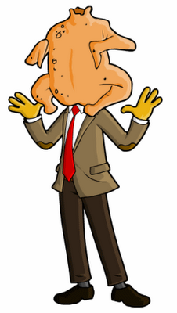
The UK
- The Beatles is arguably the most famous band of all times. What are the names of the four members of the group? (1p)
- The upcoming James Bond film is the 24th in line about the British secret agent. What is it called? (1p)
- In an unfortunate incident, Mr. Bean once got his head stuck inside his Christmas turkey. What was he trying to achieve? (1p)
- The British are proud of their pub culture. What is "pub" short for? (1p)
The US
- The TV show Breaking Bad is set in the state of New Mexico. What is the name of the city? (1p)
- Which American author is known for his love of boxing, fishing and hunting, and for having written, among several others, the 1929 novel A Farewell to Arms? (1p)
- There are three towns in the United States that have the name Santa Claus. What is the other name for Santa Claus (julenissen) used in the US? (1p)
- Soccer is currently the 5th most popular sport in the United States, based on viewership and participation. Can you name the four most popular ones? (4p)
Australia
- What is the population of Australia? And how many sheep are there in the country?
- What is the name of the capital of Australia? (1p)
- Australia is famous for its wildlife. Can you name four animals not found anywhere else on the planet? (max 4p)
- Which Australian actor is famous for playing the Wolverine in the X-Men film series? (1p)
The rest
- Which country in Africa has the largest English-speaking population? (1p)
- The name of New Zealand's national bird is also a nickname for the nation's inhabitants. What is it? (1p)
- India, Australia, Canada and the United States are all huge countries. Can you rank them from largest to smallest? (1p)
- The fastest man in the world comes from an English-speaking country. What is his name and where does he come from? (2p)

