Native Kitchen
By Bronia Hamilton

I am often asked what Australian cuisine is and I have tended to answer that we do not have one cuisine. As a relatively young, multicultural country, we enjoy food from all parts of the world and mix and match, creating interesting fusions. While this is still true, an emerging trend for native Australian ingredients means that there are some dishes that are truly Australian. Clinton Whiteman, of Petrel Kitchen, is producing delicious dishes, using native Australian meats, vegetables and spices.
I interviewed Clinton in his restaurant. Consequently, there is some background noise as the chefs prepare for the evening’s settings.

Listen and Understand

Part One: Menus and Meat (19 minutes 30 sec)
- Clinton is the designer of the restaurant and menu. What does this mean that he is able to control?
- Clinton has been influenced by his travel to a number of areas. List them.
- What are some of the meats that are on offer at Petrel now, and what would he consider using in the future?
- Some people don’t like the idea of eating “cute” animals. What is Clinton’s response?
- Clinton explained various ways that gravlax can be cured using different agents to break down the fish or meat. What are the agents that he mentioned and where are they traditionally used?
- How did Clinton prepare the crocodile that Bronia enjoyed?
- Where is Clinton from and how long has he been in Australia?
- What were some of the challenges that Clinton experienced with sourcing ingredients and what has he learnt from this process?
- How does Clinton see his role in contributing to Australian food culture and why does he think this is important?
- What does Clinton say about the importance of good produce?

Part Two: The Dining Experience (7 min 45 sec)
- Describe how Clinton likes diners to experience the food and the meal.
- What is the role of wait staff in this kind of dining experience?
- Clinton says, “There are no rules”. What does this mean for him in terms of his role in the restaurant?
- What is Clinton’s expectation of wait staff in knowing the food they are serving?
- What does Clinton say about the relationship between chefs and waiters?
- How would you describe Clinton’s expectations of himself?
- Why does Clinton think that the final presentation of a meal is so important?
- Why does Clinton often employ European wait staff?

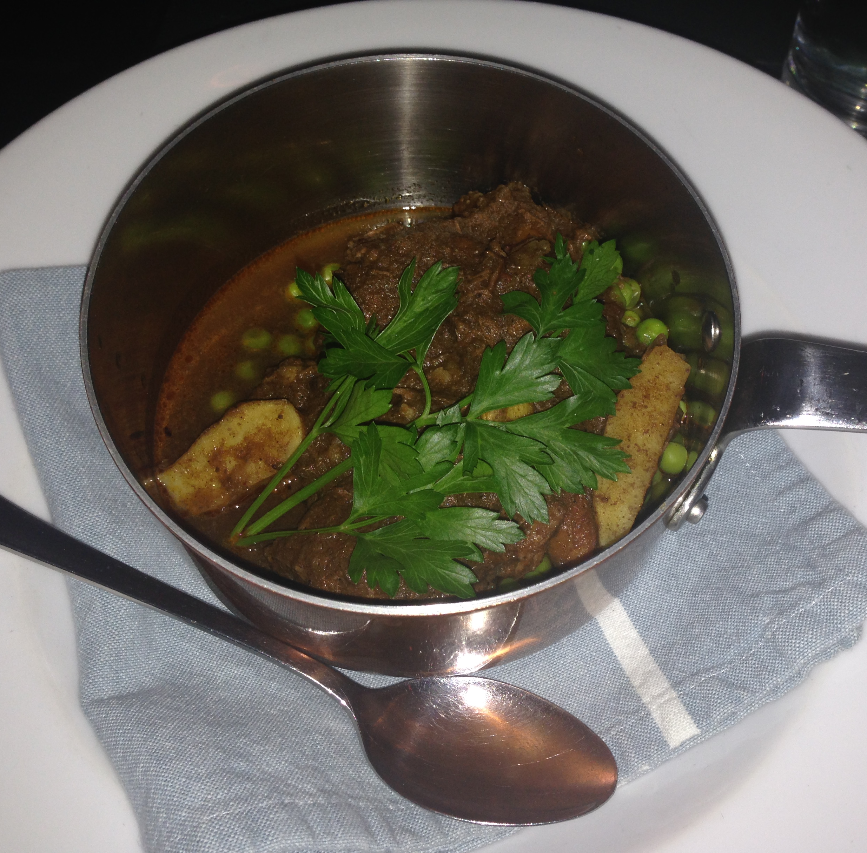
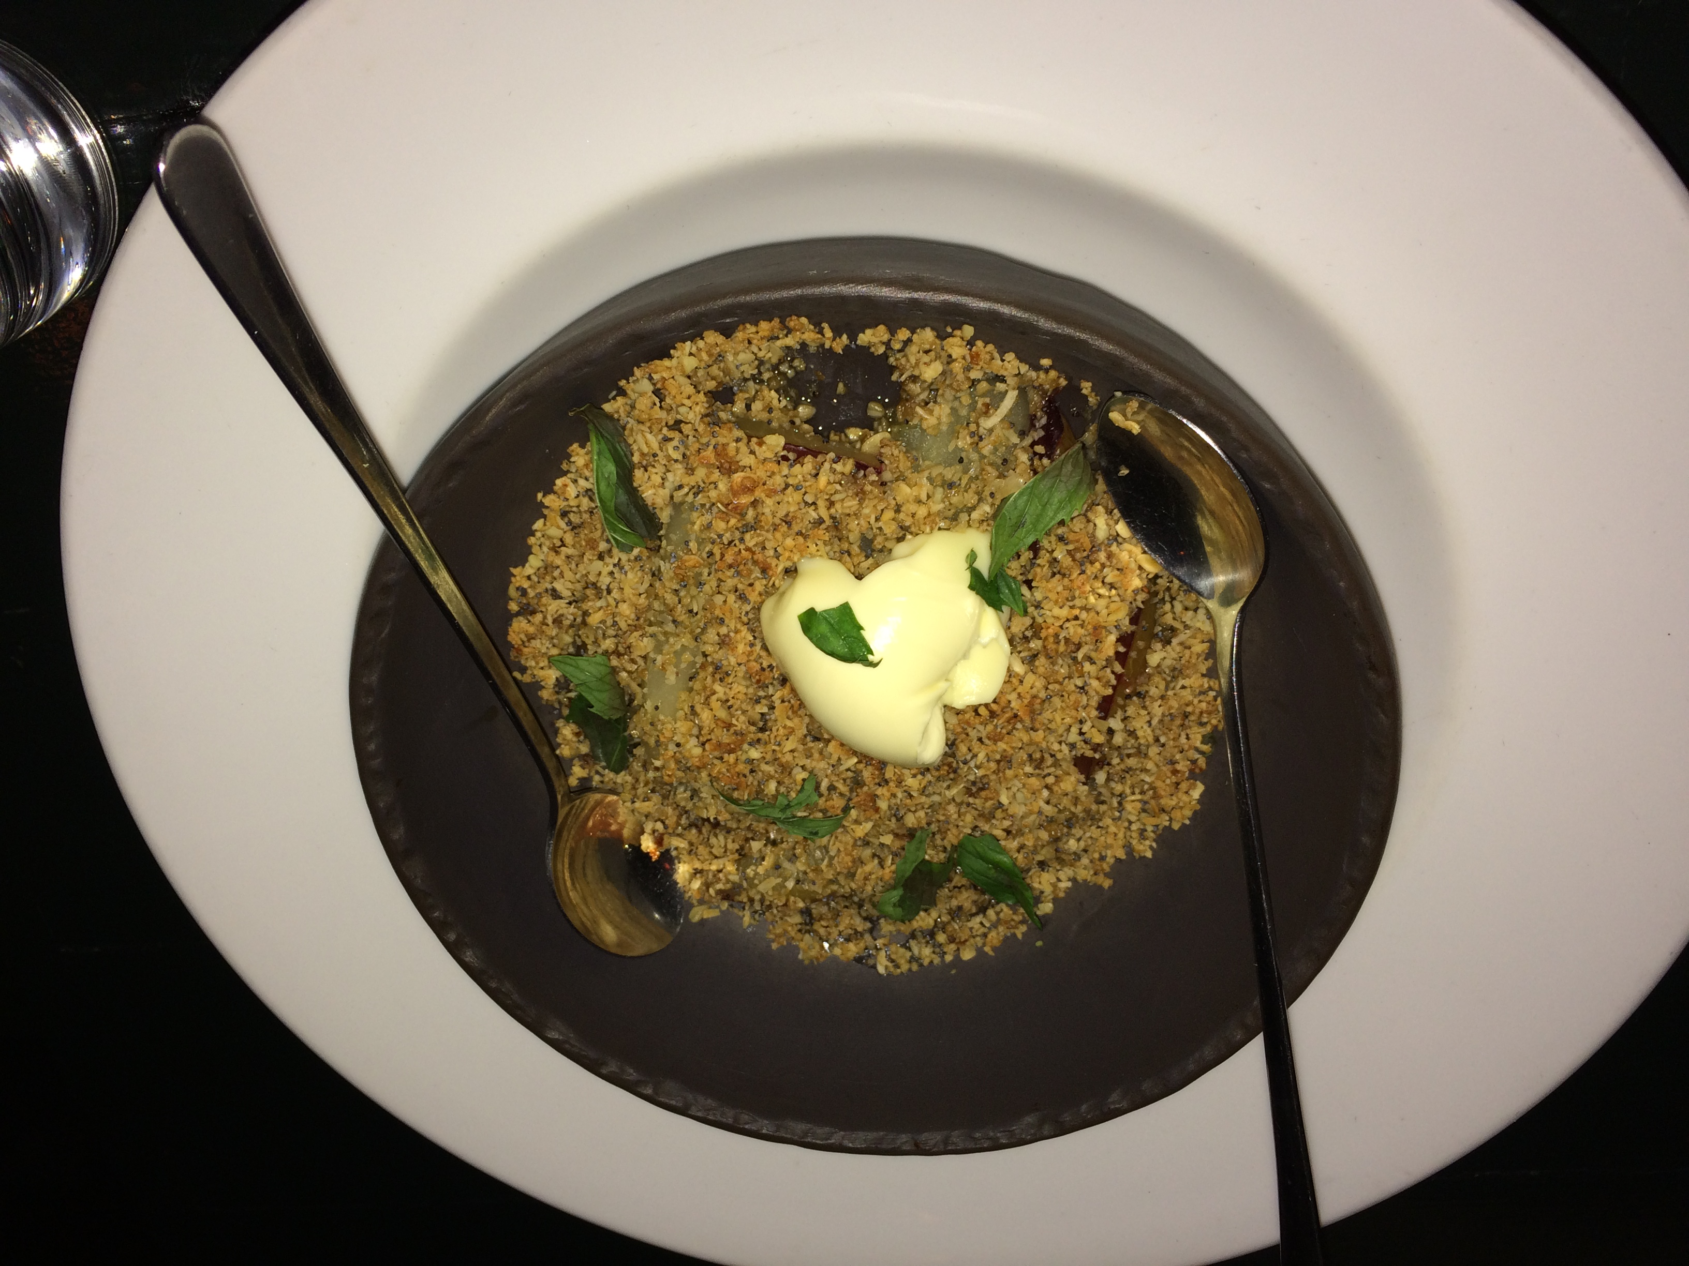
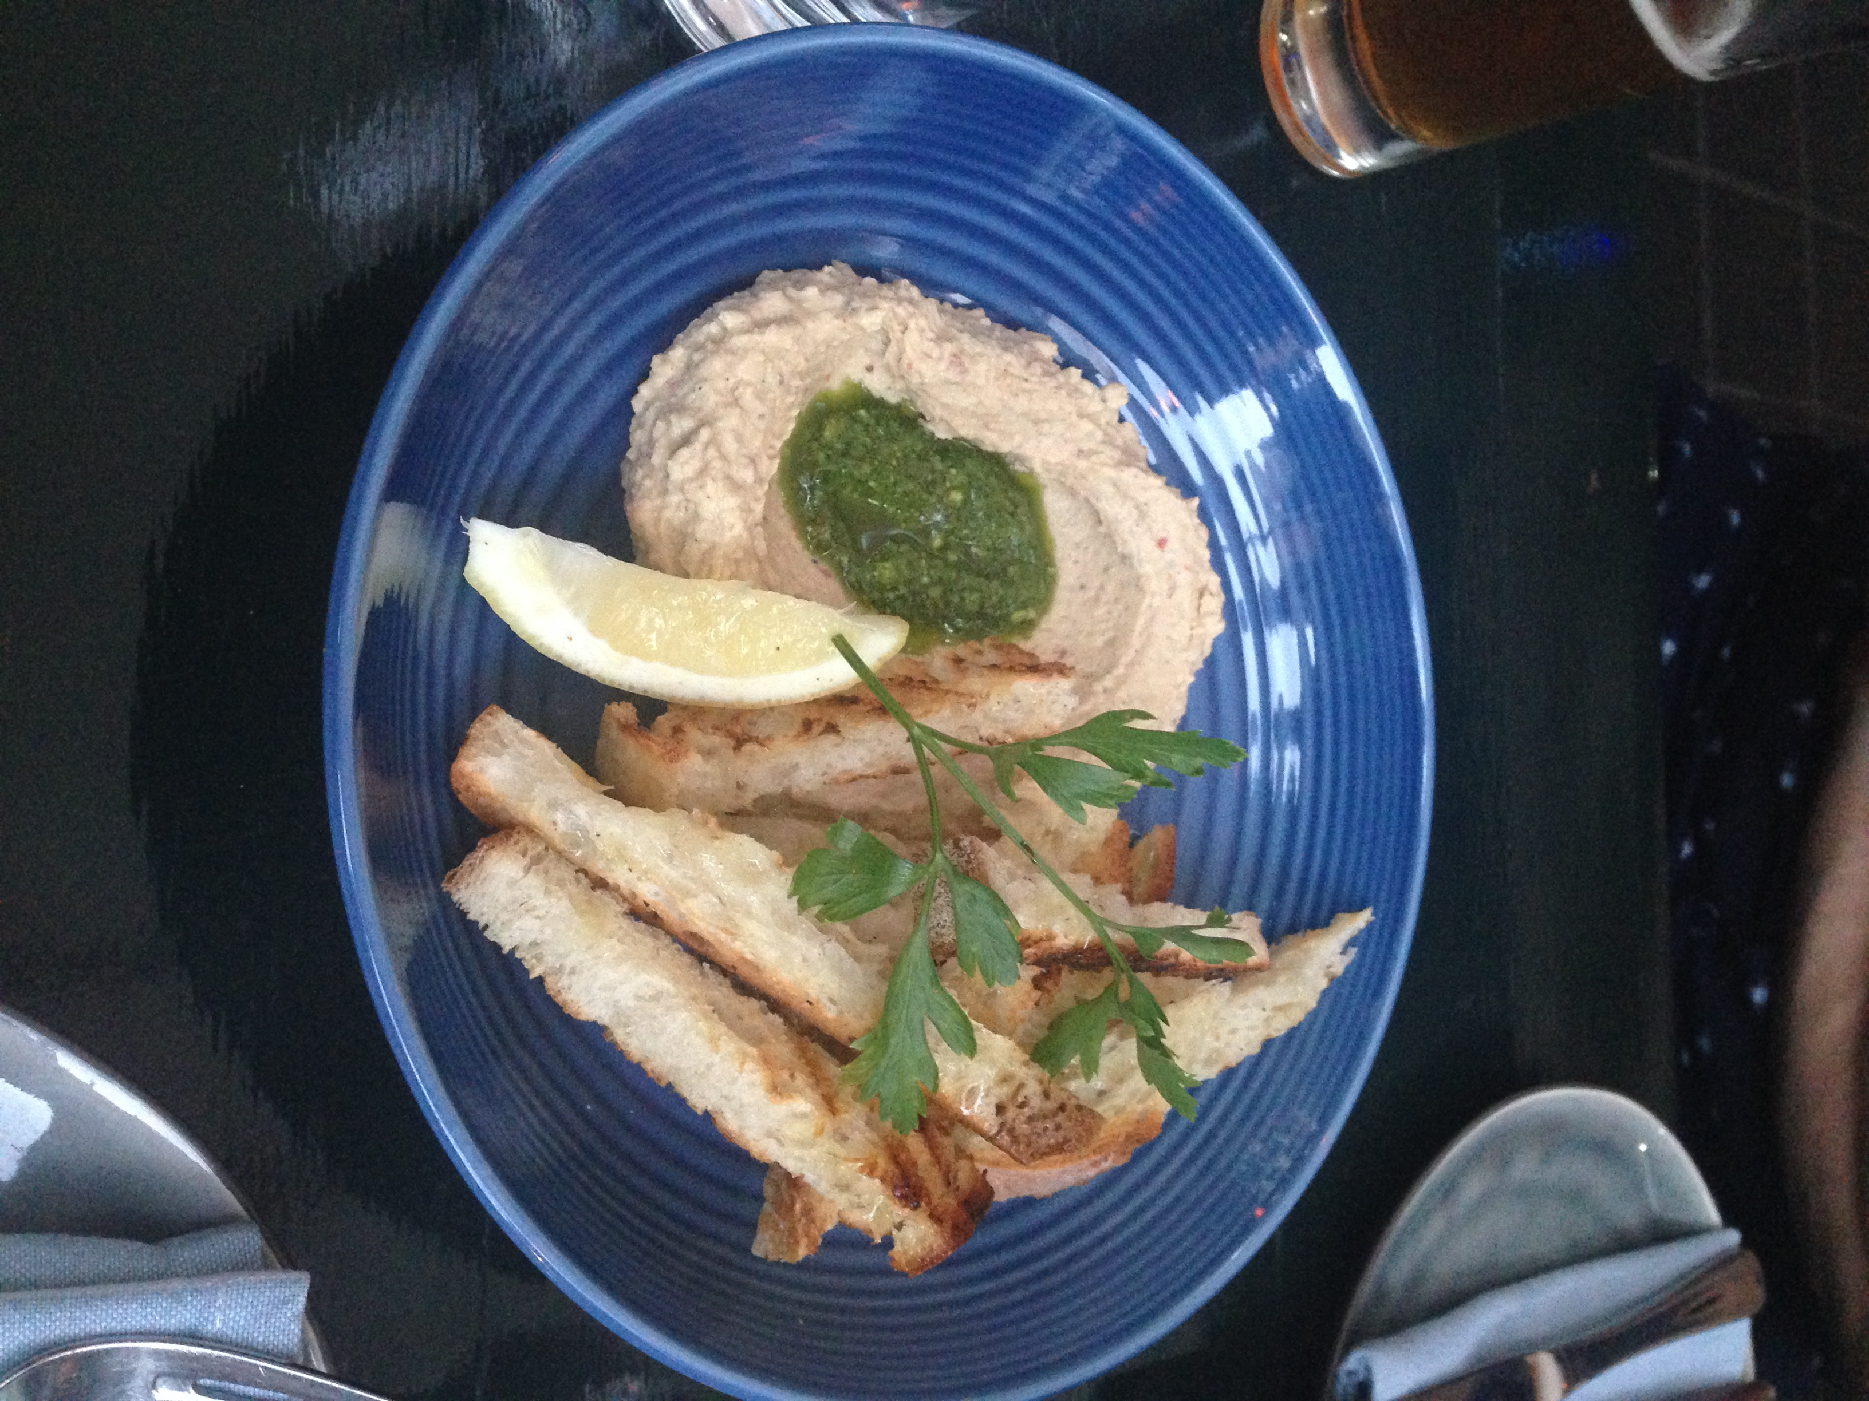
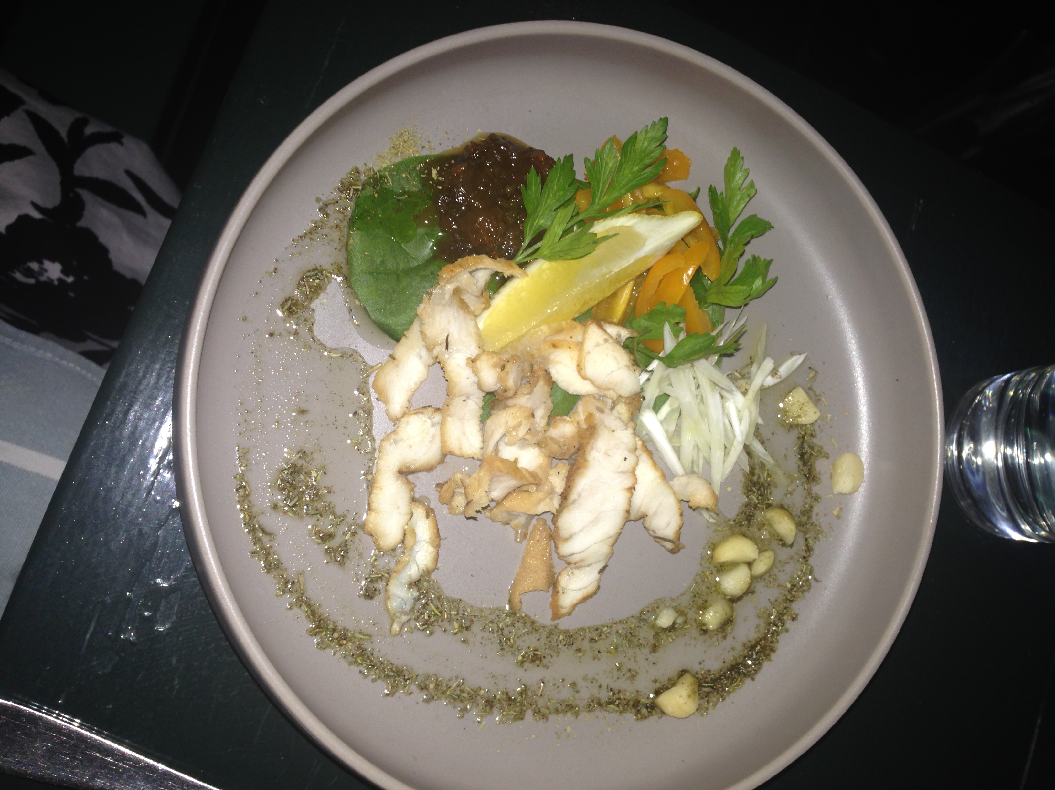
Slow Cooked Kangaroo
Crocodile Gravlax
Plum Crumble with Mascarpone
Hummus with Damper
- Explore

You have now heard about Petrel Kitchen and the dining experience. It is time to explore the ideas raised by Clinton. Look at the menu from Petrel Kitchen and decide what you would recommend to diners and why. Record a role-play in which a customer asks for your recommendations and you provide your advice. You should include some of the ideas that Clinton shared in either Menus and Meats, or The Dining Experience, or both.

- Write

- Language is used in different ways for different purposes and for different audiences. Look at three different menus; one for a school canteen, one for a pizza restaurant, and Petrel Kitchen’s; an upscale restaurant. Write a short text comparing the language of these texts with reference to the purpose and audience for each text.
- Go to TripAdvisor and choose a poor or terrible review of a restaurant (perhaps one you know and respect). Write a reply to the reviewer addressing their concerns. Consider the language you use carefully to ensure that you improve, not inflame, the situation.

- Talk

When discussing the benefits of multiculturalism in Australia, food is often mentioned. In Sydney, you can find restaurants with cuisine from all corners of the globe. Choose one national cuisine and prepare a talk about some of its signature dishes and how culture is represented in the ingredients, preparation, presentation and traditional consumption of the meal.
Perhaps you can even make and present this dish in your program subjects?

