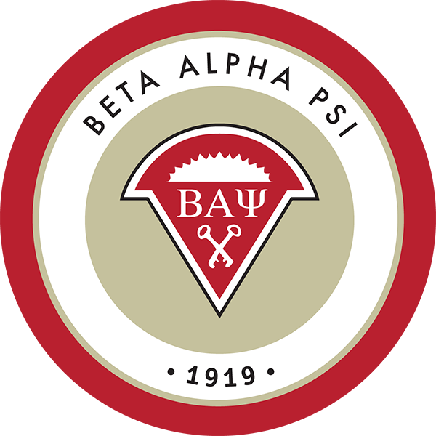
Beta Alpha Psi Hours Required to be an Active Member
(Hours) | Reaching Out Activities | Professional Activities | Service Activities
Mission Based | 3 | 6 | 1
Distinguished | 5 | 6 | 1
Superior | 8 | 6 | 1
Required by the National Beta Alpha Psi Chapter:

https://www.bap.org/2015-pca
* Events must be at least 50 minutes long and must have at least 25% active member participation.
** Events that last 60 minutes are counted as 1.2 hours.

Active Member required hours by quarter for the Beta Alpha Psi at the University of California, Riverside:

Quarter | Reaching Out Activities | Professional Activities | Service Activities
Fall | - | 6 | -
Winter | 2 | 1 | 1
Spring | 3 | 1 | -
*Total | 5 | 8 | 1
*Our member’s total hours will fulfill the requirement to be recognized as a distinguished chapter.
**Hours to become a member are non-negotiable unless otherwise approved by the BAP President.
***The hours by quarter outlined above are merely suggested hours based upon how general meetings will be structured. However, the total required hours (bolded) are non-negotiable for becoming an active member and must be completed by the end of the academic year.

Candidate required hours by quarter for the Beta Alpha Psi at the University of California, Riverside:

Quarter | Reaching Out Activities | Professional Activities | Service Activities
Quarter 1 | - | 6 | -
Quarter 2 | 2 | 1 | 1
*Total | 2 | 7 | 1
*Additionally, Candidates must attend at least 75% of all meetings.
**Attending Accounting Society Meetings & Events will count toward your required hours.
***Upon completion of candidate hours you will be initiated into Beta Alpha Psi. However,
in order to stay an active member you must finish the required Active Member hours.
Emphasis by Quarter

Fall: The Fall Quarter for Beta Alpha Psi will be emphasizing professional activities mainly due to the fall recruiting season for accounting firms. Accounting firms recruit, and sometimes solely recruit, during the fall for upcoming summer internships/summer leadership programs or end of summer full-time start dates. Due to this, we will focus on professional activities such as bringing out firms to general meetings on campus, firm tours, recruiting, mock interviews, and meet the firms preparation.

Winter: The Winter Quarter for Beta Alpha Psi will be emphasizing service activities. The Winter is traditional busy season for accounting firms and many firms are not recruiting or attending general meetings. Due to this, we will focus on reaching out to the community and increasing our presence in the community through service activities like volunteering. As well, we will be holding reaching out activities to help bring alumni on campus and develop our members professionally, technically, and socially.

Spring: The Spring Quarter for Beta Alpha Psi will be emphasizing reaching out activities. The spring quarter generally is more active with accounting firms and we will have some firms coming out to our general meetings. For the most part, we will have the spring quarter be focused on developing our members and preparing them for the upcoming fall recruiting season or to start working full-time. We will hold meetings such as excel, networking, resume, and interview workshops. As well, during the spring we have our Annual Accounting Society and Beta Alpha Psi Spring Banquet where over 30 professionals from 8 or more firms and over 70 students have attended in the past.

Description of Professional Activities: An activity that involves professionals, firms, meet the firms, workshops/seminars on professional development, mock interviews, firm tours, etc.

Description of Reaching Out Activities: An activity that involves alumni, collaborating with other chapters, engaging an activity with minorities, an excel workshop, attending the regional conference, etc.

Description of Service Activities: An activity that involves the giving of one’s time, energy and talents to benefit either the campus or local community.

Price
- Candidates
  - $65 for National (one time lifetime membership)
  - $65 for UCR Chapter
- Returning Members
  - $35 for UCR Chapter
- Discounts
  - $30 off for an “A” in a lower or upper division concentration class
  - $10 off for an “A-” in a lower or upper division concentration class
*Discounts may only be used once per year
**Only 1 class may be used towards a discount
***Discounts are only applicable to Candidate UCR Chapter fee ($65)
****Must show transcript to VP of Finance to receive discount
We take cash or check
Make 1 check out to: “Beta Alpha Psi” (this goes to national)
Make 1 check out to: “BAP ASUCR”

