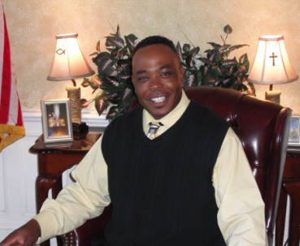
Pastor Johnny Jones (Sr. Associate pastor)
Pastor Johnny Jones is the Senior Associate Pastor of the City of Refuge Church. In this capacity, he is responsible for overseeing the pastoral staff and assists in developing and maintaining the organization’s outreach ministries. Since 2000 Pastor Jones has been faithful with the ministry and serves as a Sunday school teacher and also serves on the board of trustees.
Pastor Johnny and his Wife, Penny, reside in Talladega, Al.

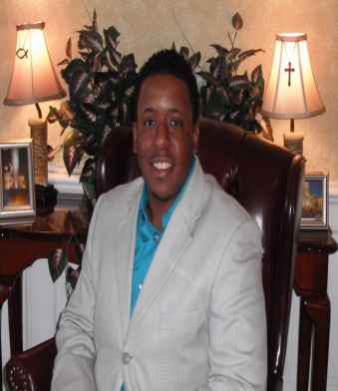
Minister Otis Brister (Church Administrator)
Minister Otis Brister supports the vision, mission, ministry, and core values of the church Ensuring timely, efficient, and cost effective delivery of all administrative services and developing and maintaining a productive and supportive working relationship between church staff, ministers and the congregation. Min. Brister is the son of Pastor Debra George. Brister is currently in the Alabama Army National Guard. He received a Bachelors in Business Administration from Miles College of Fairfield, AL in 2008. He was raised in Birmingham, AL and resides in Talladega, AL.

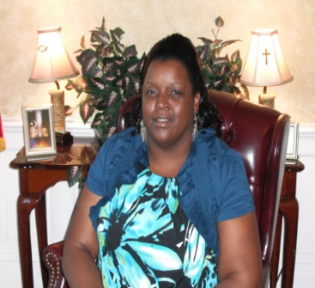
Lachina Carmichael (Administrative Secretary)
Lachina Carmichael had her Spiritual rebirth in 1999 and has been a faithful member of the City of Refuge since then. She served in the usher ministry, after being faithful she became head usher and a member of the trustee board. She serves with the armor bearer team for Pastor Debra George.
Mrs. Carmichael was born and raised in Pell City, AL and now with her Husband resides in Talladega, AL. They are the parents of two children.


Josephine Knowles (Young Adults director)
Josephine Knowles serves with the armor bearer team to Pastor Debra George, and is a member of the women fellowship “Sisters in the Spirit”. Knowles equips the City of Refuge youth with the knowledge needed to declare, communicate, and demonstrate Biblical principles. Knowles believes “Train up your children in the way they should go”…so that they may be equip to go into the world and bring the world to the church! The youth department strives to broaden their understanding of the vast differences and similarities of people groups; as a result we prepare them to be more effective witnesses of Christ to all races and cultures.

Sheeba Streeter (Children’s Ministry Director)
Sheeba Streeter is a current nursing student. Streeter prays for the volunteers and the children of City of Refuge. She Attends ongoing Children’s Ministry training and meetings when necessary and oversees the nursery department including toddler classes. Streeter demonstrates a positive and friendly attitude with the parents and the children who are in her care. She is the Daughter of Pastor Debra George born and raised in Birmingham, AL. She resides in Talladega, AL.

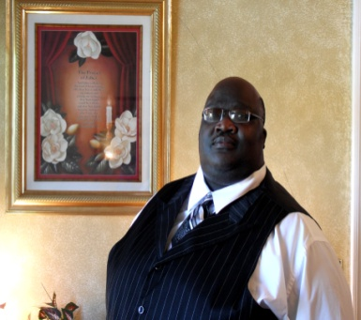
Minister Stanley Weed (Hospitality Director)
Stanley Weed treats food like an art and he not only prepares a dish, but is also passionately involved with it that it should both taste good and look beautiful. Weed believes hospitality is one of the most important aspects of any such organization. Weed’s pure dedication to serving others puts him in position to always be bless. Stanley Weed and his Wife reside in Talladega, AL. They are the proud parents of one son.

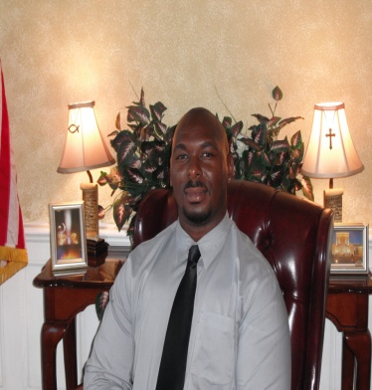
Kendrick Carmichael (Director of Deacons)
Kendrick Carmichael had his Spiritual rebirth in 1999 and has been a faithful member of the City of Refuge since then. Carmichael being faithful in the Lord and to the ministry, now serves on the board of trustees. Deacon Carmichael was born and raised in Talladega, AL. Carmichael and his wife reside in Talladega, AL. They are the proud parents of two children.

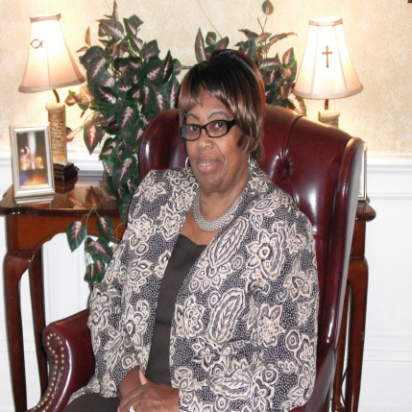
Mother Mary Heath
Mother Heath as one of the elders of the City of Refuge brings her wisdom and knowledge from being rooted and grounded in the word of God all her life.

