User Interface

Fill in the blanks for the name of each element of the user interface shown.

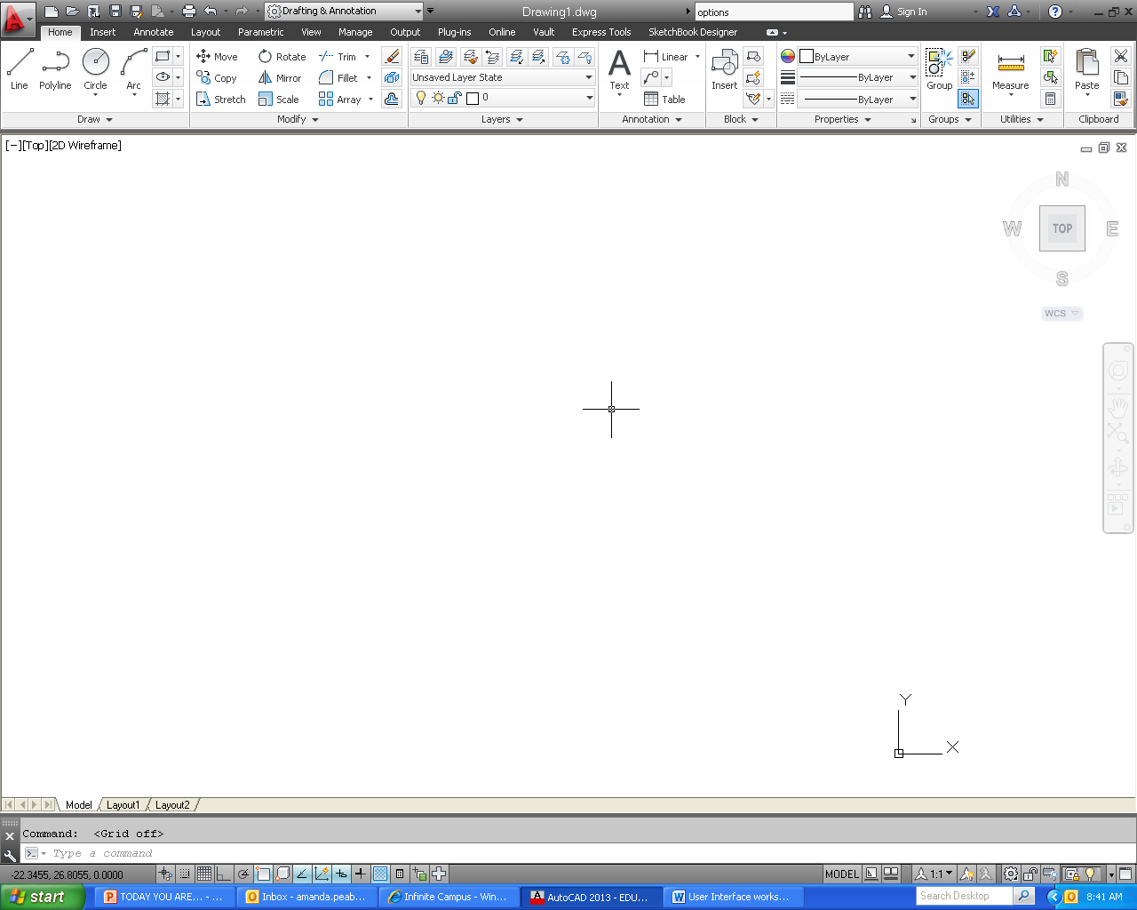

5 ways to input a command:
1)
2)
3)
4)
5)

4 ways to cancel a command
1)
2)
3)
4)

What do you press after you enter a command?

What are the two type of files that AutoCAD saves?

