Adding Plumbing Fixtures to a Floor Plan
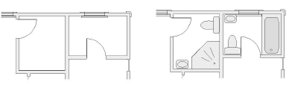

Add a lavatory, a toilet and a bath tub to the plan below for a bathroom that is 6’ x 7’ | 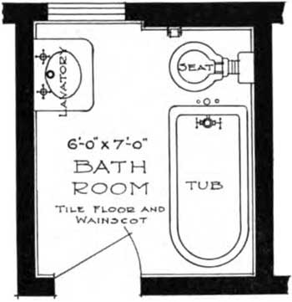
Add two lavatories, a toilet and a bath tub to the plan below for a bathroom that is 6’ x 10’ – 6” | 