TINY HOUSE PROJECT RUBRIC
CONSTRUCTION DOCUMENT AND DESCRIPTION OF POINTS | POINTS POSSIBLE | POINTS ACHIEVED
Floor Plan (50 Points) – Submit ALL levels; Hide (vv) topography/plantings and floors; Detail level: Medium  Scale: 1/4” = 1’-0”  - Exterior Walls: Correct thickness and wall type used on floor plan (5 Points)  - Interior Walls: Correct thickness and wall type used on floor plan (5 Points)  - Room Sizes and Layout: Rooms laid out logically and room sizes are practical. (5 Points)  - Windows and Doors: Windows placed plausibly on exterior walls and in compliance with building codes; correct door type used for each room and placed in a logical position on interior and exterior walls. All windows and doors should be tags (10 Points)  - Each room should be named and numbered and each door should be numbered to correspond to the number of the room it is entering (living room – 105, a door going to the living room would be 105, if there are two doors then one would be 105A and 105B).  - Room Names (ALL CAPS): Room tags with area should be added to all rooms and should be large enough and easy enough to read. (5 Points)  - Dimensions: Floor plan should be fully dimensioned – See examples below. No dimensions should be in fractions of an inch – 2’- 0” NOT 2’ – 3 ½” (10 Points)  - Fireplace and/or Stairs: (5 Points)  - Kitchen Layout: Kitchen includes upper and lower cabinets, counter top, appliances (refrigerator, stove/range, dishwasher, etc) and a sink. Layout should comply with building codes and be practical for cooking and movement in room. (25 Points)  - Bathroom Layouts: Three-fourths or full bathrooms should include a toilet, sink, shower and/or tub. When including a vanity, the following should be included: a cabinet, counter top and sink. Half baths must include a toilet and sink. Layout should comply with building codes and be practical for use and movement in room. (10 Points)  - Washer/Dryer Layout: Minimum of a washer and dryer should be included (5 Points)  Information for Tiny House:  - Trailer bed size: 6’-11” (width) x 18’-0”, 20’-0”, 22’-0” or 24’-0” (length)  - Trailer bed height: 22” – 24” above the road  - Maximum width of home, including roof overhang and/or gutters: 8’-6”  - Maximum height of home (on fully inflated tires and ready for transport): 13’-6”  - Wall height should be less than 7’-0” tall  - Conventional framing materials (2’x2’s, 2’x4’s and 2’x6’s) should be used when selecting wall types  - 2x4s typical interior wall  - 2x6s typical wet/plumbing wall  - Aluminum or vinyl windows (fixed, sliding, single-hung, double-hung, etc.) *  - Interior doors should be standard hollow core doors (2’-0” – 2’4” x 6’-8”) – be wary of using bi-fold, by-pass or pocket doors*  - Exterior doors should be standard solid core doors (2’-0” – 3’-0” x 6’-8”, unless reduced height for exterior utility areas is necessary) *  - Appliances and fixtures for kitchen and bathroom areas should standard and available at home improvement stores*  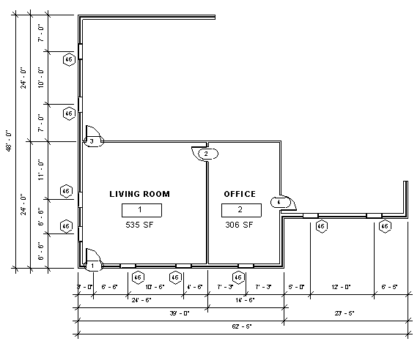 | 5  5  5  10  5  10  5  25  10  5 | _______  _______  _______  _______  _______  _______  _______  _______  _______  _______
85 _______
Electrical Plan (20 Points) Submit ALL floors; Hide (vv) topography/plantings and floors
Scale: 1/4” = 1’-0”
- Follow codes when adding the following symbols: smoke detectors (2 Points), outlets (10 Points), switches (3 Points), lights (3 Points), fans (2 Points) and connections (2 Points).
20 _______
Exterior Elevations (20 Points) Hide (vv) topography/plantings, and levels
Scale: 1/4” = 1’-0”
- Roof (9’ thickness), floors, chimney size, exterior appearance and location of windows and doors will be evaluated. Add items such as exterior lighting, shutters, etc to enhance exterior appeal. (10 Points)
- Add notes (text with leader) for materials (type of roofing, façade, etc.) (4 Points)
- Include slope of the roof (annotate – spot slope – slope representation: change from arrow to triangle and click on slope of the roof in the elevation view) (2 Points)
- Dimension the overall height of the house (1 Point)
- Dimension the overall width of the house (eave to eave) (1 Point)
Correct placement of elevations (2 Points):
- Include South and North on one sheet
- Include East and West on the second sheet
*There is a supplemental video for roofs and floors

Information for Tiny House:
- Roof pitch should not exceed 12/12 (45-degree)
- Maximum width of home, including roof overhang and/or gutters: 8’-6”
- Trailer bed decking to be replaced with 2x4 floor joists on 24” center (insulation between the joists) and 3/4"sub-flor with finished floor (vinyl, hardwood, carpet, or tile) to be installed on top – should not be thicker than 5” so you may have to change the thickness of the layers
20 _______
Roof Plan (5 Points) When in roof plan change view range for bottom and level to level below (second floor)
Scale: 1/4” = 1’-0”
- Draw hidden lines (model line – <hidden> line) for edge of exterior wall, change transparency of roof if you need to be able to see exterior wall (vv) and then change the transparency back to 0 (3 Point)
- Include any relevant notes and information through the use of text and model lines (ridge, hip, arrows to indicate slope of roof) (2 Points)
- _______
Bathroom Interior Elevation (10 Points) Show multiple elevations if needed to show all required information
Scale: 3/8” = 1’-0”
- Fixtures: The following fixtures should be shown: include toilet, sink, shower/tub and a mirror (4 Points)
- Notes: Include notes with leaders for fixtures and dimensions where necessary (4 Points)
- Overall appearance and functionality: Elevations should be labeled place neatly on title block. Elevation should NOT cut through vanity (2 Points)
- _______
Kitchen Interior Elevations (20 Points) All views of the kitchen must be shown in different elevations
Scale: 3/8” = 1’-0”
- Cabinets: Correct height, especially corner, upper cabinets and upper cabinets above appliances (8 Points)
- Countertop(s): Should be continuous when possible and should cover dishwasher if applicable. (2 Points)
- Appliances: The following appliances should be included: refrigerator, stove/range, sink (3 Points)
- Notes: Sizes of cabinets dimensioned and text with leaders for appliances and fixtures (5 Points)
- Overall appearance and functionality: Kitchen is easy to navigate and windows do not go below counter top. Elevations should be labeled and place neatly on title block. Elevation should NOT cut through cabinets. (2 Points)
20 _______
Door and Room Schedule (10 Points) Each room should be named and numbered and each door should be numbered to correspond to the number of the room it is entering. When creating schedules go to view – schedules – schedule/quantities. Place both schedules on one title block.
- Door schedule (in this order): mark, width, height, family and type. (5 Points)
- Window schedule (in this order): mark, width, height, sill height and family and type. (5 Points)

10 _______
Cross Section and Longitudinal Section (20 Points) Hide (vv) topography/plantings; Hides (vv) sections
Scale: 1/4” = 1’-0”
- Check floors, walls, stairs, roof, ceilings, etc. and make sure that all items were created correctly. Choose the sections that shows the most detail of your house.
- Cross Section (10 Points)
- Longitudinal Section (10 Points)
20 _______
Wall Section (20 Points) Hide (vv) topography/plantings
3/8” = 1’-0”
- Create a wall section of one wall of your house that will show the following elements: roof, ceiling, exterior wall, a window, and floor(s) (2 Points)
- Add necessary features to wall section: insulation, plates (top and bottom), headers, baseboard and/or crown molding (8 Points)
- Include necessary notes and dimensions for the wall section (10 Points)
20 _______
Exterior Perspective (20 Points)
- Rotate 3D view to the best view and place on a title block. Exterior will be evaluated on overall appearance and quality.
10 _______
Exterior Rendering (20 Points)
- Exterior rendering should show the exterior to the best possible advantage and should be rendered on medium. This should be a DIFFERENT angle than used for the exterior perspective. Rendering will be evaluated on appearance of materials and color choices used on the façade of the house. Take a picture (camera icon) and render picture.
20 _______
Total + Work Ethic (50 Points) | 240 + 50 | ____+____
290 _______

