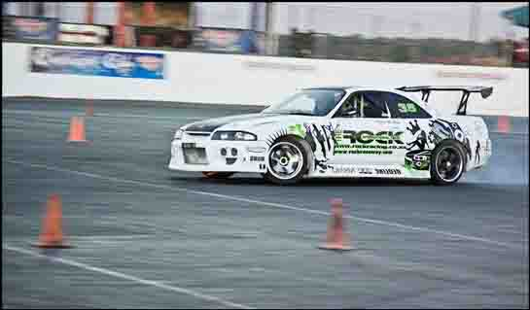

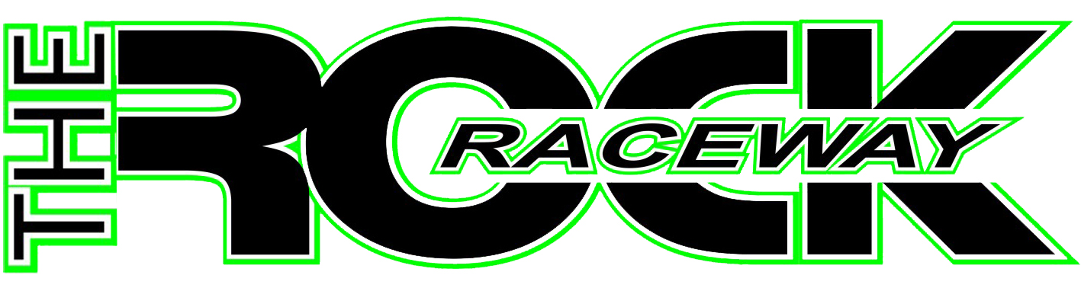

THE ROCK 18 MAIN REEF RD
RACEWAY BRAKPAN

WWW.ROCKRACEWAY.COM / WWW.ROCKRACING.CO.ZA

TEL: O11 740 8315 / 740 1206
FAX: 086 508 2388
Commentator, press media liaison and marketing representative. Abie Sada 082 453 8271 info@rockracing.co.za

30 July 2026

High speed oval action@ The Rock Raceway weekend past.

This past weekend saw the hotfooted oval competitors converge onto the 400m tar oval at The Rock Raceway circuit in Brakpan for the Champ of Champs shootout. Competitors from Klersdorp. Pretoria, Witbank and various areas from the East Rand united and put up a heck of a race for the screaming patrons.

Thirteen categories each running two heats and a final, kept the crowds entertained as each discipline had its own unique twist to it.

Starting off with the juniors, the Ninja class catering for the youngsters from ages 6 to 12 years old, buried their throttles in their Midgets based on a kart design with the huge wing resembling the look of the bigger cousins the V8 Thunder Sprints.

With 11 starters on the line the boys and girls, yes girls as well challenged each other’s driving skills to the finish line. It was Hennie Adlem who drove his Adlem Auto Ninja Midget first over the finish line. Sadly for the youngsters it was lights out for the championship event as their karts where all underweight with exception of two of the chariots.

Four drivers made it to the start line in their Minis Stox all between the ages varying from 8 to 16 years old, with young Steve Engelbreght to the podium as winner followed by Leigh Ann Wood 2nd and Henry Pike 3rd.

1600 Stock Rods had a great field with 15 starters to the line as the fast pace kept all the drivers on their edge of their seats, the old Datsun’s and Nissans dominated the race for the night with two Fords in hot per suite. Some mastered the art of drifting in the corners as their race cars went sideways, first time I have ever seen front wheel drive cars drift sideways through the corners.

In the Micro Midgets the 100cc Karts was dominated by Red Bull Racing driver Karika de Bruin in the no 7 Kart, winning all three heats. In close second was brother Matt in a borrowed kart.

Formula N circuit racing was a blast with 14 cars track side as the gaggle of VW Golf’s did battle against the Datsun, Ford, Opel’s, Renault and Fiat drivers. Laughs roared from the stands as the guys bounced their cars around the corners like a Columbus polisher, some hair raising moments for the Opel Astra driver Dr Hudgess and Renult driver Kevin Durant.

Plenty of door to door racing and fender rubbing as these guys fought tooth and nail for track position. These cars all bought from ex Stannic Group N drivers and now being used in the all new exciting Formula N category, keeping the racing dream alive in the various A, B, C and D class categories for new aspiring up and coming racing drivers.

1660 Saloons was dominated by Andre Pitzer from Umsafaya Sound Off & Show and Shine winning all three heats. Eight starters made it to the line with hard racing done by all, crowds enjoyed the fast pace of the saloon class.

Formula 2 Midgets saw the return of Riaan Draper piloting his father’s no 15 Midget, hungry for racing Riaan showed how eager he was to winning the first heat. In the Finals it was Charles Halley walking off with top score Second place went to William Draper and a surprise for the night went to the youngest Midget driver ever to race at The Rock 12 year old Tiaan Greyvenstein. Not a stranger to racing the ex Ninja driver drove his heart out and as consistency paid off for the youngster, a podium place had Tiaan gleaming with joy with his 3rd place... Well done sun shine keep it up.

In the 2L saloons it was a two horse race as the combined Retro Rods and 2L class was held. Winning the race Gerhard Koekemoer won the night in his Bez Megga sponsored Toyota Starlite with JJ Tank Hire Ford Fiesta driven by Jan Hamman in second. While in the Retro Rod Class Natasha Human drove her Fiat Uno sponsored by JJ Bike and Car to victory lane in all three heats. Second was Kobus Jordan in his Datsun GX coupe and Hennie Theart Snr in a Ford Anglia in 3rd.

Pinto Class had eight starters to the line with Gerhard Koekemoer in his no 111 sponsored by Bez Mega Motors dominating the field followed by Spanner Pretorius driving the 24 Hour Security Opel Corsa no 214 in for second spot and Hannes Brits taking final spot on the podium 3rd.

American Saloons had six entries but sadly Mr Rock Tim Stephens car failed to make it to the start line as mechanical failure plagued The Rock Raceway Sheriff’s car.

There was absolutely no competition for STS Property Services Johan Alberts Snr who annihilated the entire field from start to finish in his Ford Fiesta V8 in all three heats, but it was curtains for Albert’s short before the finish of the final heat as the engine reaper claimed Johan’s engine in a huge cloud of smoke... mmm guess Johan drove it a bit too hard.

While taking a more conservative approach to racing, consistency paid off for son Johan Alberts Junior in his no 128 Nissan Sentra also sponsored by STS Property Services who claimed 1st place for the night and second place went to JP van Zyl in his Nissan Skyline GTX and Peter Malan in his Datsun 280 ZX Sport.

The return of the V8 Flexis class made for some entertaining racing as the oddly looking beasts thundered around the oval. Six starters to the Flexis as Att du Bryn crowned winner followed by CJ Bitzer and 3rd Bytenbaght.

The highlight of the night had to be the V8 Thunder Sprints as 8 cars rolled onto the start line. Great to have Jacques Roos back home in his no 46 Thunder Sprint as he and his fellow competitors had the entire grandstand to their feet and close up against the catch fence to witness absolute thunder sideways bliss! Roos smoked the right rear tyre in and out of every corner as he pitched the thunder sprint sideways. Quenten “Lightning” Lehman dominated all three heats also drifting his no 87 Thunder Sprint around the circuit.

Two new faces to The Thunder Sprints from Witbank also made an appearance Oneil Kok and Jacobus Smit who also got accustomed to the high speed action and delivered sideways power slides around the track. Brothers Quintin “Dynamite” Saayman and Eugene “Sideways” Saayman dazzled the crowds with skilful high speed sideways action together with “Spiderman” Rudi Foster.

Podium victor Quenten Lehman was followed in by Quintin Saayman and 3rd Eugene Saayman.

Missing in action was veteran “Wild Thing” Willie Zurich as a wedding commitment had his diary schedule booked for the night, I am pretty sure Wild Thing Willie would have loved to be part of all the track side action.
The steady growth of V8 Thunder Cars is a positive sign for this to come....

As the night ended and fans made headway back to their mode of transport, one could hear the banter amongst family and friends of what they just witnessed before them absolute oval bliss!

For those of you who missed out this exciting event remember to make your way to The Rock Raceway on the 14 of April for the next round of Hotfoot Oval Action.

Big thank you goes out to SA Car Club Magazine Nick for all of the exciting articles and to Racing memories Rudi who captured all of the action on DVD, this event will be on sale and available at the next event.

To all of The Rock Raceway photographers who capture all of the events on camera and share the “Kodak” moments with us all, to the dedicated officials, medical staff, sponsors, competitors and most of all you the spectator.... because without you there is no us! The Rock Raceway Team thanks everyone, you guys Rock!

Rock Raceway - Where the action is!

For more info contact office 011 740 8315

Regards

Abie Sada

Rock Raceway Marketing

Di”Rock”tions to the track: N12 head towards Witbank, take the Snake Rd off ramp, turn right, 5th robot turn left into Main Reef Rd, travel straight, keep right over next robot +-3Km, under railway bridge, exit from under rail way bridge turn left into Rock Raceway.

Contact : Office No TEL: O11 740 8315 / 740 1206 / Abie Sada 082 453 8271 email: / www.rockracing.co.za / www.rockraceway.com

ROCK RACEWAY IS ADDICTIVE; WE WILL NOT BE HELD RESPOSIBLE FOR YOUR RETURN DUE TO THE ADRENALIN RUSH THAT YOU HAVE OBTAINED DURING OUR EVENTS. WE WILL ALSO NOT BE HELD ACCOUNTABLE IF YOU JOIN THE CLUB AND ENJOY PARTICIPATING IN ANY OF OUR EVENTS, PLEASE NOTE THAT YOUR VEHICLES MAY SUFFER DEPRESSION FROM LACK OF RETURNING TO THE ROCK.
AN ANTI DEPRESSION REMEDY FOR EITHER YOURSELF OR YOUR VEHICLE CAN BE OBTAINED BY THE ROCK, IN THE FORM OF RETURNING TO OUR NEXT EVENT.
YOU’VE BEEN ROCKED AND WARNED!
Rock Raceway - Where the action is!

