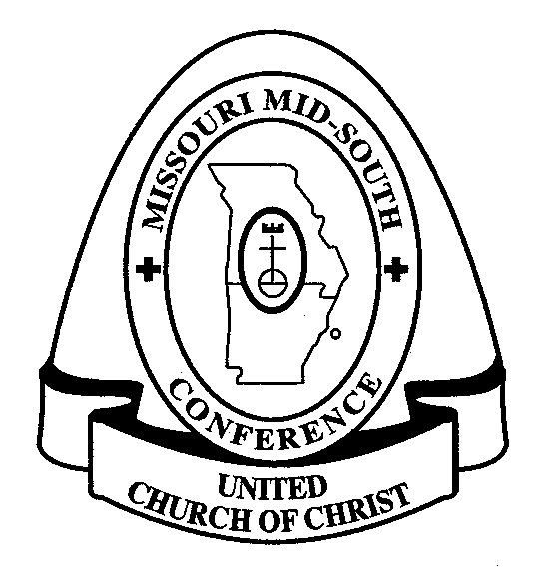
Western Association
Missouri Mid-South Conference
United Church of Christ

April, 2017

Dear Ministers,
Those of us who serve on the Committee on Ministry thank you for the service you give to the church of Jesus Christ and to the Western Association of the Missouri Mid-South Conference of the United Church of Christ.
Each minister with standing in the Western Association should support one another and be accountable to each other. This mutual care and accountability takes many forms; one of them is to identify yourself and your ministry by completing the Annual Clergy Informational Review (IR) form.
Each minister is to complete the IR form once a year. It is the only way we have to “count noses” and be sure we have accurate contact information for each minister. It is the only way the COM formally inquires “how’s it going?” in your ministry setting and “what are you up to?” in your continuing education and participation in the wider church. The information you provide also helps our Conference maintain an accurate data base, as well as the data hub in our Cleveland office. The IR may not seem important, but it is very important to the UCC, and it is a requirement for maintaining your good standing in the Western Association.
Please help us keep good records by completing the accompanying form and returning it to me by May 8, 2017. You may return the form via email: malarson8@gmail.com. Or make a copy and snail mail to: Melissa Larson, 4412 Blue Ridge Blvd., Kansas City, MO 64133.
Because paper can get lost on our desks so easily when the due date is weeks away, we suggest you complete it TODAY and return immediately.
If we don’t receive it back by May 8, we will nag you by email, and if need be, a COM member will contact you directly; SO please spare us this extra work and honor the deadline!
In this season of resurrection, we hope the blessing of new life for you and your ministry,

Melissa Larson, COM Chairperson
Western Association
Committee on Ministry

