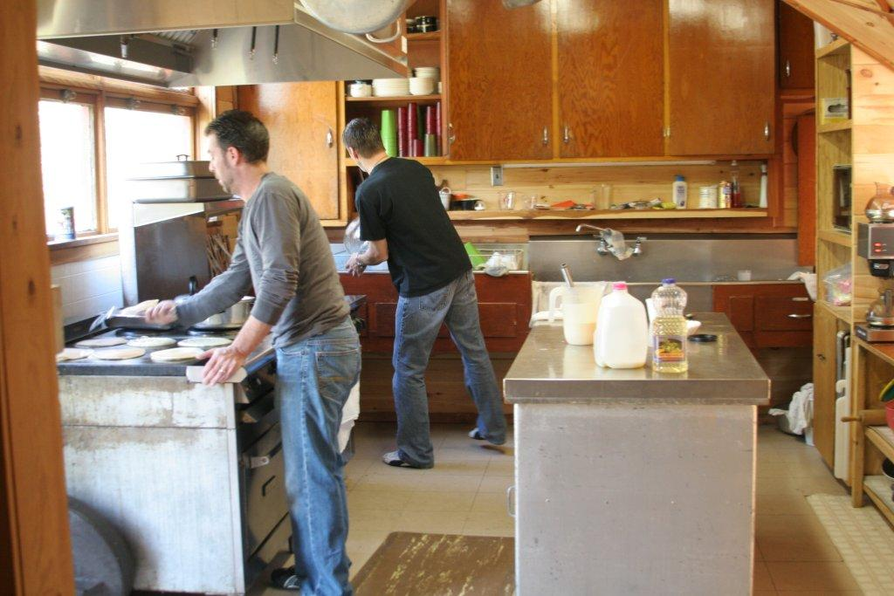
MEALS:
Meals will be family style at Timber Lodge.

“I attended the retreat for the first time just thinking it would be an opportunity for a weekend escape from the busyness of life. I enjoyed getting to know several of the men during the work session and the afternoon free time touring the area. The weekend became special for me as I sat on a bench in the middle of the woods in prayer and for the first time in 47 years I heard an audible response from God, it is an experience I will reflect on for many years to come…

…I encourage you and your breakout groups to attend the retreat and not only grow closer to each other, but spend time reconnecting with God.”
-Glenn Haake

WORK PROJECTS:
Work projects will depend on the number of men and the skills of the men attending. Please let Jonathan know what specific skills you can provide.
Schedule

Friday:
- Drive down to Shannondale. Car pools are encouraged for safety & fellowship.
- Arrive at Shannondale – Get familiar with the location & the other men
- Orientation meeting

Saturday:
- Hearty breakfast
- Work projects at Shannondale
- Lunch
- Afternoon Activities:
  - Canoeing – (extra cost)
  - Golf – (extra cost)
  - Hiking
  - Enjoying the outdoors
  - Relaxing & conversation
- Steak Dinner
- Campfire / star-gazing /conversation

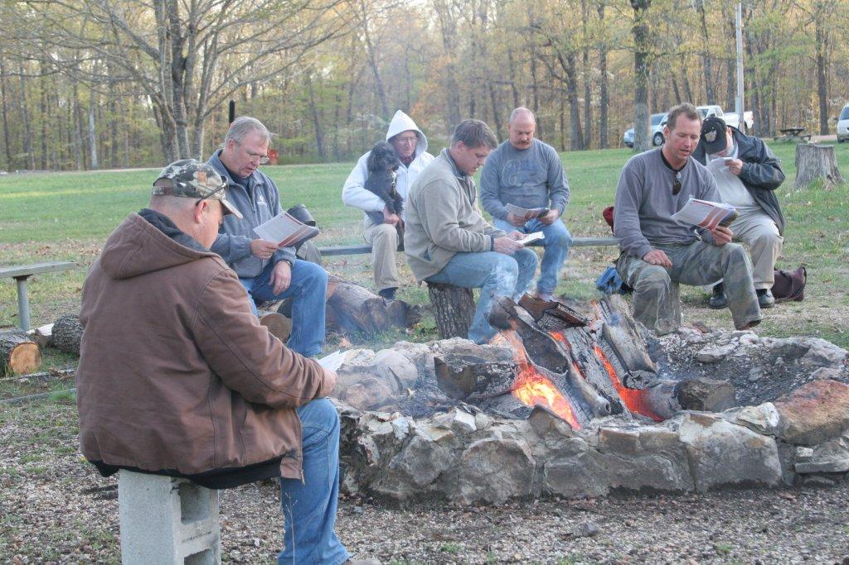

Sunday:
- Breakfast
- Clean-up
- Church Service at Shannondale UCC
- Head back home

Contact Jonathan Jones at (314) 608-0783 or jonathan@jonathanjonesconsulting.com
RSVP and $20 deposit is requested by Apr 25th.

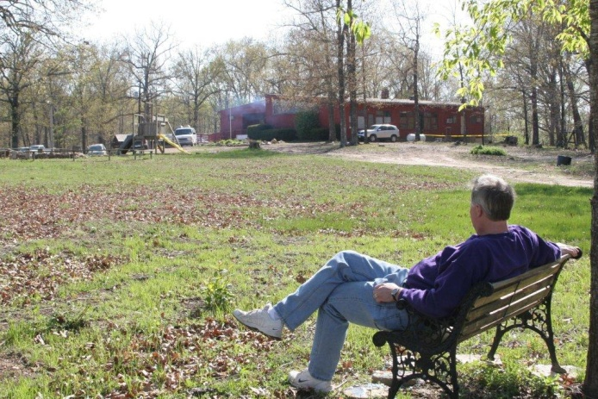

About Shannondale

Shannondale Community Center is a Mission project serving the spiritual educational & economic needs of Shannon & the surrounding counties through its many functions. Shannondale also encompasses the Bucher Memorial Tree Farm, the oldest continuing tree farm in the state of Missouri. The tree farm illustrates our continuing commitment to God's land & its resources.

Shannondale is about 48 mile south of Rolla, MO,
21 miles south of Salem, MO on highway 19,
near the Ozark National Scenic Riverway.
(Current River-Akers Ferry / Pultite /Round Spring)

I have been facilitating this retreat since 2004. I started with my church in Chesterfield and have been expanding it to other men’s groups over the years. It was a way to use my gifts of organizing to enhance the lives of men.
Shannondale is a special place where a person, a family, a youth group, or any group can get away and rest a while. Shannondale is unique from most locations since it has very limited cell phone coverage. We can really disconnect from the outside world and reconnect with God. Shannondale is a ministry that can be experienced. It serves the local community in many ways. Yet, for retreat participants, this ministry gives back many times over.
For some, it is a way to give back to a poor community. Some need the experience to get away from the hectic life in the city. Many enjoy the opportunity spend time with other Christian men. It is my annual personal reflection on my life and a reminder of my spiritual gifts.
I encourage men to come with others within their congregation as an annual or semi-annual retreat. Some churches have started with one or two and have added more each year. This retreat continues to grow in numbers as the experience continues to grow spiritually for each of us involved. This event can strengthen the men, organizations, and the churches involved.
I will be happy to share with you on how to promote this event with others.
- Jonathan Jones

Great food
Fellowship
Sharing
Reflection
Renewed Friendships
New Friendships
Spiritual Networking

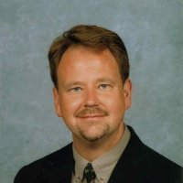
I personally invest a great deal of my ministry to especially reach weekly out to men in the congregation - whom I believe I can be the largest neglected minority in the church. Beyond serving on building and ground committees and civic group-style breakfasts, I challenge you to ask yourself how men are included in spiritually transforming ways. Statistics bear out that men's personal engagement in the church impacts their entire family.
This weekend pulls together, now twice a year, to gather men from several congregations for a weekend on our sacred ground called Shannondale. Men are reached from several approaches that can touch core aspects of his being: through service, rugged recreation, contemplative communal with nature, sharing around bonfires, table (kitchen and grill) fellowship, heart-felt worship, and many one-on-one deep encounters.
Aside from the incredible experience, we hope to jump-start communal faith back home at your church. I make it to a point to round-up and wrangle as many men from my community to attend and I make sure my batteries are recharged by attending myself. Will you strive to encourage at least one man to attend?
- Pastor Paul Koch
St. Peter's UCC in Washington, MO

Spring Men’s Retreat
Shannondale, MO
May 1-3, 2015

SHANNONDALE Tree Farm & Retreat Center Shannon County, Missouri
(Near the Current River)

Purpose:
1) Spiritual growth
2) Fellowship
3) Recreation & fun
4) Great eating
5) Service to the Shannondale community
6) Opportunity to recharge

COST: $60 per person – Includes Lodging & Food

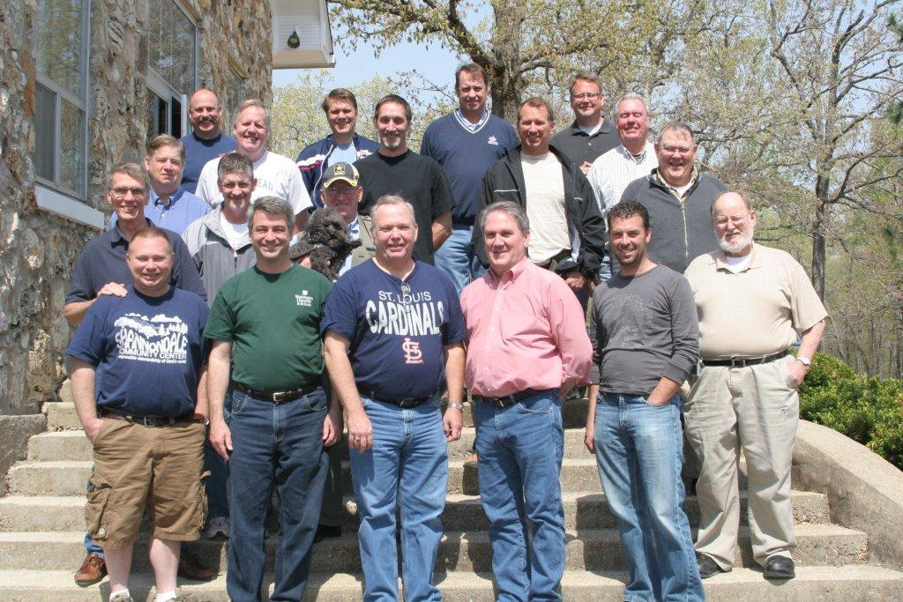

LODGING:
Dormitory-style air-conditioned bedrooms. Please bring your own bedding & pillow. Camp sites and camp sites with electrical hook ups are available.

