POSTCRYPT ART GALLERY is located in the basement of St. Paul's Chapel on the Columbia University Morningside campus. The campus covers a six-block area between Broadway and Amsterdam Avenue from 114th Street to 120th Street. The main entrances of the campus are located at 116th and Broadway and 116th and Amsterdam.

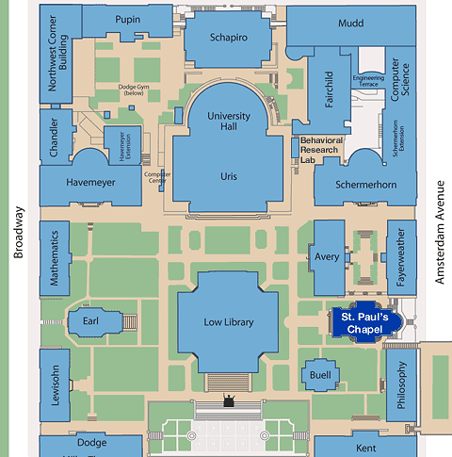

Directions
Subway: take the 1 to 116th Street, Columbia University. St. Paul's Chapel is located at 117th and Amsterdam Avenue.
Bus: take the M-104, M-4, or M-5 to 116th Street. For further bus and subway information, please call (718) 330-1234.
Parking: The Square Parking Garage is located at 114th Street between Broadway and Amsterdam Avenue. It is open 24 hours a day. For more information call: (212) 523-1051.The Claremont Parking Garage is located at 120th Street between Riverside Drive and Claremont Avenue. It is open: Monday through Sunday 7:00am to midnight.
For more information call: (212) 866-1000.

