Underhill School and Children’s Centre

Recommended Reading List

Year 3
If your child is a competent reader or has read all these titles then try the books from the Year 4 list. Alternatively if these books are a little challenging try books from the Year 2 list.
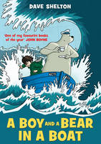 |  | A Boy and a Bear in a Boat  Dave Shelton  A boy and a bear go to sea, equipped with a suitcase, a comic book and a ukulele. They are only travelling a short distance and it really shouldn't take long. But their journey doesn't quite go to plan...Faced with turbulent storms, a terrifying sea monster and the rank remains of a very dangerous sandwich, the odds are against our unlikely heroes. Will the Harriet, their trusted vessel, withstand the violent lashings of the salty waves? And will anyone ever answer their message in a bottle? Brilliantly funny and tender, this beautiful book maps the growth of a truly memorable friendship and explores how, when all else is lost, the most unexpected joys can be found.

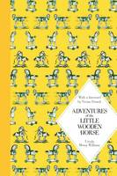 |  | Adventures of the Little Wooden Horse Macmillan Classics Edition  Ursula Moray Williams  When Uncle Peder the toymaker falls on hard times, his little wooden horse must go out into the world to seek his fortune. But whether he's working in a coal mine, sailing the seven seas with a band of pirates, or walking the tightrope in a circus, the loyal little horse only has one wish: to return to his beloved master. Gloriously illustrated with the original line drawings by Joyce Lankester Brisley, a ribbon marker and a foreword by Vivian French, this beautiful hardback edition of Ursula Moray Williams's Adventures of the Little Wooden Horse is a truly special gift to treasure.

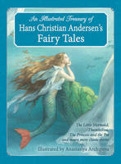 |  | An Illustrated Treasury of Hans Christian Andersen's Fairy Tales The Little Mermaid, Thumbelina, the Princess and the Pea and Many More Classic Stories  Hans Christian Andersen  Hans Christian Andersen's classic tales of foolish emperors, lonely mermaids, icy queens and clever princesses have delighted children and adults alike for nearly two centuries. The stories' unique magic and wonder make them essential reading for any childhood. This beautifully illustrated collection of Andersen's best-loved fairy tales includes The Little Mermaid, The Snow Queen, Thumbelina, The Princess and the Pea and The Emperor's New Clothes.

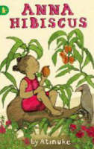 |  | Anna Hibiscus  Atinuke  Anna Hibiscus lives in amazing Africa with her mother, her father, her baby twin brothers, and lots and lots of her family. Join her as she splashes in the sea, prepares for a party, sells oranges, and hopes to see sweet, sweet snow.

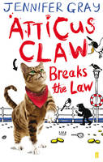 |  | Atticus Claw Breaks the Law  Jennifer, (Children's story writer) Gray  This title is the winner of the Red House Children's Book Award, 2014. When Atticus receives a mysterious message asking him to a meeting in a sleepy coastal town, he packs his bags and sets off. The world's greatest cat burglar likes a good mystery and this time curiosity has got the better of him. The writer of the message, it turns out, is none other than Jimmy the Magpie, gang leader. He wants Atticus to steal all the jewels in town and leave the humans baffled. And what could be more straightforward? But when Atticus moves in with Inspector Cheddar and his family, he starts to wonder if a life of crime is really for him ...

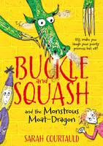 |  | Buckle and Squash and the Monstrous Moat-dragon  Sarah Courtauld  WINNER OF THE 2014 SAINSBURY'S CHILDREN'S BOOK AWARD Here begins a tale of two sisters - Eliza, who dreams of becoming a swashbuckling hero, and Lavender, whose greatest wish is to be a pampered princess. When Lavender gets kidnapped in the Forest of Toothy, Vicious and Flatulent Dragons, the sisters must face a host of deadly enemies. Hairy-faced villains. Ominous turnips. A witch called Boris. And a moat-dragon who is just a little bit peckish for a tasty child-sized snack. Will Eliza and Lavender ever escape? Why is their goat, Gertrude, so depressed? Whose side is Bonnet, the smallest giant in the world really on? And what day is it today? This book will answer some, but not all, of these questions ...Buckle and Squash and the Monstrous Moat-Dragon by Sarah Courtauld is a brilliantly funny debut for fans of How to Train Your Dragon and Mr Gum.

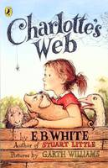 |  | Charlotte's Web  E. B. White  Charlotte's Web is the classic children's story by E B White. The tale of how a little girl named Fern, with the help of a friendly spider, saved her pig Wilbur from the usual fate of nice fat little pigs.

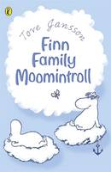 |  | Finn Family Moomintroll  Tove Jansson  Poor little chap! He had been turned into a very strange animal indeed ...Although they're small, fat and shy creatures; Moomins have the most amazing adventures. It all begins when Moominpappa tries on a magic hat that makes exciting and funny things happen.

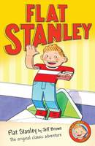 |  | Flat Stanley  Jeff Brown  The classic adventures of everybody's favourite flat boy - It's Jeff Brown's Flat Stanley. Stanley Lambchop is an ordinary boy with an extraordinary problem. One night, a giant pinboard falls on top of him leaving him completely flat. At first, Stanley enjoys the benefits of his strange predicament - it can be fun going in out of rooms simply by sliding under the door. And it's a hoot being posted to your friends in California for a holiday. But it's not always easy being different, and, once the novelty begins to wear off, Stanley wishes he could be just like everybody else again. But how will he ever fill out? Jeff Brown's world-famous character Flat Stanley continues to charm half a century after he first found his way into print.

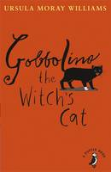 |  | Gobbolino the Witch's Cat  Ursula Moray Williams  Gobbolino by Ursula Moray Williams is the charming tale of a witch's cat who would rather be a kitchen cat. Gobbolino has one white paw and blue eyes and isn't wicked at all, so his mother doesn't like him. He escapes to look for a kitchen home but is distrusted everywhere he goes and blamed for mysterious happenings, such as the farmer's milk turning sour and the orphanage children's gruel turning into chocolate. A perfect story for A Puffin Book with charming black and white illustrations by the author, Ursula Moray Williams..

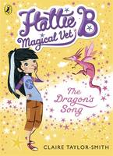 |  | Hattie B, Magical Vet: The Dragon's Song (Book 1)  Claire Taylor-Smith  Hattie B, Magical Vet: The Dragon's Song (Book 1), is the first in a brand new magical series for girls. Discover a secret world of fairy-tale creatures! On her tenth birthday, Hattie B is swept into the magical Kingdom of Bellua where she meets a little pink dragon who needs her help. Evil King Ivar of the Imps has stolen the dragon's magical voice and Hattie is the only one who can help her get it back. Hattie B is inspired by a little girl called Harriet, who once asked 'where do unicorns and dragons go when they're unwell?' Her mum, Lindsay Taylor, and their friend, Suzanne Smith thought long and hard and suddenly realised - a magical vet of course! With this twinkle of an idea they met the writer Claire Baker and together they created the Kingdom of Bellua - and the pen name Claire Taylor-Smith.

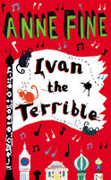 |  | Ivan the Terrible  Anne Fine  A classic children's story from one of our best-loved authors, former Children's Laureate Anne Fine. It's Ivan's first day at his new school, and Boris is told to look after him, and translate for him, because Ivan can only speak Russian. After all, St Edmund's is a civilized school. Only problem is, Ivan isn't civilized. So when Ivan starts greeting people as 'lowly shivering worms', and asking for words in English like 'crush' and 'mutilate', Boris realises that he's going to have his work cut out for him. And that's just the start of the day ...Anne Fine's fun school stories have been delighting children for more than 20 years, winning her awards such as the Smarties Book Award and Carnegie Medal along the way.

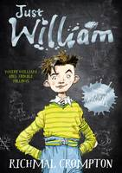 |  | Just William  Richmal Crompton  In Richmal Compton's Just William the Outlaws plan a day of non-stop adventure. The only problem is that William is meant to be babysitting. But William won't let that stop him having fun with his gang - he'll just bring the baby along! There is only one William. This tousle-headed, snub-nosed, hearty, loveable imp of mischief has been harassing his unfortunate family and delighting his hundreds of thousands of admirers since 1922. This delightful children's classic features a contemporary cover look illustrated by Chris Riddell, along with the original inside illustrations by Thomas Henry, which will bring the antics of the mischievous William Brown to a new generation of children.

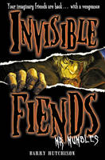 |  | Mr Mumbles  Barry Hutchison  Kyle's imaginary friend from childhood is back...with a vengeance. Kyle hasn't seen Mr Mumbles in years. And there's a good reason for that: Mr Mumbles doesn't exist. But now Kyle's imaginary friend is back, and Kyle doesn't have time to worry about why. Only one thing matters: staying alive...A major series from a fresh new talent, brought to you by the publisher that put horror on the map.

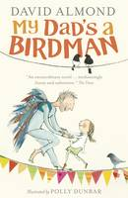 |  | My Dad's a Birdman  David Almond  Lizzie and Dad live in a rainy town in the north of England. It's just the two of them, and Auntie Doreen, who pops round to check Lizzie's spellings and tell Dad he's daft - and make them nice hot dumplings. But today there's something unusual going on: why is Dad building himself a pair of wings and studying the birds to see how they fly? The Great Human Bird Competition of course!

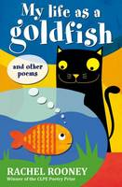 |  | My Life as a Goldfish And Other Poems  Rachel Rooney  Magic slips between the cracks in real life. One day you will step on it. A monster's lunch, a wolf boy, Monday mornings, monkeys, headlice, Christmas, making friends, goldfish - and lots more. Full of jokes, surprises and puzzles, but also sensitive and thought-provoking, this is a spellbinding new collection from the winner of the CLPE Poetry Award.

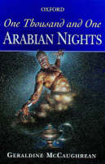 |  | One Thousand and One Arabian Nights  Geraldine McCaughrean  This is a completely original version of the Arabian Nights Stories by award-winning author Geraldine McCaughrean. In order to delay her inevitable execution, Queen Shaharazad tells her murdering husband, King Shahryar, a wonderfully exciting story every night. The King is used to a new wife every day, only to put her to death the following day, but finds himself so intrigued in the magical stories Shaharazad tells, he can't bring himself to kill her. Night after night she tells her wonderful stories until the King starts to realize that he won't be able to live without them...

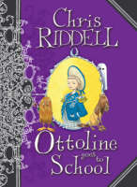 |  | Ottoline Goes to School  Chris Riddell  Meet Ottoline and her hairy, helpful friend Mr Munroe. No secret is ever too scary for the two of them to discover together. Ottoline is off to the Alice B. Smith School for the Differently Gifted. She is rather worried that she doesn't have a special gift. Mr Munroe is worried about the ghost who is said to haunt the school halls at night. Does Ottoline discover how to be different and can they expose the spook?

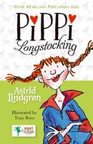 |  | Pippi Longstocking  Astrid Lindgren  Pippi Longstocking is one of the most popular children's characters of all time and is still much loved by millions of children today. This anniversary edition of Pippi Longstocking will introduce Pippi and her adventurous spirit to a whole new generation of readers. Nine year old Pippi is an unusual and unpredictable character, she lives alone with a monkey, a horse, and no rules whatsoever! Every day is a crazy adventure with Pippi, but what else would you expect from the daughter of a swashbuckling pirate captain?!

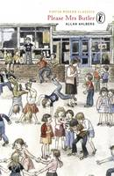 |  | Please Mrs. Butler Verses  Allan Ahlberg, Julia Eccleshare  This witty collection of poems about school is full of typical classroom events that will be recognized and enjoyed by everyone: the candid revelations in a pupil's newsbook, the problem of copycats, bickering, making up, swaps, picking teams and forming gangs. Fritz Wegner's line drawings beautifully complement the hilarious and poignant verses. Please Mrs Butler was voted the most important twentieth-century children's poetry book in a Books for Keeps poll.

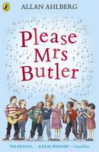 |  | Please Mrs. Butler Verses  Allan Ahlberg  The bestselling and much-loved children's poetry classic, Please Mrs Butler by Allan Ahlberg is celebrating its 30th anniversary! With a fresh new look for a brand new generation of school children to take to its heart, every teacher, parent and child should have a copy. Nobody leave the room. Everyone listen to me. We had ten pairs of scissors At half-past two, And now there's only three. This witty collection of school poems by Allan Ahlberg, re-jacketed for its 30th anniversary and for a whole new generation of school children to fall in love with, is full of typical classroom events that will be recognized and enjoyed by everyone. From never-ending projects, reading tests, quarrelling, making-up, excuses and 'Please, Sir, it isn't fair.' Fritz Wegner's line drawings beautifully complement the hilarious and poignant verses. Please Mrs Butler was voted the most important twentieth-century children's poetry book in a Books for Keeps poll. Praise for Please Mrs Butler: Hilarious and poignant school verses about primary school life. A real winner . (Guardian). Clever, funny and nostalgic, the collection is a delight . (Sunday Times). Please Mrs Butter - The most important 20th-century children's poetry book . (Books for Keeps poll). Praise for Allan Ahlberg: By far our best writer for the young . (Telegraph). Author Allan Ahlberg, a former teacher, postman, plumber's mate and grave digger, is in the super-league of children's writers. He has published over 100 children's books and, with his late wife Janet, created such award-winning picture books as Each Peach Pear Plum and The Jolly Christmas Postman - both winners of the Greenaway Medal. He has also written prize-winning poetry and fiction for older readers. The Telegraph described him as 'By far our best writer for the young.'

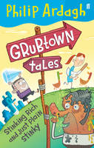 |  | Stinking Rich and Just Plain Stinky  Philip Ardagh  You won't find Grubtown on any maps. The last time any map-makers were sent anywhere near the place they were found a week later wearing nothing but pages from a telephone directory, and calling for their mothers. It's certainly a town and certainly grubby - except for the squeaky clean parts - but everything else we know about the place comes from Beardy Ardagh, town resident and author of these tales. Grubtown is full of oddballs - from the singing Grumbly girls to a family of duck-haters, and an out-sized mayor who's knitting a new house - but Manual Org is too repulsive even for them. Getting him to leave town is top priority, until the discovery of a humongous diamond changes everything...

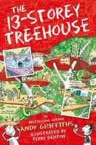 |  | The 13-Storey Treehouse  Andy Griffiths  Andy and Terry live in the WORLD'S BEST treehouse! It's got a giant catapult, a secret underground laboratory, a tank of man-eating sharks and a marshmallow machine that follows you around and shoots marshmallows into your mouth whenever you're hungry! Just watch out for the sea monkeys, and the monkeys pretending to be sea monkeys, and the giant mutant mermaid sea monster ...Oh, and, whatever you do, don't get trapped in a burp-gas-filled bubble ...! Andy Griffith and Terry Denton's fantastically funny 13-Storey Treehouse is told through a combination of text and cartoon-style illustrations.

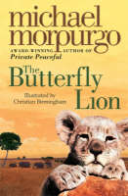 |  | The Butterfly Lion  Michael, M. B. E. Morpurgo  ILLUSTRATED BY CHRISTIAN BIRMINGHAM. A lyrical and moving tale of a young boy growing up in Africa, and his lifelong friendship with a white lion. All my life I'll think you you, I promise I will. I won't ever forget you. Bertie rescues an orphaned white lion cub from the African veld. They are inseparable until Bertie is sent to boarding school far away in England and the lion is sold to a circus. Bertie swears that one day they will see one another again, but it is the butterfly lion which ensures that their friendship will never be forgotten.

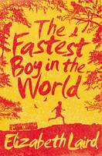 |  | The Fastest Boy in the World  Elizabeth Laird  Eleven-year-old Solomon loves to run! The great athletes of the Ethiopian national team are his heroes and he dreams that one day he will be a gold-medal-winning athlete like them, in spite of his ragged shorts and bare feet. When his grandfather announces that he's going to take Solomon to Addis Ababa, Solomon cannot believe his ears. A trip to the capital? It's unfathomable. Solomon's joy is increased when he realizes that the Ethiopian running team will be doing a victory parade through the city that day. Maybe he'll get a glimpse of Haile Gebrselassie or Derartu Tulu?! But Solomon's grandfather has other plans. As Solomon follows him through the big, overwhelming streets, he learns something he cannot believe. The strict old man is a war hero who once risked his life to save a friend and has been in hiding ever since. When grandfather collapses, Solomon knows that getting help from his village is up to him. It's a twenty-mile run from the city to home, and grandfather's life hangs in the balance. Can the small bare-footed runner with the big heart do it? Shortlisted for the CILIP Carnegie Medal, The Fastest Boy in the World by Elizabeth Laird is the inspiring story of a small Ethiopian runner with a very big heart.

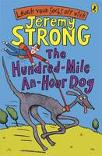 |  | The Hundred-mile-an-hour Dog  Jeremy Strong  The Hundred-Mile-an-Hour Dog by Jeremy Strong has become a children's classic! From The Hundred-Mile-an-Hour Dog to karate princesses and hot cross bottoms, there's a Jeremy Strong story to suit every child's sense of humour. Jeremy's readers range from 7 to teen, perfect for fans of Roald Dahl and Andy Stanton. Streaker is a mixed-up kind of dog ...with quite a bit of Ferrari and a large chunk of whirlwind. Streaker is no ordinary dog. She's a rocket on four legs with a woof attached, and Trevor has got until the end of the holidays to train her. If he fails, he'll lose his bet with horrible Charlie Smugg, and something very, very yucky involving frogspawn will happen...Award-winning Jeremy Strong has written many wacky books for children aged 7-teen, including My Dad's Got an Alligator and My Brother's Famous Bottom. Most of which are illustrated by Nick Sharratt, who also illustrates for Jacqueline Wilson! The Hundred-Mile-An-Hour Dog is back causing more chaos and getting into more trouble in Return of the Hundred-Mile-An-Hour Dog, Lost! The Hundred-Mile-An-Hour Dog, Wanted! The Hundred-Mile-An-Hour Dog, Christmas Chaos for the Hundred-Mile-An-Hour Dog and The Hundred-Mile-An-Hour Dog Goes for Gold - guaranteed to have you laughing your socks off!

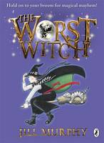 |  | The Worst Witch  Jill Murphy  The Worst Witch written and illustrated by Jill Murphy is reissued with exciting new branding and format. The Worst Witch is the first in the bestselling children's series by Jill Murphy. Hold on to your broomstick for magical mayhem! Jill Murphy's much-loved classic The Worst Witch is the original story of life at a magical boarding school, perfect for readers aged 5 - 9 years. Mildred Hubble is a trainee at Miss Cackle's Academy for Witches, but she's making an awful mess of it. She keeps getting her spells wrong and crashing her broomstick. And when she turns Ethel, the teacher's pet into her worst enemy, chaos ensues... Millions of young readers have fallen under the spell of Jill Murphy's Worst Witch . (Sunday Express). Jill Murphy was born in London in 1949. From a very early age she was drawing and writing stories, and was already putting books together (literally, with a stapler) by the time she was six. She went on to study at Chelsea, Croydon and Camberwell Schools of Art. Jill worked in a children's home for four years and as a nanny for a year, before becoming a freelance writer and illustrator. The Worst Witch stories, of which this is the first, are some of Puffin's most successful titles. If you'd like to read more of Mildred's disastrous adventures at Miss Cackle's Academy The Worst Witch Strikes Again, A Bad Spell for the Worst Witch, The Worst Witch All at Sea, The Worst Witch Saves the Day and The Worst Witch to the Rescue are also available from Puffin and are perfect for children aged 5-9.

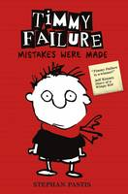 |  | Timmy Failure: Mistakes Were Made  Stephan Pastis  Perfect for fans of Wimpy Kid and Big Nate, Timmy Failure: Mistakes Were Made is the first book in the New York Times bestselling series. Listed as one of 100 Modern Children's Classics by The Sunday Times, it was also a Booktrust Best Book Awards winner. Meet Timmy Failure, founder of the best detective agency in town - Total Failure, Inc. With the help of his polar bear, Total, the clueless, comically self-confident Timmy already has plans for world domination. Plans that will make his mother rich and unpaid bills a thing of the past. And plans that will defeat Corrina Corrina, The One Whose Name Shall Not Be Uttered . But she's not going away. Riotously funny, Timmy Failure is sure to have readers in stitches.

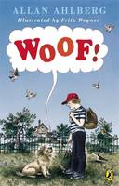 |  | Woof!  Allan Ahlberg  He felt a curious tingling in his hands and feet. He felt his nose becoming cold and wet, his ears becoming flappy. The thought in his mind was: 'I'm turning into a dog!' Eric is a perfectly ordinary boy. Perfectly ordinary that is, until the night when, in fifteen seconds flat, he turns into a dog! Eric and his best friend are determined to sniff out the truth - what makes an ordinary boy go 'woof'?

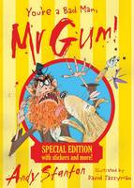 |  | You're a Bad Man, Mr Gum!  Andy Stanton  FLOSK IT UP, YOU WHIPPERS! This SPECIAL EDITION of You're a Bad Man, Mr Gum! includes: Over 50 stickers! An exclusive introduction from the author! And! A brand new bonus story - 'Old King Thunderbelly and the Wall of Lamonic Bibber' Good evening. Mr Gum is a complete horror who hates children, animals, fun and corn on the cob. This book's all about him. And an angry fairy who lives in his bathtub. And Jake the dog, and a little girl called Polly and an evil, stinky butcher all covered in guts. And there's heroes and sweets and adventures and EVERYTHING. You're a Bad Man, Mr Gum! is the first book in the internationally best-selling series by Andy Stanton, which has won everything from the Blue Peter Book Award (twice) the Roald Dahl Funny Prize and the Red House Children's Book Award. Praise for Mr Gum: 'Smooky palooki! This book is well brilliant!' - Jeremy Strong 'Worryingly splendid' - Guardian NOT FOR BORERS!

