Underhill School and Children’s Centre

Recommended Reading List

Reception
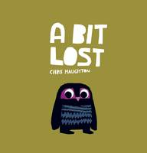 |  | A Bit Lost  Chris Haughton  The award-winning debut title from Chris Haughton, the acclaimed author-illustrator of Oh No, George! and Shh! We Have a Plan, this is the heart-warming story of Little Owl - who must be more careful when he is sleeping...Uh-oh! He has fallen from his nest, and with a bump he lands on the ground. Where is his mummy? With the earnest assistance of his new friend Squirrel, Little Owl sets off in search of her, and meets a sequence of other animals. Yet while one might have his mummy's big eyes, and another her pointy ears, they are simply not her. Chris Haughton's striking colour illustrations follow Little Owl on his quest. Which of his new friends will lead him back to his mummy?

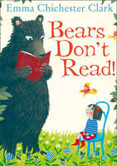 |  | Bears Don't Read!  Emma Chichester Clark  An exquisite new picture book from renowned illustrator, Emma Chichester Clark, creator of Blue Kangaroo. A magical story of friendship to power the imagination and encourage children (and bears!) towards a lifelong love of reading. That's just silly! said his sister. Bears don't read! George isn't happy doing the usual bear things like chatting and fishing. But what else is there? Then one day, he finds a book beneath a tree and knows...More than anything he wants to learn to read! But, arriving in town, George soon discovers that it's not easy to be a bear at school! If only he could find someone to teach him the alphabet and change his life forever...Perhaps a little girl called Clementine can help? A feel-good story of determination and friendship - sure to encourage a lifelong love of books.

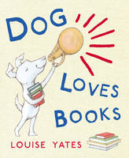 |  | Dog Loves Books  Louise Yates  Dog loves books! Dog loves books about dinosaurs and Dog loves books about aliens: in fact Dog loves all books! Dog has his very own bookshop, although he doesn't have many customers. But that's all right, because when Dog is surrounded by books, he is never short of friends or fun. And when someone does come into the shop, Dog knows just which books to recommend.

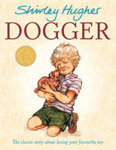 |  | Dogger  Shirley Hughes  When Dave loses his favourite toy, Dogger, he is desolate. But then Dogger turns up at the school summer fair, and everything seems all right - until someone else buys him before Dave can get the money!

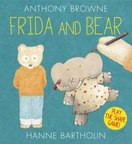 |  | Frida and Bear  Anthony Browne, Hanne Bartholin  Frida and Bear both LOVE to draw - but what? First, Frida draws a shape. Bear adds to it and turns it into a picture. Then Bear draws a shape for Frida as the game begins again. Anthony Browne and Hanne Bartholin celebrate the power of imagination and the importance of creativity in this delightful picture book that invites the reader to join in and play the shape game with them.

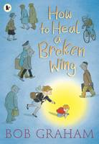 |  | How to Heal a Broken Wing  Bob Graham  When Will helps an injured bird, he learns that a little kindness can go a long way. No one in the busy city sees the bird lying on the pavement, its wing broken. No one but a small boy called Will. He and his mum carry it home and, with time, rest, and a little bit of hope, the wing mends...and they set the bird free to soar over the city once more. This is a paperback edition of a magical story, endorsed by Amnesty International UK. It is a poetic picture book full of hope and tenderness, from a multi-award-winning creator.

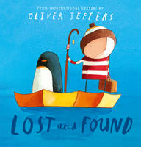 |  | Lost and Found  Oliver Jeffers  New cover reissue of this magical story from award-winning international bestselling picture book creator, Oliver Jeffers There once was a boy...and one day a penguin arrives on his doorstep. The boy decides the penguin must be lost and tries to return him. But no one seems to be missing a penguin. So the boy decides to take the penguin home himself, and they set out in his row boat on a journey to the South Pole. But when they get there, the boy discovers that maybe home wasn't what the penguin was looking for after all...

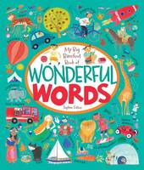 |  | My Big Barefoot Book of Wonderful Words  Sophie Fatus  Each scene is teeming with people, places and things. But what makes this book really different is that each of the narrative, real world scenes is followed and further developed by an abstract, interactive one.

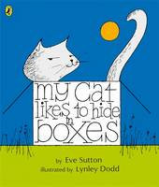 |  | My Cat Likes to Hide in Boxes  Eve Sutton, Lynley Dodd  Lots of cats all around the world do exciting things like fly aeroplanes or play the violin - but my cat, an ordinary round-the-house cat, likes to hide in boxes. Children will love joining in with this fun rhyming story that is just right for beginner readers.

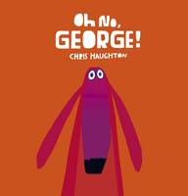 |  | Oh No, George!  Chris Haughton  Harris is off to do some shopping. Will you be good, George? he asks. George hopes he can. He really wants to ...but chocolate cake is just so very delicious and he does love to chase cat...What will George do now? Chris Haughton's distinctive artwork perfectly accompanies the innocent charm of affable George, a dog trying to be good - with hilarious results!

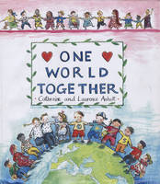 |  | One World Together  Catherine Anholt, Laurence Anholt  I want a friend but who will I choose? Take a trip around the world, meet children from lots of different places and peep into their lives. This is a delightful story about friendship across nations and cultures, in which one small child visits nine different countries to find a friend - and ends up being friends with ALL the children he meets. Along the way he discovers how children live in other countries and the things they enjoy doing - showing both how their lives are different, and how many of the things children enjoy are the same throughout the world. The countries featured are: USA, Brazil, China, Russia, Kenya, the Netherlands, Sweden, Japan and Morocco

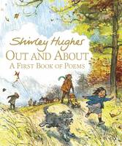 |  | Out and About A First Book of Poems  Shirley Hughes  In this wonderful collection of poems, Katie and her little brother Olly romp through the changing seasons, taking pleasure in the different elements and weather conditions - sunshine, wind, rain, mist, snow...From the joys of the seaside to the miseries of the sickbed, this exuberant volume captures to perfection the world of childhood.

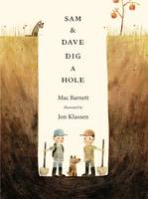 |  | Sam and Dave Dig a Hole  Mac Barnett  From the award-winning team behind Extra Yarn, and illustrated by Jon Klassen, the Kate Greenaway-winning creator of This is Not My Hat and and I Want My Hat Back, comes a perfectly paced, deadpan tale full of visual humour. Sam and Dave are on a mission. A mission to find something spectacular. So they dig a hole. And they keep digging. And they find ...nothing. Yet the day turns out to be pretty spectacular after all. Attentive readers will be rewarded with a rare treasure in this witty story of looking for the extraordinary - and finding it in a manner they'd never expect.

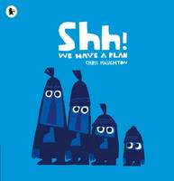 |  | Shh! We Have a Plan  Chris Haughton  Four friends, three big and one little, are out for a walk. Suddenly, they spot it - a beautiful bird perched high in a tree! They simply MUST have it and - SHH! - they have a PLAN. So they tip-toe, tip-toe very slowly, nets poised - Ready one ...ready two ...ready three ...GO! But, at the turn of the page, we find a ridiculous bunch of very tangled characters and a blissfully oblivious bird, flying away. One hilarious foiled plan after another and it's clear that this goofy trio CANNOT catch that elusive birdie! But the littlest of this group, a quiet spectator up until now, knows that a bit of kindness and sweetness can go a lot further than any elaborate scam. Will his three friends follow his gentle lead or will they get themselves into even more trouble?

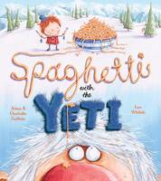 |  | Spaghetti with the Yeti  Charlotte Gullain, Adam Gullain  Hurrah! shouted George, At last it is you. I've been looking so hard for the Yeti. The monster looked down with a horrible howl ... Are you bonkers? My name is Netty! Join George, a young and courageous explorer, determined to track down the elusive Yeti against all the odds. With only a map, a woolly hat and a tin of spaghetti in his rucksack, George sets off on his quest up the steep mountain path ...and spots the Yeti immediately! But wait ...just look at that lipstick! Can it really be the Yeti?

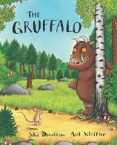 |  | The Gruffalo  Julia Donaldson  A mouse took a stroll through the deep dark wood. A fox saw the mouse and the mouse looked good. Walk further into the deep dark wood, and discover what happens when the quick-thinking mouse comes face to face with an owl, a snake and a hungry gruffalo ...

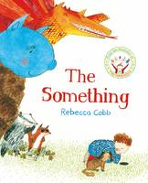 |  | The Something  Rebecca Cobb  When a little boy's ball disappears down a mysterious hole in the garden, he can't stop thinking about what could be down there - a little mouse's house? The lair of a hungry troll? Or maybe even a dragon's den. Whatever it may be, he's determined to find out! A glorious imaginative adventure from the award-winning creator of AUNT AMELIA and LUNCHTIME, and illustrator of THE PAPER DOLLS, written by Julia Donaldson.

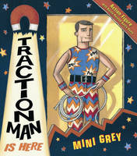 |  | Traction Man Is Here  Mini Grey  With an action outfit for every occasion, Traction Man patrols the house. Whether he is saving toys (in latex space suit and Perspex helmet, teamed with Rocket Boots); searching the sink for the lost wreck of the sieve (in sub-aqua suit, fluorescent flippers and infra-red mask) or rescuing damsels in distress (in jungle pants, camouflage vest and a bandanna), Traction Man is never less than stylishly turned out and expertly accessorised. He is the last word in heroic fashion flair - until, that is, the day that he is presented with an all-in-one knitted green romper suit and matching bonnet by his owner's granny. Can Traction Man overcome the humiliation of his desperately dowdy new look and rediscover the action hero within or will the burden of the knitted green monstrosity be too great?

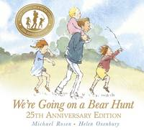 |  | We're Going on a Bear Hunt  Michael Rosen  We're going on a bear hunt. We're going to catch a big one. Will you come too? For a quarter of a century, readers have been swishy-swashying and splash-sploshing through this award-winning favourite. Follow and join in the family's excitement as they wade through the grass, splash through the river and squelch through the mud in search of a bear. What a surprise awaits them in the cave on the other side of the dark forest!

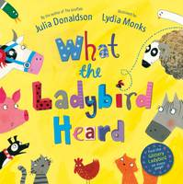 |  | What The Ladybird Heard  Julia Donaldson  Oink! said the cats ...With all the MOOing and HISSing and BAAAing and CLUCKing, the farmyard is full of noise. But when Hefty Hugh and Lanky Len hatch a plot to steal the fine prize cow, it's the quietest animal of all who saves the day!Spot the glittery ladybird on every page of this wonderful rhyming tale from the creators of the bestselling THE PRINCESS AND THE WIZARD and SHARING A SHELL.

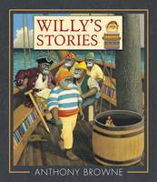 |  | Willy's Stories  Anthony Browne  Once a week, Willy walks through an ordinary-looking set of doors and straight into an adventure. Where will those doors take him today: to a mysterious desert island with footprints in the sand; down a deep, dark rabbit hole full of curious objects; or perhaps on board a pirate ship, face to face with Captain Hook? Wherever he ends up, Willy's journeys begin when he walks through those inviting doors.

