Agricultural Hydropower Case Studies
- Wenschhof Cattle Ranch Hydro Project
George Wenschhof, a cattle rancher in Meeker, Colo., figured out how to harness the mechanical energy in his center pivot sprinkler irrigation system to power his ranch through installation of a 23-kW hydropower plant from Canyon Hydro.

- Wenschhof installed a hydroelectric generator to offset the electrical load of his irrigation system and all of his ranch operations. Center pivot sprinkler systems consume a large amount of energy; incorporating a hydroelectric turbine in a center pivot project can make the entire project more cost effective.
- A case study from the Colorado Energy Office notes that the project is saving $10,000 to $13,000 per year in avoided electric bills.
- George Wenschhof participated in the Natural Resources Conservation Services (NRCS) Environmental Quality Incentives Program (EQIP) to convert his irrigation from flood to a sprinkler system.

- Bear River Ranch Hydro-Mechanical Center Pivot Irrigation Project
When confronted with rising water costs and low crop yields, Bear River Ranch, located near Steamboat Springs, installed a hydro-mechanical system to power its center-pivot irrigation system.

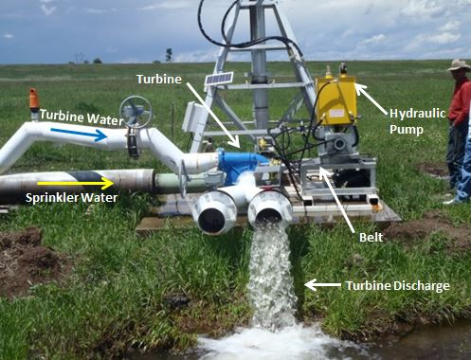
- This system uses the power of falling water to directly drive and pressurize the center pivot; this eliminates the need for electricity and significantly reduces operating expenses.
- The turbine uses 126 feet of head and 560 gpm to produce the equivalent of 5.2 kW of power which drives the center pivot.
- The $13,000 project was funded through $6000 in support from NRCS, yielding out of pocket cost to the ranch of $7000 and an expected payback of slightly over 3 years.
- A center pivot sprinkler was chosen as the water conservation measure, which uses significantly less water than the previous method of flood irrigation.
- A hydro-mechanical system was installed to eliminate the energy required to power the center pivot.

Presenters’ Take-Away Points & Contact Information
Welcome & Southwestern Water Conservation District’s Programs
Bruce Whitehead, Southwestern Water Conservation District
970-247-1302
brucew@southwesternwater.org
swwcd.org

CDA’s Approach to Agricultural Hydropower
Eric Lane, Colorado Department of Agriculture
303-239-4182
eric.lane@state.co.us
www.colorado.gov/ag/energy

- The Colorado Department of Agriculture is presently building a small hydropower program for the agriculture community to facilitate the development of pressurized irrigation systems and ditch drops.
- This program will engage all of the stakeholders (private and public) that can play a role in helping producers and ditch companies build small hydropower projects more quickly and cost-effectively.
- The Department is hiring an energy specialist that will work directly with producers and ditch companies as needed to move projects more quickly from conception to completion. This specialist will help wherever it is needed and provide connectivity to rural electric co-ops, USDA, and others to facilitate implementation. The position should be on board by late May.

Findings from the Agricultural Hydro Assessment & Agricultural Hydropower Case Studies
Lindsay George, Applegate Group
303-452-6611
LindsayGeorge@applegategroup.com
www.applegategroup.com

- We are confident about the statewide potential of pressurized irrigation system, but need more information to quantify the potential of ditch drops across the state.
- Hydropower can be used to power a center pivot with electricity or mechanical energy using excess pressure or flow.
- When technically feasible adding hydropower to pressurized irrigation system installations is very cost effective.
- Developing hydropower on ditch drops is site specific and depends on conditions which must be known, such as flow.

NRCS’s EQIP Program & Agricultural Hydropower
Sterling Moss, USDA – Natural Resources Conservation Service
970-259-3289 ex 3
sterling.moss@co.usda.gov
www.nrcs.usda.gov
- Small hydro is NOT on the NRCS 2014 Eligible Practice List for Environmental Quality Incentives Program financial assistance, small hydro is not eligible for assistance in 2014.
- NRCS is working to add small hydro as an eligible Practice for 2015 if it is part of an irrigation system improvement project, but it has not been officially added as of May 2014.
- NRCS can accept applications now for the 2015 EQIP program year. Interested individuals should contact their local NRCS office at their earliest convenience to start the planning process and to discuss basic EQIP eligibility requirements.
Funding Opportunities through USDA’s Rural Development REAP Program
Charles Thompson, USDA Rural Development
charles.thompson@co.usda.gov
www.rurdev.usda.gov

Electrical Interconnection
Dan Harms, La Plata Electric
970-382-3514
dharms@lpea.coop
www.lpea.com

Getting New Small Hydro Permitted, Financed and Built
Kurt Johnson, Colorado Small Hydro Association
970-728-2031
kurt@telluridenergy.com
www.smallhydro.co

- The Colorado Energy Office has developed a Small Hydropower Handbook which provides an overview of the development process.
- The process starts with a site assessment which can be completed over the phone, followed by a feasibility assessment which requires a site visit.
- FERC permitting is now relatively quick and straightforward. FERC can complete processing of applications in about 60 days
- There are federal and state financing sources which can support development of agricultural hydropower. Most importantly, forthcoming new incentives though NRCS are expected to significantly reduce costs.

