Economically Feasible Ditch Drops within Delta County
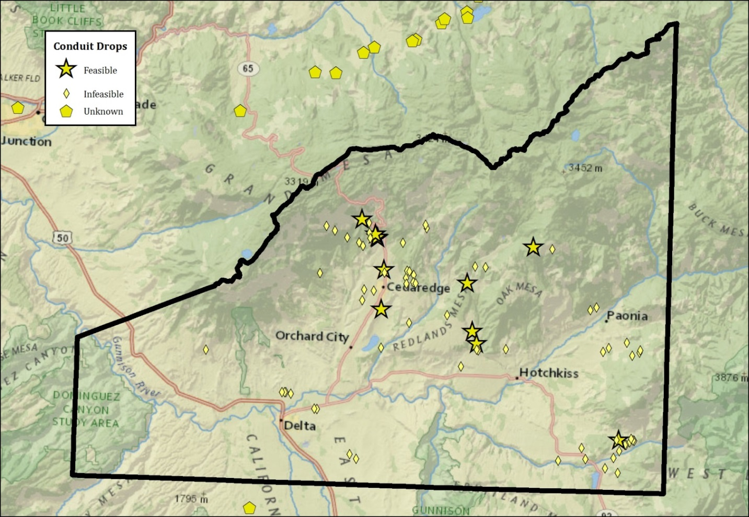
Pressurized Irrigation Sites in Delta County
