Welcome!

Welcome to the Aero Center Study Seminar. This is a study group that is website-based but is also open to face-to-face interaction if necessary. We will be discussing strategies and techniques of how to learn and memorize the Aero Center radar map. We will also be familiarizing ourselves with the different aspects of the National Airspace System that are depicted on the Aero Center map. Your Introduction to ATC class requires you to draw the map on **November 28th**. In the meantime, this study group will allow you to discover ways of easily memorizing the map.

**ZAE Study Seminar**

*Figure 1A:*



*Figure 1B:*

**66  
JAN LO  
125.0-325.0**

***Sector 66***

***“Jackson Low”***

***VHF – 125.0  
UHF – 325.0***

Throughout your air traffic career at Middle Georgia College, you will refer back to this map in future classes. Therefore, retaining the information on this map is critical to your success in the ATC program.

**IMPORTANT:** If you ever have any questions about this map, the air traffic control program here at MGC, or any other questions that you may be afraid to ask in a classroom setting, here is your chance to ask them. I myself am an air traffic control student here at MGC and am more than happy to answer any question you have. Please feel free to contact me anytime with your questions or concerns.   
  
E-mail: [sthomson91@yahoo.com](mailto:sthomson91@yahoo.com)  
Phone number: (706) 255-0954

Sectors

The first aspect of Aero Center that we will cover is the sector.

**Refer to Figure 1A on the sidebar.** The sector depicted in figure 1A is a rough representation of how the Jackson Low sector is configured. Before you move on, find this sector of airspace on your map so that the following will make more sense.

A sector of airspace is a defined area of airspace that has distinct radio frequencies and is usually controlled by one controller. Each sector of airspace is identified by a sector number, a three letter identifier, and the frequency that the sector uses for communications. Although there are more than two types of sectors in the real world, your Aero Center map only utilizes two types of sectors; low and high sectors.

**Refer to Figure 1B on the sidebar.** The first number is the sector number. Each sector number that is inside of Aero Center will only contain two digits, while sectors that are inside other ARTCCs will contain a letter pertaining to its ARTCC and the two digits. So a sector in Fort Worth Center such as “Monroe Low” has a sector number of F30 (when being referred to from the standpoint of Aero Center.)

The second line of information provides you with the sector identifier and the type of sector that it is. In this case, JAN LO represents “Jackson Low”.

The third and final line of information contains the distinct frequencies that the sector operates with. The first frequency is VHF (Very High Frequency) and the second is UHF (Ultra High Frequency).

Victor Airways

The next aspect of Aero Center that we will discuss is the system of victor airways. Victor airways are pre-determined routes flown under Instrument Flight Rules that are defined by VOR radials. Think of victor airways as “highways in the sky” in the national airspace system.

As you will find in further studies of air traffic control, many things are altitude dependent. Such is the case with Victor airways as they are only usable below flight level 180 (18,000 feet MSL). There are eleven different victor airways on the Aero Center map. Below is an illustration of one of the victor airways from your map.

 V18 V18

**MLU JAN MEI**

Fixes

**Fixes are another type of “waypoint” that pilots fly to on the way to their destination. Fixes are geographical positions determined by reference to one or more radio NAVAIDS. Fixes are depicted on the Aero Center map by either a solid or transparent triangle.**

**Compulsory reporting points:**

**A compulsory reporting point is depicted as a solid triangle on the Aero Center map as shown below. Compulsory reporting points require a pilot in a non-radar environment to report his or her position when directly over the fix. You will have to distinguish between the solid triangles and the transparent triangles when you draw your map.**

**V427 HATER V427**

**Non-compulsory reporting points:**

**Non-compulsory reporting points do not require pilots to make position reports over a specific fix. These type of fixes are depicted as transparent triangles as shown below.**

V245

**TALPY**

V245

Mileages

All of the victor airways on the Aero Center map have **three types** of mileages associated with them.

1. 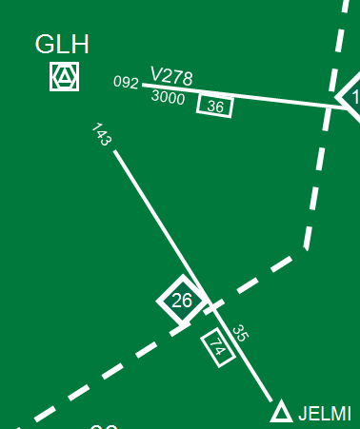The first type of mileage marker that we will discuss is the total mileage of the victor airway. This number represents the distance in nautical miles from NAVAID to NAVAID. The total mileage of a victor airway from NAVAID to NAVAID is depicted inside of a small box placed directly under the victor airway line.
2. The second type of mileage is the individual segment mileage of one portion of a victor airway. These mileages typically show the distance between fixes along the victor airway route and are depicted above the victor airway segment that is being measured.
3. The third type of mileage measures the distance from a navigational aid to an airspace boundary. This type of mileage is shown in a diamond.

To the right is a depiction of a portion of Aero Center. The mileages described above can be applied to this victor airway (Victor 74). The following terms are not official mileage terms but serve as an easy way to remember their functions.

**Total Mileage:** The total mileage on Victor 74, from GLH to JAN ironically, is 74 nautical miles. This can been determined by the “74” that is shown in the box directly under the airway.

**Fix to Fix Mileage:** As stated before, the individual mileage is the mileage from fix to fix, or some other navigational point. Here, the individual mileage is 35 nautical miles and is measuring the distance from JELMI and GLH.

**Diamond Mileage:** Here the mileage from the NAVAID to the boundary is 26 miles with GLH being the NAVAID and the Jackson Low sector being the airspace boundary.

MEAs

The acronym “MEA” stands for the **M**inimum **E**n Route **A**ltitude. The MEA is the lowest published altitude between two radio fixes which assures acceptable navigational signal coverage and meets obstacle clearance requirements between those fixes. MEAs are depicted on the Aero Center map below the Victor airway lines as shown below.

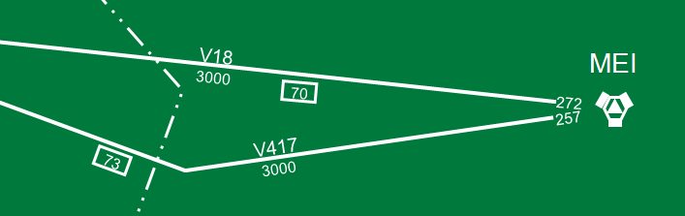

As you can see from the image above, the displayed portion of Victor four seventeen (V417) has an MEA of 3000 feet. This altitude is 3000 feet MSL, or 3000 feet above sea level.

Airports

There are a total of seven airports that are shown on the Aero Center map. All seven of the airports are within the Jackson Low sector. Airports are depicted by a circle with four lines extending from each side of the circle as shown below.

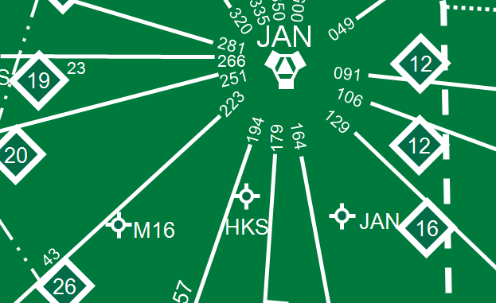

John Bell Williams Airport, Hawkins Field, and Jackson-Evers International Airport are shown in this picture of Aero Center

|  |  |  |
| --- | --- | --- |
| **Name** | **Identifier** | **Control Tower** |
| Jackson-Evers International Airport | JAN | Yes |
| Hawkins Field | HKS | Yes |
| John Bell Williams Airport | M16 | No |
| Vicksburg Municipal Airport | VKS | No |
| Tallulah Regional Airport | TVR | No |
| Byerley Airport | 0M8 | No |
| Greenwood-Leflore Airport | GWO | Yes |

Radials

The compass is an invaluable and absolutely required piece of knowledge that you as an air traffic controller must be able to use effectively. The radials from the navigational aids on the Aero Center map are directly taken from the compass. If you haven’t done so already, I **highly** recommend that you become familiar with the compass.

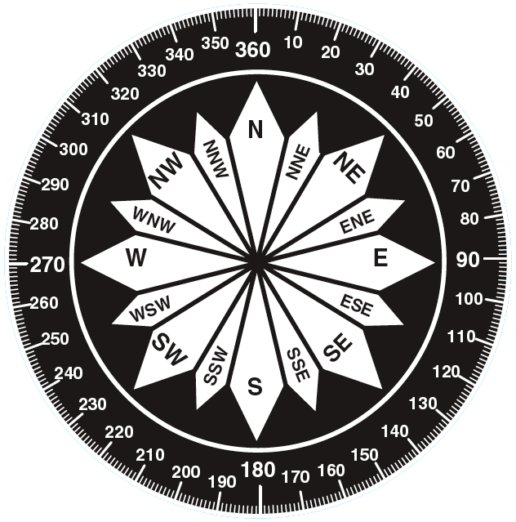

Jet Routes

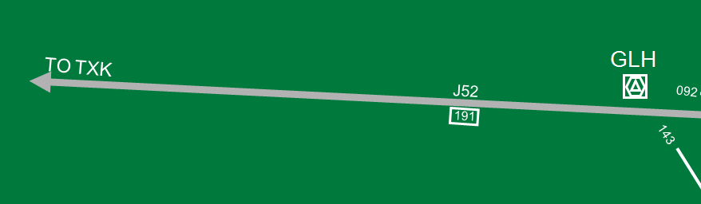A Jet Route is a route designed to serve aircraft during operations from flight level 180 (18,000 feet MSL) up to and including flight level 450 (45,000 feet MSL). You can think of Jet Routes as “highways in the sky”, such as victor airways, but the difference is that Jet Routes are used by aircraft at higher altitudes. There are technically four Jet Routes on your Aero Center map, but only three are shown because two of them overlap.

**As shown above:**

Here you can see that Jet Routes are shown on the map with a “J” and the corresponding numbers. Just like victor airways, the mileage is shown under the Jet Route’s line and in a box. The “TO TXK” refers to the direction of a navigational aid. In this case, if you were to fly westbound on J52, you would fly to the Texarkana VORTAC (TXK).

Restricted Areas

Restricted areas contain airspace identified by an area within which the flight of aircraft, while not wholly prohibited, is subject to restrictions. Restricted areas denote the existence of unusual, often invisible, hazards to aircraft such as artillery firing, aerial gunnery, or guided missiles. Entry of restricted areas without authorization from the using agency may be extremely hazardous to the aircraft.

There are two restricted areas in the Aero Center map. They include R931A and R931B. The altitude limits of these areas are depicted on the map as well as below.

*R931A R931B  
AT OR BELOW 9000MSL 9001 TO BUT NOT  
 INCLUDING FL 180  
 INTERMITTENT BY NOTAM  
 ZAE/FSS*

MOAs

MOAs, or **M**ilitary **O**perating **A**reas, consist of airspace of defined vertical and lateral limits established for the purpose of separating certain military training activities from IFR traffic. Whenever a MOA is being used, nonparticipating IFR traffic may be cleared through a MOA if IFR separation can be provided by ATC.

There is one Military Operating Area within the Aero Center map. This MOA is called the “*Columbus 3 MOA”* and is shown below.

*Columbus 3 MOA  
8000 TO BUT NOT  
INCLUDING FL 180  
BY NOTAM  
ZAE/FSS*

Tools to Help

There are several aviation websites that will help you learn the different aspects of the national airspace system. Visit the websites below for information on airports, navigational aids, airliners, and much more.

[](http://www.airnav.com)[](http://www.flightaware.com)