Coming Saturday May 27th & May 28th 2017
Gates open at 4:00 pm

“Presents”

At
Homestead Valley Park
1501 Bellfield Blvd.
Landers, Ca 92285
For more info or to sponsor this event.
Contact Missy Buchanan (760) 218-1980

Non profit tax ID# 33-0210906
Subject: Sponsor/ Donation Request
From: National Police Rodeo Association
Dear Hi Desert Community and businesses,
Here is your chance to be a part of Grubstake Days Rodeo 2017.
We are currently looking for partners/ Sponsors to help with our operating expenses.
We expect to spend around the range of $60,000.00 for 2017 Rodeo.
We have advertising opportunities listed below.
The Rodeo will be held during Grubstake day’s weekend, Saturday May 27th, and Sunday May 28th 2017 at 7:00 pm Saturday night and 6:00 pm Sunday night with gates opening at 4:00pm each day.
All sponsorship/ Donations should be received no later than March 1st 2017.
We thank you for your support.

Sponsor levels are as follows,

Turquoise Sponsor – $300.00 Donation, allows you:
- Company name/ Logo on promotional flyers and advertisements
- One banner at Rodeo (provided by sponsor)
- Announcements during opening ceremonies.
- Two rodeo tickets for one performance

Silver Sponsor- $500.00 Donation, allows you:
- 1-Flag run during the Rodeo
- 1 –Banner provided by sponsor on rodeo grounds
- Public announcements made during opening ceremonies
- Company name /Logo on promotional flyers and advertisement and on our website.
- Two rodeo tickets for one performance

Copper Sponsor- $800.00 Donation, allows you:
- 1-Flag run during rodeo
- 1- Banner in arena
- Public announcements made during opening ceremonies
- Company name/Logo on promotional flyers and advertisement and on our website.
- Two rodeo tickets for one performance

Gold Sponsor- $1000.00 Donation, allows you:

- Company name/logo banner on bucking chute for Rodeo
- One Flag run during Rodeo at least twice.
- 1-banner on Rodeo grounds
- Public announcements during opening ceremonies
- Company name /logo on all promotional flyers and advertisements.
- Company name logo on our website.
- Four Rodeo tickets for one performance

Platinum Sponsor- $5000.00 Donation, allows you:
This level is the most coveted. Categories such as” Official Truck” “Official Outfitter” and” Official Trailer” are available at this level.
- Company name /logo on a bucking chute or barrels of your choice
- Company name/ logo on banner in front of spectators
- Flag run at least twice during Rodeo
- Company name as our official sponsor on all advertising
- Public announcements recognizing you as our official sponsor
- Company name /logo on our website
- Four rodeo tickets per night

Additional Sponsor levels
- Sponsor barrels- your company name and or logo on complete barrel cover, to include all three barrels in the arena during Barrel Racing at Rodeo(examples will be attached to this letter)…. $3000.00

- Buy a 1/3 section of the Barrel- your company name and or logo on a 1/3 section of the barrels in arena during Barrel Racing.(examples will be attached to this letter) $1,500.00
- Arena banners (provided by sponsor) 3000.00 (examples will be attached to this letter)
- Flag Sponsor- $500.00 per Rodeo
- Flag and banner Sponsor- $800.00 per Rodeo

On behalf of the National Police Rodeo Association, We would like to thank you for your time and any sponsorship/ donation you may be able to provide.
We are looking forward to another successful Rodeo!

Sincerely, Missy Buchanan (NPRA Secretary)
Email: kwbmmn@msn.com
Phone: (760) 218-1980
Website: gonationalpolicerodeo.org

Sponsor Application
“2017”

Name:________________________________________________________

Name of Business:_____________________________________________________

Address:______________________________________________________

_____________________________________________________________

Telephone#:___________________________________________________

Contact person:________________________________________________

Your sponsor: $________________________________________________
Mail to: P.O. Box 2351 Yucca Valley Ca 92286 by March 1st 2017
Make checks payable to NPRA:
Your website Address http://________________________________________________________

A note regarding your business for our announcer:

_____________________________________________________________

_____________________________________________________________

_____________________________________________________________

Banner Spots Requested @ no charge: Yes or No (while spots remain available)
Spots we have are: Arena, peremptory fencing, Bucking Chutes, Tractor, Water truck, near band and Dance, near venders on fencing, at entrance.
If yes please explain_____________________________________________

_____________________________________________________________
Please be sure to email your company logo to kwbmmn@msn.com
Thank you!
National Police Rodeo Association
P.O. Box 2351 Yucca Valley Ca, 92286

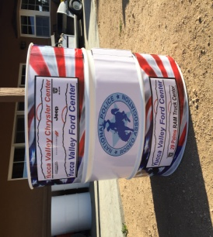

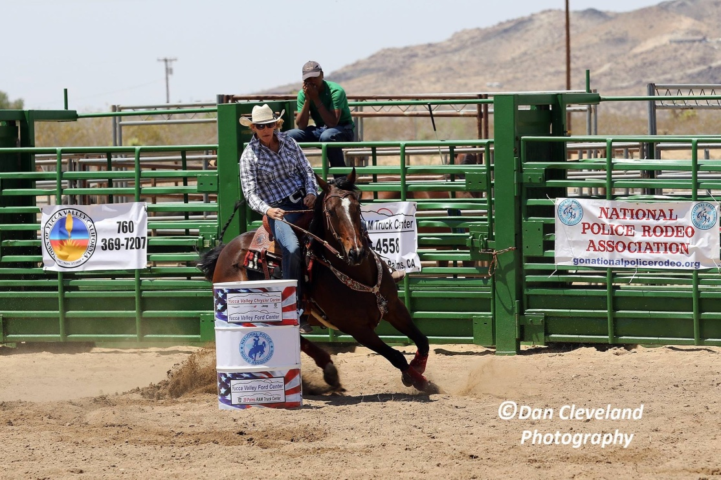
Examples of barrel advertising.

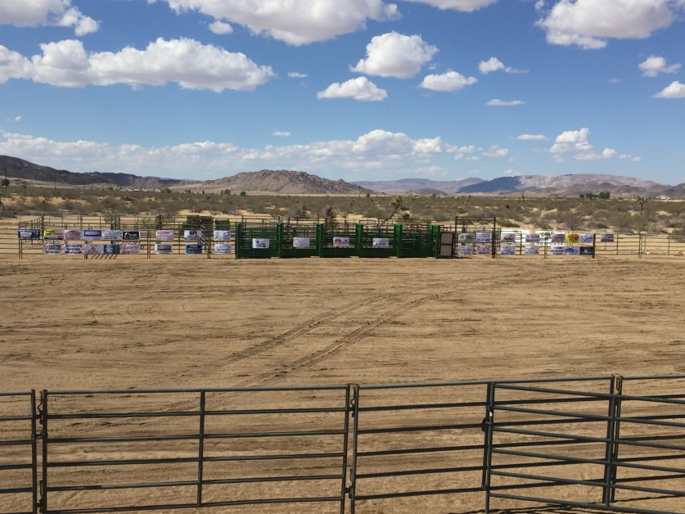
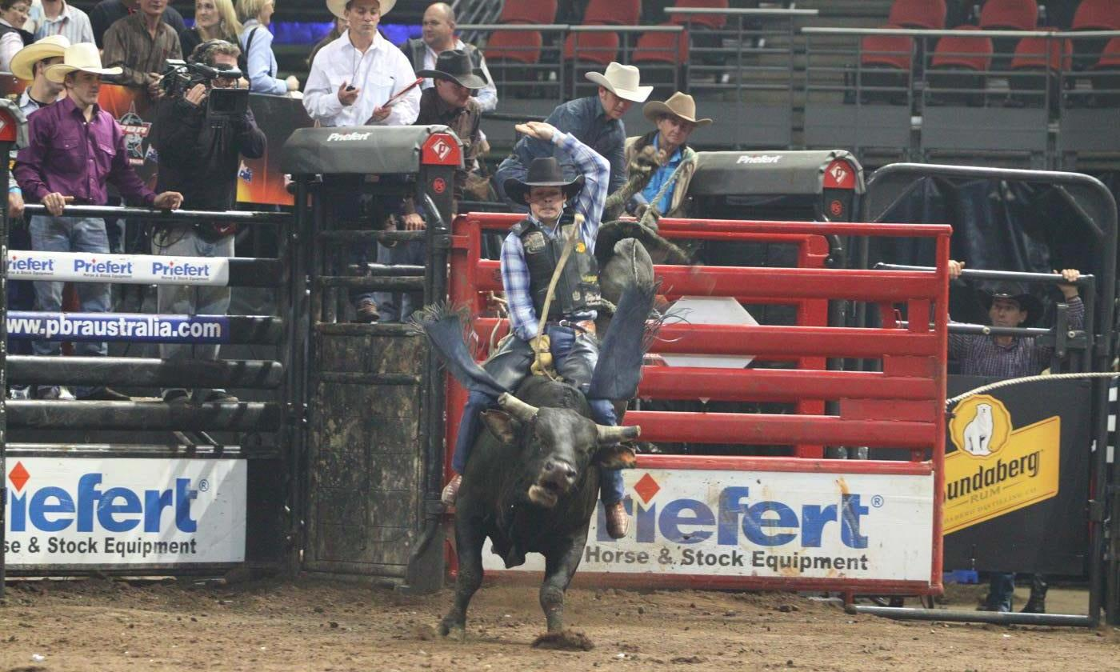Examples of bucking chutes and arena advertising.

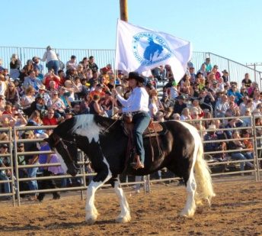
Examples of arena flag’s during Rodeo

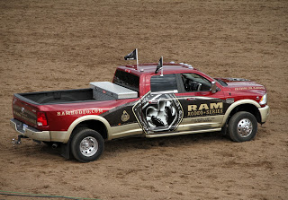
Example of official truck

