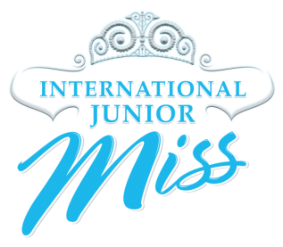
2016 State Pageant Director’s Checklist
International Junior Miss

- Forward a copy of your winner’s registration form to jessica@internationaljrmiss.com.
- Send a list of girls that will be attending appointed/registration forms to jessica@internationaljrmiss.com
- Send scholarship balances to the International Office.
  - Mail to: International Junior Miss, 14419 Greenwood Ave N.
Suite A - #342, Seattle, WA 98133
- Send a copy of the Entrant Statement of Understanding to the International Office. (see address above)
- Send a copy of your Judge’s Acknowledgements to the International Office. (see address above)
- Send a copy of your Signed Rules and Regulations Agreement to the International Office. (see address above)
- Make sure that your girls order their opening number dresses by March 15, 2016. If your pageant is scheduled after March 15, 2016, please make sure that you have submitted estimated sizes for your state queens.
- Plan for an official meeting/workshop with your state queens to help them prepare for Internationals(other than your first meeting after the pageant)
  - Remind your state queens that we will only accept the first 100 talents.
  - Remind your state queens that talent is limited to 90 seconds.
  - Remind your state queens that only one casual wear entry is allowed.
  - Remind your state queens to make their registration appointment starting April 15, 2016.
  - Assist your state queens with hotel reservations.
- Plan for the 2016 Director’s Briefing during Internationals Week, Wednesday, July 20, 2016 at 10: 00 am at The Westin VA Beach.
- Plan for the 2016 – 2017 Director’s Meeting - Labor Day Weekend 2016.

