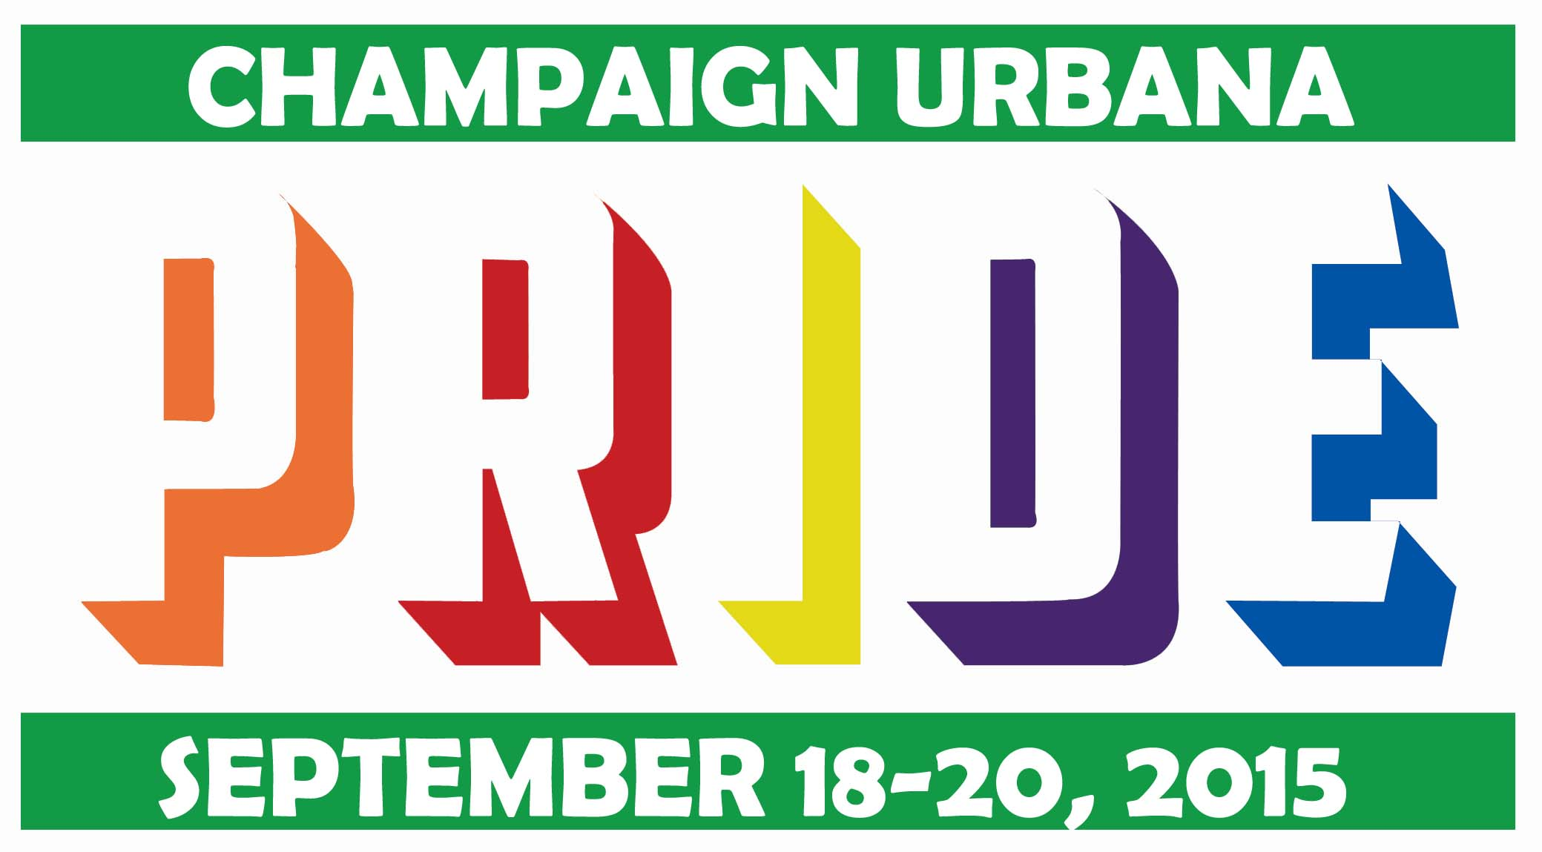

Saturday September 19th - 5:00pm
2015 Entry Form – Deadline: September 4th

Optional Entry Fee Donation:
- $10
- $20
- $50
- Other Amount ____________
- All entries are free but donations are appreciated and will help pay for parade fees.
- Please make checks payable to The UP Center of Champaign County.

Name of Group/Individual: __________________________________________________________________________________
Contact Person: ______________________________________________ E-mail: _______________________________________
Street: __________________________________________________________________________________________________________
City: _____________________________________________ State: ______________________ Zip: ___________________________
Phone: __________________________________________________________________________________________________________

Type of Entry (Check All That Apply)
- Car/Truck/Tractor/Motorized/Animal Drawn
- Band/Marching Unit/Drill Team
- Decorated Float/Mounted/Non-Motorized
- Walking
- Political
- Other ________________________________

Due to specific turns in the route, there are several length maximums as follows:
- Pick-up truck with 27’ trailer (30’ total length)
- Semi cab with 33’ trailer (WB-40)
- 40’ Bus/Truck

Driver and Vehicle information
All drivers must possess a valid driver's license. All vehicles must be insured and registered for the day of the Parade. Vehicles must be in good physical as well as operating condition.

Describe your entry and organization as completely as possible:
_____________________________________________________________________________________________________________________________________________________________________________________________________________________________________________________________________________________________________________________________________________________________________________________________________________________________________________________________________________________________________________________________________________________________________________________________________________________________

Total Length (required): ________________ Feet Number of Decorated Vehicles: ______________________________
Music on entry: ______ Yes ________ No Number of entry participants: Riding ___________ Walking ___________
Are you a performance entry: ______ Yes ______ No If yes, describe: ____________________________________________

Decoration Information
This year’s Pride Festival Theme is Love Wins. Please make sure to represent this theme in your contingencies decorations, signage, etc. Each contingency should be colorful and represent the LGBT* Rainbow colors of Red (light), Orange (healing), Yellow (sun), Green (calmness/nature), Blue (serenity/harmony), and Purple (spirit). If you plan on having confetti, it must be biodegradable.

Mail or email your completed entry form by Friday September 4, 2015:

The UP Center of Champaign County
Attn: Heath Peterson
44 E. Main Street, Suite 516
Champaign, IL 61820
heath@unitingpride.org

