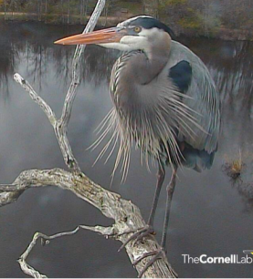

*I’m big, long-necked, with a blue-gray hue,*

*the NestCam brought me my fame.*

*I’m a majestic bird, which you already knew,*

*‘cause “great” is my first name!*

**Size:** about 38-54 inches

**Great Blue Heron**

**Migration Mobile Adventure!**

**Migration Mobile Adventure!**

**Great Blue Heron**



*I’m big, long-necked, with a blue-gray hue,*

*the NestCam brought me my fame.*

*I’m a majestic bird, which you already knew,*

*‘cause “great” is my first name!*

**Size:** about 38-54 inches

**Great Blue Heron**

**Migration Mobile Adventure!**

**Migration Mobile Adventure!**

**Great Blue Heron**

**Size:** about 38-54 inches

*I’m big, long-necked, with a blue-gray hue,*

*the NestCam brought me my fame.*

*I’m a majestic bird, which you already knew,*

*‘cause “great” is my first name!*

**Size:** about 38-54 inches

*I’m big, long-necked, with a blue-gray hue,*

*the NestCam brought me my fame.*

*I’m a majestic bird, which you already knew,*

*‘cause “great” is my first name!*

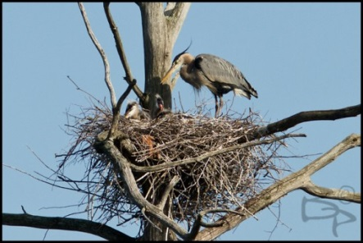

**COOL FACT:** Thanks to specially shaped neck bones, Great Blue Herons can curl their neck into an S shape. This makes it easier to quickly strike prey at a distance, and supports their long neck while flying.

**Eggs:** lay 2-6 eggs, pale blue that fade and blotch with time

**Nest:** Great Blue Herons nests are a large platform of sticks high in dead trees

**Food:** fish, frogs, snakes

**Habitat:** Fresh or saltwater wetlands, often near a forest

**Habitat:** Fresh or saltwater wetlands, often near a forest

**Food:** fish, frogs, snakes

**Nest:** Great Blue Herons nests are a large platform of sticks high in dead trees

**Eggs:** lay 2-6 eggs, pale blue that fade and blotch with time

**COOL FACT:** Thanks to specially shaped neck bones, Great Blue Herons can curl their neck into an S shape. This makes it easier to quickly strike prey at a distance, and supports their long neck while flying.

**Habitat:** Fresh or saltwater wetlands, often near a forest

**Food:** fish, frogs, snakes

**Nest:** Great Blue Herons nests are a large platform of sticks high in dead trees

**Eggs:** lay 2-6 eggs, pale blue that fade and blotch with time

**COOL FACT:** Thanks to specially shaped neck bones, Great Blue Herons can curl their neck into an S shape. This makes it easier to quickly strike prey at a distance, and supports their long neck while flying.

**Nest:** Great Blue Herons nests are a large platform of sticks high in dead trees

**Food:** fish, frogs, snakes

**Habitat:** Fresh or saltwater wetlands, often near a forest

**Eggs:** lay 2-6 eggs, pale blue that fade and blotch with time

**COOL FACT:** Thanks to specially shaped neck bones, Great Blue Herons can curl their neck into an S shape. This makes it easier to quickly strike prey at a distance, and supports their long neck while flying.