IT’S OUR BIRD-DAY, AND WE’LL FLY IF WE WANT TO
By Rachel Lowy and Anne Rosenberg

ITHACA, NY—Who’s your favorite celebirdy? The star of our NestCams, the Great Blue Heron? Or maybe the Wood Thrush, whose song is the most beautiful in the forest? Here at the Cornell Lab of Ornithology, we can’t pick just one, which is why we are celebrating all of them at our 7th annual Migration Celebration, Saturday May 11th, 10:00a.m.-3:00p.m. Admission to this event is free.

Migration Celebration is the largest one-day public event at the Cornell Lab of Ornithology, each year offering more than 1,000 visitors the chance to learn more about birds, as well as the diverse research, conservation, and outreach projects at the Cornell Lab. Migration Celebration is part of International Migratory Bird Day (IMBD), which highlights an annual conservation theme that is celebrated in thousands of events across the hemisphere.

During Migration Celebration, you and your family can take guided walks along the trails of Sapsucker Woods Sanctuary, play a variety of interactive learning games, and experience a wild bird being banded. Children may also get banded like a bird for the day and “migrate” from one exhibit to another while their progress is monitored by scientists! And as always, the popular Cornell Raptor Program will be featured at the celebration with its live eagles, owls, and hawks.

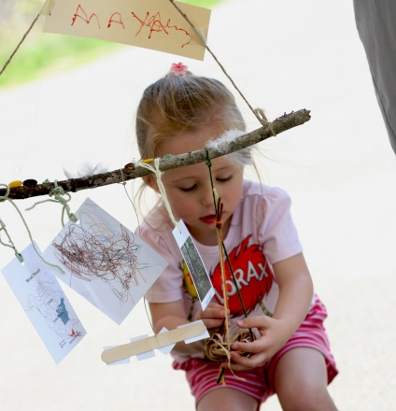
We are pleased to announce that last year’s big hit, the Migration Mobile Adventure, will be featured again this year—this time with a twist! After choosing which migratory bird to feature for your hanging mobile, you will begin your adventure on your bird’s wintering grounds to learn about the habitat you use there. Then you’ll “migrate” through a fun obstacle course to your summer breeding grounds to gather food and build a nest for your bird’s eggs. The final product is a hanging mobile that you can take home to share with friends and family and remind you of all you learned.
Photographer: Alex Chang
Child admiring her completed migration mobile
Don’t miss out on this year’s Migration Celebration, it should be a hoot (and a squawk, and a tweet, and a chirp)!

The Cornell Lab of Ornithology is located at 159 Sapsucker Woods Road in Ithaca. For more information about Migration Celebration call the Cornell Lab at (607) 254-2473 or (800) 843-BIRD or visit www.birds.cornell.edu/birdday.

###

