**Application**

**Send this document and the attachments to**

***[INFO.LABVERDE@GMAIL.COM](mailto:info.labverde@gmail.com" \t "_blank)***

**APPLICATIONS UP TO JANUARY 31TH 2017**

**\*Name and Surname:**

\*Occupation:

\*Birth Date:

\*Nationality:

\*Home Address:

\*City:

\* Country:

\* E-mail:

\* Skype Username:

\*Website:

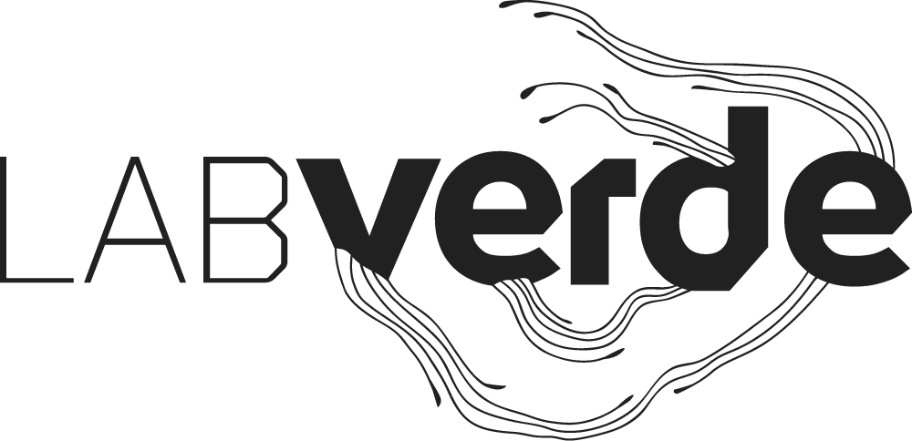

**\*How do you know about the program:**

( ) Facebook

( ) Instagram

( ) E-mail

( ) Residency Unlimited

( ) Resartis

( ) Others \_\_\_\_\_\_\_\_\_\_\_\_\_\_\_\_\_\_\_\_\_\_\_\_

**Attachments**

\*250 word bio

\* 500 word description of a creative project idea

\*5 to 10 images Portfolio

If you would like to apply for a grant, please include a letter of motivation with your application (500 words maximum). The condition for all modalities of grant will be discussed with the selected artist by Skype meeting. **Participants from emerging countries that have been investigating the intersection between art and nature will be prioritized.**