Department of Permanent American Dream

OMB No. ???????????????? ??????- Non Expiring
Form AD-01, Application to Register
American Dream Citizenship and Permanent Dream Services
Permanent Dream Card

START HERE - Type or Print (Use ink you want)
Part 1. Information About You
Family Name (Last Name) :
( optional)
Given Name (First Name) :

Place of Birth (Country and City) :

Place of Residence (Country and City) :

Nationalities:

Date of Birth (mm/dd/yyyy) :

E-mail address :

Part 2. Information About Your American Dream :
Your American Dream is : ( 50 cha max.)

My American Dream :

- has come true ☐ Yes ☐ No
- is happening ☐ Yes ☐ No
- hasn't happened (yet) ☐ Yes ☐ No

Part 3. Signature of Person Preparing Form
☐ I declare that I participate in this art project
☐ I authorize the use of my American Dream card for artistic purposes

Date : Signature :

Sample of your future Permanent Dream Card :

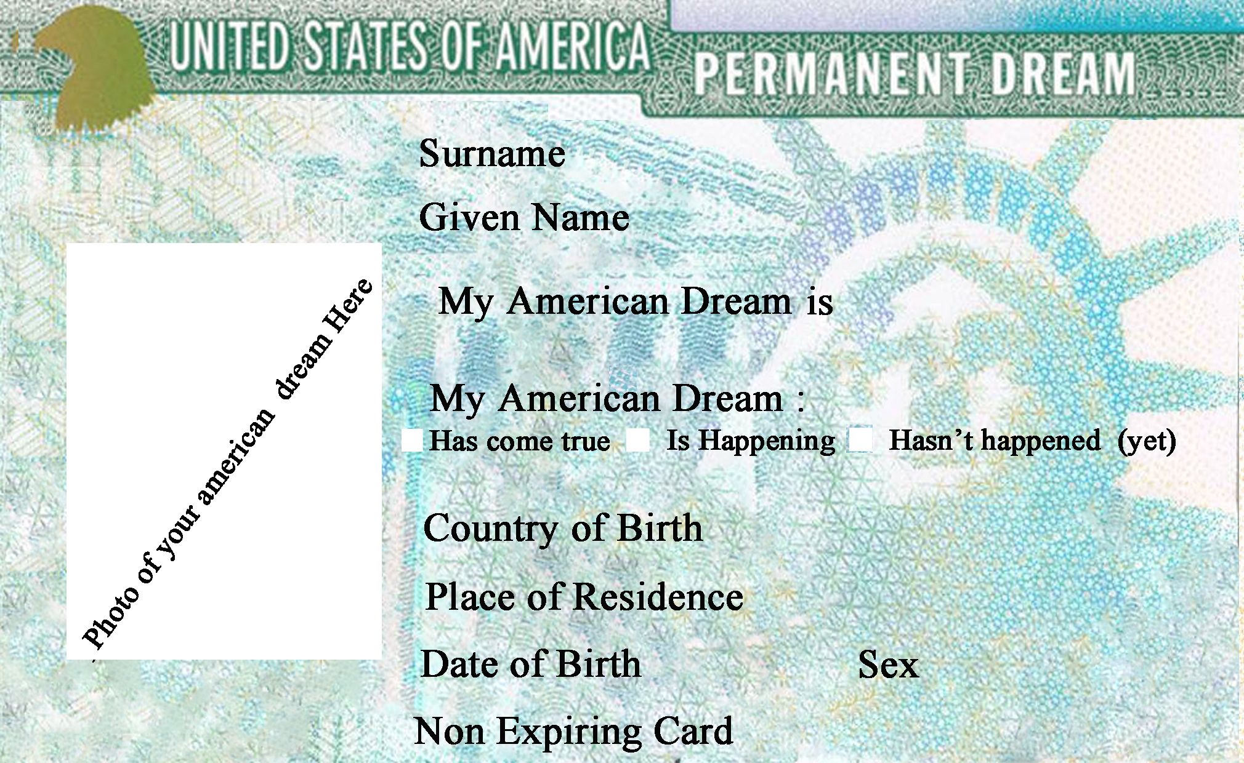

- Important : Don’t forget to send attached to the form a photo of your American DREAM

Send This form at this adress : permanentdreamcard@gmail.com

permanentdreamcard@gmail.com

