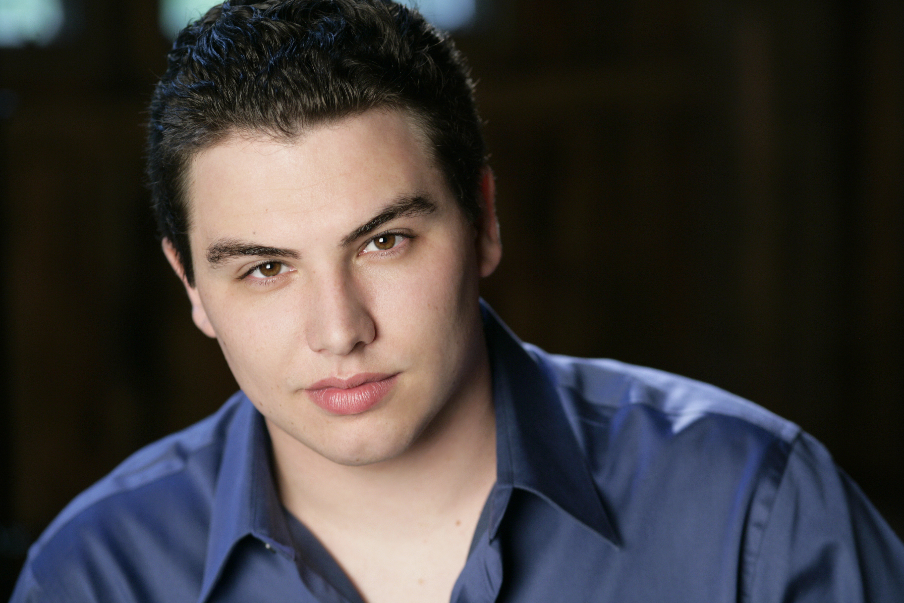
email eric.ferring@gmail.com
phone 563.513.1805
website www.ericferring.com
Eric Ferring
Tenor

Operatic Roles
Gastone/Alfredo* | La traviata | Cedar Rapids Opera Theatre | Upcoming ‘16
Bill | Flight | The Boston Conservatory | Upcoming ‘15
Act II Young Man/Prunier* | La rondine | Opera Theatre of Saint Louis | 2015
Tom Rakewell | The Rake’s Progress | The Boston Conservatory | 2015
Pylade | Iphigénie en Tauride | The Boston Conservatory | 2015
Lacouf | Les mamelles de Tirésias | Wolf Trap Opera | 2014
Remendado* | Carmen | Wolf Trap Opera | 2014
Nanki-Poo | The Mikado | Drake University | 2014
Remendado | Carmen | Cedar Rapids Opera Theatre | 2014
Albert Herring | Albert Herring | Seagle Music Colony | 2013
Lensky | Eugene Onegin | Seagle Music Colony | 2013
Daniel Buchanan | Street Scene | Seagle Music Colony | 2013
Stage Manager | Our Town | Drake University | 2013
Don Ottavio | Don Giovanni | Seagle Music Colony | 2012
Anthony | Sweeney Todd | Seagle Music Colony | 2012
Nemorino | The Elixir of Love | Drake University | 2012
St. Brioche/Camille* | The Merry Widow | Cedar Rapids Opera Theatre | 2012
*Denotes Cover
Training
Master of Music in Opera Performance, The Boston Conservatory, 2016
Bachelor of Music in Vocal Performance, Drake University, 2014
Piano: Cynthia Giunta and Randa Chesney (5 years) Saxophone: Micki Marolf (7 years)
Oratorio & Solo Work
Tenor Soloist: Fort Dodge Choral Society, Haydn’s Creation (2014), Beethoven Mass in C Major (2013)
Tenor Soloist: Drake University, Vaughan Williams’ Hodie (2013)

Orchestral Experience
Conductor: A Hand of Bridge/Old Maid and the Thief (Upcoming ’16), A Chorus Line (2014), Sweeney Todd (2013),
Anything Goes (2012), A Little Night Music (2011)
Assistant Conductor: Le nozze di Figaro (Upcoming ’16), Iphigénie en Tauride (2015)

Musical Accomplishments & Awards
Encouragement Award: Metropolitan Opera National Council Auditions, Iowa District (2015), Nebraska District (2013)
2nd Place: Hal Leonard Vocal Competition: Art Song Division (2014)
Finalist: International Crescendo Music Awards (2nd Place 2013, 3rd Place 2014)
Winner: Central Iowa Symphony Competition and Fort Dodge Symphony Competition (2013)

Programs
Opera Theatre of Saint Louis: Gerdine Young Artist (2015)
Wolf Trap Opera: Studio Artist (2014)
Houston Grand Opera Young Artists Vocal Academy (YAVA): Participant (2014)
Seagle Music Colony: Young Artist (2011, 2012, 2013)
Cedar Rapids Opera: Young Artist (2012, 2013, 2014)

Affiliations
AGMA, Phi Mu Alpha Sinfonia, Pi Kappa Lambda

Voice Teachers | Coaches/Conductors | Stage Directors | Administrators
Kristen Eby | Andrew Altenbach | David Gately | Laura Canning
Dr. Rebecca Folsom | Tyson Deaton | Matthew Ozawa | Daniel Kleinknecht
Leanne Freeman-Miller | Stephen Lord | Nathan Troup | Lee Anne Myslewski
Byron Jones | Eric Melear | Johnathan Pape | Darren Keith Woods

