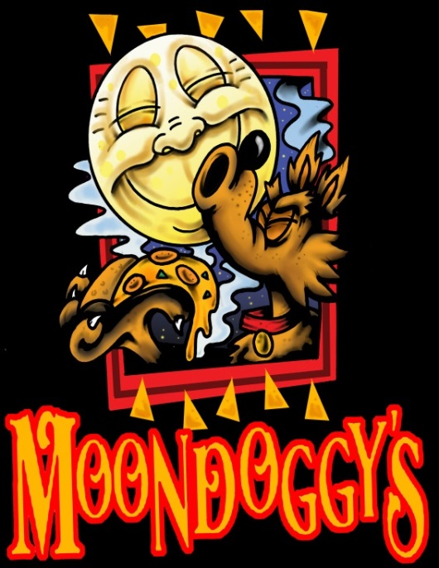
Moondoggy’s Pizza & Pub
November Entertainment
36 Canal Road Plaza, Brunswick, GA 31525
Off of Jetport Rd.
912-264-4888

Friday, November 4th Signal Box 7 to 10pm
Monday, November 7th Josh Nunn and Jaime Rowell 6 to 9pm
Friday, November 11th 3 Day Weekend 7 to 10pm
Saturday, November 12th UFC 205: McGregor Vs. Alvarez: Prelims start at 8pm!
Monday, November 14th Michael Brown & Jaime Rowell 6 to 9pm
Friday, November 18th Flood Brothers 7 to 10pm
Monday, November 21st Nick Bryant 6 to 9pm
Friday, November 25th Touch of Grey 7 to 10pm
Monday, November 28th Chris Ryder & Jaime Rowell 6 to 9pm

