Mission  The mission of LETC is to enhance the Charleston Community through a lifelong commitment to education, economic development and cultural empowerment  LETC Board of Directors  Sharon D. Wigfall  Chair  Carolyn Bennett  Vice Chair  Nina Davis  Secretary  Jenna Richardson  Financial Secretary  Felicia Veasey  Treasurer  Members  Claire Commodore Wheeler  Christine Moore  Naquita Page-Dawson  Sharlonda Tullock  Gwendolyn Whitsell  Ex– Officio  Cheryl Williams  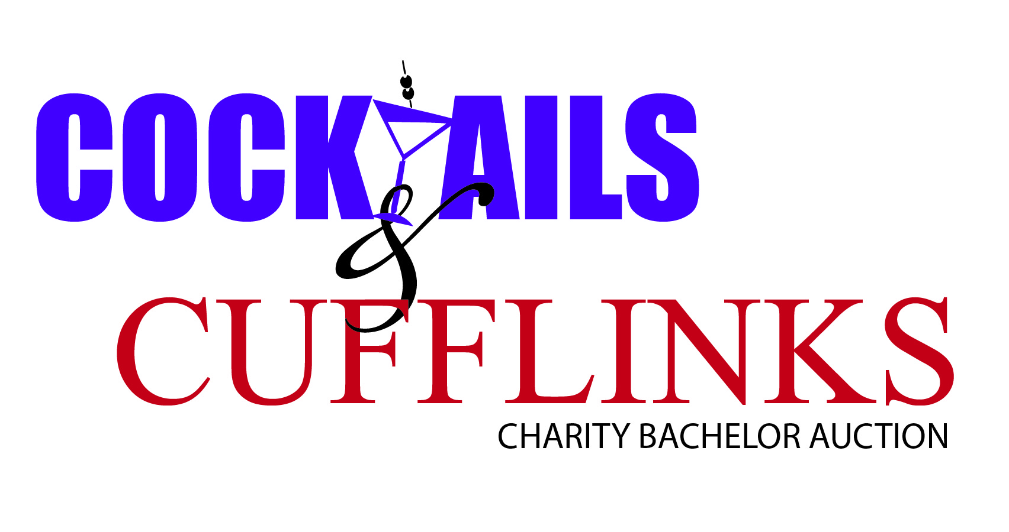 | February 1, 2014  Greetings,  On August 2nd, Ladies Enriching The Community (LETC) will host our inaugural Charity Bachelor Auction, Cufflinks & Cocktails. The event aims to be one of the most anticipated and exciting events in the Charleston area. We are excited about this endeavor and will be announcing the location in the very near future.  We invite you to support the fundraising efforts of our organization by becoming a Sponsor for the Charity Bachelor Auction. As a sponsor, you will be entitled to benefits listed on the attached sponsor form. This event will be an excellent opportunity for marketing and building awareness for your organization within the Charleston community.  In 2001, members of the Charleston Alumnae Chapter of Delta Sigma Theta Sorority, Inc. rallied together to establish a 501(c) (3) status Foundation named Ladies Enriching The Community, LETC. LETC’s purpose is to enhance the Charleston community through a lifelong commitment to education, economic, and cultural empowerment. The proceeds from the Bachelor Auction will provide financial resources for LETC to continue its community-based programming. Since establishment, some of the initiatives that have benefited from our efforts include:  - Donating more than $10,000 to literacy organizations such as Palmetto Project-Begin with Books, Moja’s 4th Grade Read Out and to local k-12 schools  - Participating in Kids Fair and hosting book fairs that have provided 1,000 books to lowcountry youth  - Providing physical resources that enable community groups to plan and implement mentoring and community initiatives, such as the Charleston Youth Leadership Council, Delta G.E.M.S, Charleston Pan Hellenic Council and “Helping A Sista Out" Seminar  - Cosponsoring the “Off the Wall & Onto the Stage” cultural production including the educational outreach events that reached 5,000 tri-county students  In addition, your sponsorship will help reinforce our vision of housing and sustaining a computer lab for underserved families in Charleston County. The goal of this initiative is to provide learning opportunities through the use of modern computer technology for people within their immediate community to take free computer literacy and life skills classes.  We hope that we can count on your support. Please consider completing and mailing in your sponsor form today. If you have questions, concerns or require additional information, please contact Nina Davis (nomdavis2@gmail.com, 843-276-0741), Sponsorship Chair.  Thank you in advance for considering our request and for your support of our youth and community.  Sincerely,  Sharon Wigfall  LETC Board Chair
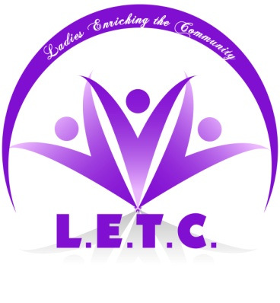

BACHELOR AUCTION SPONSORSHIP
Platinum Sponsorship Level - $1,200.00  Company Name & Logo in Event Program  full page Ad, w/ 30 second Video Loop during event, table for product sampling, gift or marketing pieces (sponsor to provide materials for table), Logo on website, Logo on all printed marketing materials during & prior to event, & six (6) Preferred Seating tickets to Auction.  Gold Sponsorship Level - $600.00  Company Name & Logo in Event Program  half page program Ad, Logo on Website, & Company Name mention on all printed marketing materials during & prior to event, & four (4) Preferred Seating tickets to Auction.  Silver Sponsorship Level - $300.00  Black & White Small Logo in Event Program &  Company Name mention on printed marketing  materials during event, & two (2) General  Admission tickets to Auction.  In Kind Sponsorship (Product or Service)  (for bachelor packages)  Company Name & Logo in Event Program and website, acknowledgement during bachelor presentation  Individual Donation  For participants who wish to donate to a good cause, acknowledgement in event program |  | Saturday, August, 2nd 2014  Ladies Enriching The Community (LETC) is proud to present the 1st Annual “Cocktails & Cufflinks” Bachelor Auction, a charity event to raise funds in support of LETC’s literacy programs and services. The money raised from this event has been earmarked to help the Foundation provide a community computer lab that will be used by youth, boomers and seniors, acknowledging that there are some in every generation being left behind the times technologically speaking.  This highly anticipated evening includes music, entertainment, high-end silent auction items and the auction of approximately 15 eligible bachelors. Attendees will be able to bid on several exciting packages, while supporting a vital cause to bridge the technological gap in our community.  This Charity Bachelor Auction aims to be the Foundation’s largest fundraiser and we are turning to you for help and support to boost interest in the event. You or your company can help by donating gift certificates, auction items, unique opportunities, or by contributing cash sponsorships. All contributions are tax deductible to the fullest extent of the law. A statement will be sent following the event.  For your support, you will receive: Marketing Package as stated on the left according to monetary donation given, and/or retail amount in the equivalent to the amount in package chosen.  Please submit all donations and marketing materials by July 12, 2014. Your contribution will not go unrecognized. *(Art must be 300 dpi or higher for marketing materials)
Ladies Enriching The Community  P.O. Box 80815  Charleston, SC 29416  Primary Event Contact  Nina Davis  Sponsorship Chair  843-276-0741  Alternate Event Contact  Jenna Richardson  Auction Co-Chair  770-864-2928  Contributions are tax deductible to the extent permissible by law. | In-Kind Donor Information  Please provide description of donated items. Ensure all items are transferrable and any restrictions and/or blackout dates are included on the certificate.  Item Description / Retail Value  For Certificates: Please make expiration date at least one year from date of event. PLEASE INCLUDE CERTIFICATE ON YOUR LETTERHEAD stating what the winner receives, applicable restrictions and/or blackout dates and whom they should contact for additional information. Include any brochures or information about the items.
 | Name or Company Name  Contact Name/Title  Phone & Email Address  Address  Address  THANK YOU FOR YOUR SUPPORT! |  | SPONSORSHIP LEVELS  - Platinum Sponsor …………...$1,200  - Gold Sponsor ………………….$600  - Silver Sponsor …………………$300  .00  - Other Amount ………….….  - In Kind Sponsor  Method of Payment:  - Check - mail to address above with copy of form.  - PayPal - via website - www.letcinc.org

SILENT AUCTION SUPPORTER
Saturday, August, 2nd 2014

Ladies Enriching The Community (LETC) is proud to present the 1st Annual “Cocktails & Cufflinks” Bachelor Auction, a charity event to raise funds in support of LETC’s literacy programs and services. The money raised from this event has been earmarked to help the Foundation provide a community computer lab that will be used by youth, boomers and seniors, acknowledging that there are technological gaps in every generation. This highly anticipated evening includes music, entertainment, high-end raffles and the auction of approximately 15 eligible bachelors. Attendees will be able to bid on several exciting packages, while supporting a vital cause to bridge the technological gap here in the Charleston community.

This Charity Bachelor Auction aims to be the Foundation’s largest fundraiser and we are turning to you for help and support to boost interest in the event. Another exciting way to get involved in the Charity Bachelor Auction is to provide an item for the silent auction. Your name or company name will be recognized when it is prominently displayed along with the auction item. This type of donation is a great way to show your support and generate interest in your product or service..

By sponsoring this event you will be promoting your company to a group of people who are very loyal to its sponsors, as well as to the many area professionals who will be attending the Charity Auction itself. Companies like yours make available the resources that enrich our communities and enhance our children’s education and for that we are forever grateful.

Please submit all donations and marketing materials by July 12, 2014. Your contribution will not go unrecognized. *(Art must be 300 dpi or higher for marketing materials)
Ladies Enriching The Community  P.O. Box 80815  Charleston, SC 29416  Primary Event Contact  Nina Davis  Sponsorship Chair  843-276-0741  Alternate Event Contact  Jenna Richardson  Auction Co-Chair  770-864-2928  Contributions are tax deductible to the extent permissible by law. | Silent Auction Donor Information  Please provide description of donated items. Ensure all items are transferrable and any restrictions and/or blackout dates are included on the certificate..  Item Description  $ $  Wholesale Value Retail Value  For Certificates: Please make expiration date at least one year from date of event. PLEASE INCLUDE CERTIFICATE ON YOUR LETTERHEAD stating what the winner receives, applicable restrictions and/or blackout dates and whom they should contact for additional information. Include any brochures or information about the items.
Name or Company Name

Contact Name/Title

Phone & Email Address

Address

Address

THANK YOU FOR YOUR SUPPORT!

