Precision Research & Design
Bank of America
Mobile Banking
Ashlee Blair
Daniel Carey
Stephanie Fortna
Brandi Stricklin
8/4/2011

Table of Contents

- Introduction: Main Challenge ……………. 2
- Industry Description ……………………… 3
- Brand Analysis…………………………..... 8
- SWOT Analysis………………………….... 10
- Business Model …………………. ………. 13
- Digital Marketing ………………………… 16
- Suggested Solution ……………………….. 21
- Exhibits …………………………………… 23
- References ………………………………… 26

Introduction
Bank of America launched mobile banking in May 2007. Mobile Banking lets customers easily and securely access balance information, pay bills with optional Bill Pay service, transfer funds, and find nearby ATMs and banking centers through a mobile application on their smartphones, and through mobile web on their phone browser.
Main Challenge
WHAT: Increasing overall growth in mobile banking in the financial services industry. Douglas Brown Senior Vice President of Mobile Product Development was quoted, “In less than 3 years we have four million mobile banking customers. That’s an adoption rate almost five to eight times that of our online banking several years ago.” Line-of-business managers are looking for leveraged mobile platforms to meet the needs of their specific businesses. The capabilities of mobile banking through the use of your smartphones or mobile web have become popular with today’s bank customers.
WHO:
- Jen McDonald, SVP of Bank of America (Digital Marketing Group)
- Douglas Brown, SVP of Bank of America (Mobile Product Development)
- David Carrel, SVP of Starcom Agency (Strategy and Analysis)
WHEN: January 2010
WHERE: Bank of America Headquarters; Charlotte, NC
WHY: Functionality of apps to meet different needs and specific businesses. By providing apps to the different target groups such as: Merrill Lynch brokerage, mortgages, credit cards, consumer payments, etc…
HOW: Should there be an increase in functionality of current apps? By increasing the functionality could come with risks of losing high-profiles in the marketplace because of a slowdown in the app. The complexity of the app could deter the user away to a more simplistic app from one of the competitors.
Build new apps? Building new apps would mean the opportunity cost is much higher if they were to take necessary resources away from other important business segments. At the same time this could add to the customization that customers are looking for from their financial institution.
And finally, do they refuse altogether to add complexity to current apps? It might be best to just optimize the current application and keep the complexity away to not deter current customers.
Industry description
Financial Banking
Bank of America competes in the financial banking industry. The finance industry encompasses an array of organizations that deal with the management of money. Among these organizations are credit unions, banks, credit card companies, insurance companies, consumer finance companies, stock brokerages, investment funds and some government sponsored enterprises. As of 2004, the financial services industry represented 20% of the market capitalization of the S&P 500 in the United States.
Bank of America (BofA) is an American global financial services company, the largest bank holding company in the United States, by assets, and the second largest bank by market capitalization. (See Exhibit 1 for BofA Assets breakdown.) Bank of America serves clients in more than 150 countries and has a relationship with 99% of the U.S. Fortune 500 companies and 83% of the Fortune Global 500. The company is a member of the Federal Deposit Insurance Corporation (FDIC) and a component of both the S&P 500 Index and the Dow Jones Industrial Average.
As of 2010, Bank of America is the 5th largest company in the United States by total revenue as well as the second largest non-oil company in the U.S, after Wal-Mart. In 2010, Forbes listed Bank of America as the 3rd "best" largest company in the world.
The bank's 2008 acquisition of Merrill Lynch made Bank of America the world's largest wealth manager and a major player in the investment banking industry.
The company holds 12.2% of all U.S. deposits, as of August 2009, and is one of the Big Four banks of the United States, along with Citigroup, JPMorgan Chase and Wells Fargo—its main competitors. According to its 2010 annual report, Bank of America operates in all 50 states, the District of Columbia and more than 40 non-U.S. countries. It has a retail banking footprint that covers approximately 80 percent of the U.S. population and in the U.S. it serves approximately 57 million consumer and small business relationships at 5,900 banking centers and 18,000 ATMs.

Mobile Banking
In 2007, Bank of America launched its mobile banking. Mobile banking is a term used for performing balance checks, account transactions, payments, credit applications and other banking transactions through a mobile device such as a mobile phone or Personal Digital Assistant (PDA). The earliest mobile banking services were offered over SMS. With the introduction of the first primitive smart phones with WAP support enabling the use of the mobile web in 1999, the first European banks started to offer mobile banking on this platform to their customers].
Mobile banking has until recently most often been performed via SMS or the Mobile Web. Apple's initial success with the iPhone and the rapid growth of phones based on Google's Android have led to increasing use of special client programs, called apps, downloaded to the mobile device. See Exhibit 2 for a breakdown of U.S. Mobile Users and Banking Transactions. With the use of Bank of America’s new service app, consumers will be able to:
- Check account balances for checking, savings and credit card accounts, as well as mortgages and home equity lines held with Bank of America.
- Pay bills.
- Transfer funds between Bank of America accounts.
- View transaction details for Bank of America checking and savings accounts, mortgages and home equity lines, including posted, pending and scheduled transactions.
To help protect customer information, the bank has developed a security feature that ensures that information sent between the bank and the mobile device remains encrypted.
To activate mobile banking, customers must register through the bank's Online Banking service at Bankofamerica.com. Once registered, customers can use the Internet browser on their mobile phones to conveniently access their accounts from anywhere, anytime.
Competition
Bank of America’s competitors consist of JPMorgan Chase, CitiGroup and Wells Fargo. (See Exhibit 3 for a breakdown of major players’ market share.) In 2010, Bank of America was #1 in market share for retail deposits, #1 in online banking capabilities with 29.3 million active users and #1 in mobile banking wit 6.4 million active users. However, JPMorgan Chase leads the financial industry in overall net income by $17,370 million and a market capital of $166 billion in 2010. (See Exhibit 4 for a list of competitors and breakdowns in net income, assets, market capital and equity.) The reason why JPMorgan Chase is so far ahead of the game in today’s mobile banking is because they are taking advantage of advanced technology. JPMorgan also created an application for Apple’s iPhone which enables a customer to take a check and deposit it into their bank account without actually having to go to a branch or ATM machine. All you have to do is take a picture of your check and the funds are then deposited into your account. In order for Bank of America to compete with such an empowering company they too will have to acquire more features to benefit different consumer needs.
Industry Trends
Three important trends that affect the financial banking industry is the economic downturn, government regulation changes and, of course, Web 2.0.
Market conditions and economic trends have adversely affected the banking industry. The U.S. is operating in a challenging and uncertain economic environment, including generally uncertain conditions nationally and locally in our markets. Financial institutions continue to be affected by declines in the real estate market that have negatively impacted the credit performance of mortgage, construction and commercial real estate loans and resulted in significant write-downs of assets by many financial institutions. Concerns over the stability of the financial markets and the economy have resulted in decreased lending by financial institutions to their customers and to each other.
Government regulations also affect the financial banking industry. For example, the Dodd-Frank Consumer Protection Act passed in 2010 by President Obama, to promote the financial stability of the United States by improving accountability and transparency in the financial system, to protect the American taxpayer by ending bailouts and to protect consumers from abusive financial services practices.
Lastly, the technological changes of today’s social media have an effect on the financial banking industry. Many banks are learning the era of Web 2.0 and how to better promote themselves via Facebook and/or Twitter to build their brand name, gain control and focus on increasing customer retention rates. If these institutions do not prepare themselves for the future of mobile banking, it could really take a toll on those companies, destroy their brand image and possibly become an obsolete name.

Brand analysis
Price
Free
Product
Mobile Banking is broken into three segments; Mobile Website, Text Banking, and Mobile Apps
Mobile website
P

- ay your bills whenever you want with optional online Bill Pay. Check your balances on checking accounts, savings accounts and credit cards. Transfer funds immediately to any other Bank of America account. Locate banking centers or ATMs, along with maps and directions.
Text banking
Use text message banking to request information about your checking, savings and credit card accounts. Getting the answers you need is simple when it's received within seconds on your phone.
Mobile apps
Mobile Banking App, designed specifically for iPhone®, iPad®, Windows® Phone, BlackBerry®, HP® webOS™ and Android™ devices. Wherever you are, you'll have easy access to your Bank of America accounts with their quick and convenient Mobile Banking App

Place
Convenient access to your bank accounts anywhere, anytime. Mobile banking allows convenience to consumers so that banking can be done anywhere.
Promotion
There are several distribution capabilities for Bank of America. Let’s look at the main forms of digital marketing; Mobile, Online, Onsite, and Social Media.
Mobile – Launch in 2008, provides the consumer with a more intimate channel for the promotion. Customers would eventually sign up to receive text messages (SMS) of special offers available to them.
Online – YouTube, Twitter, Hulu, Xbox game applications were heavy players in Bank of America’s online presence. BoA conducts test-control experiments, surveys and graphical display ads with their top client Google.
Onsite – Bank of America has over 5800 bank branches, 18,000+ ATM’s, along with the bank’s website to help promote the right message to the banking customers.
Social Media – Although not a strong presence on Facebook, Bank of America’s Twitter and YouTube provide as great help tools to consumers. Interaction becomes instant and problems can be made apparent to the bank and answers can come quickly to the consumer that is on the move.

SWOT ANALYSIS
Strengths
Banking Supermarket – Bank of America offers a vast array of products through its three main segments. One of the largest U.S. banks because of the vast array of products offered (deposits, debit and credit cards, mortgage loans, global wealth management, middle market lending, large corporate lending, global treasury services, investment banking).
International – Not only are they located in 50 states, Dominica Republic, and also 40 foreign countries as well. They currently have over 53 million customers.
Twitter & YouTube Presence – Strong presence on Twitter and YouTube, by providing help topics on Twitter and educational videos that allow the consumer to find answers to their questions they might have.
Partners of MLB – The official bank of Major League Baseball because they both represent the American culture through optimistic spirit and a sense of community. Bank of America is leveraging its sponsorship of the MLB All-Star Game to deploy more than 250 associate volunteers to assist in baseball-themed community events benefits and giving back to the community.
Weaknesses
Brand image – Bank of America took a huge hit in brand image when they acquired Countrywide, MBNA, Merrill Lynch. Rumors of Bank of America becoming nationalized hit hard in 2009. TARP funds that Bank of America acquired from the government contributed to this bad rumor and lead to the ultimate demise of the former CEO Kenneth Lewis.
Fees – Bank of America is known for fees that are charged to the customer.
Opportunities
Social Networking – Maybe increase their presence on other social media outlets and try to help increase a better image of how a bank can be positive even if consumer confidence is low.
Mergers & Acquisitions - Bank of America Corporation has relied heavily on mergers and acquisitions to increase its customer base, expand range of operation, cut operational costs, or acquire talent or technologies.
Threats
Downturn Economic Cycle – Bank insolvencies have grown since the market downturn causing an unstable market for most major financial institutions. Consumer confidences in banks dropped dramatically when Wall Street fell to a screeching halt.
Interest Rates - Bank of America is directly and indirectly affected by market conditions changes in interest rates could adversely affect net interest margin.
Consumer Payment - U.S. consumers have increasingly used credit cards to pay for more purchases than cash or checks, a trend that continued since then. In addition to credit cards, debit cards and electronic payments (like PayPal) have taken market share away from more traditional means of payment. One particular technology driving increased usage of credit cards is contact-less payments which do not require a swiping through a machine. J.P. Morgan Chase has become a prominent contender in this market already.
Government Regulation - The addition of future regulation could impact the operation of Bank of America in particular or the industry as a whole. Transparency through the Dodd-Frank Consumer Protection Act will help protect the consumer for any future chance their bank fall victim like several did in 2008 and 2009.
Competitive Advantage
Strong commitment to diversity - Bank of America is one of the world's largest financial institutions, serving individual consumers, small- and middle-market businesses and large corporations with a full range of banking, investing, asset management and other financial and risk management products and services.
Brand Unique Selling Proposition
Unmatched Convenience - The Company provides unmatched convenience in the United States, serving approximately 57 million consumer and small business relationships with approximately 5,900 retail banking offices and approximately 18,000 ATMs and award winning online banking with 29 million active users.
Customer driven company – Bank of America will provide clarity, choice, control, and the best products, advice and service for their customers’ and clients’ financial needs.
Attributes and Benefits
Mobile banking offers another opportunity channel for customers to help differentiate their needs. Bank of America has opened lines of communication up to reach their customer base and try to meet the needs they express. Higher level of engagement would lead to increased customer retention and higher income.
Business Model
At Bank of America, they pride themselves on the fact that they are a banking supermarket. They serve all different sectors of the banking industry which they break down into three distinct segments.
The first of these is the global consumer and small business banking segment which is widely considered as the bread and butter of Bank of Americas business model. It is here that they see to the needs of their individual customers as well as provide small business loans to new ventures just taking shape. Much of the public perception about Bank of America is formed by how they interact with this segment of their business so it is of vital importance they keep them happy.
The next segment is the global corporate and investment banking segment. This is where big businesses come to borrow from the bank and also to enlist investment opportunities. Bank of America makes a good deal of its money from this segment and must keep them completely happy with the service otherwise they risk losing them to one of their many competitors.
Lastly we have the Global wealth and investment management group. In this segment, bank of America extends out of America and seeks out investments opportunities abroad. Many of their competitors do not have the resources or capabilities to reach as far as Bank of America does so this segment provides them a good competitive advantage. However, there are of course banks in other countries with whom they must compete with.
Now that we are familiar with the segments Bank of America actively targets and does business with, we must delve into their actual market strategy which can be summed up by five points. The first point is that they deal with three types of customers; individuals, companies, and institutional investors. The next point they focus on is that they want to deliver all of their capabilities not only to their customers in the United States, but to those all over the world. Third, they provide all their capabilities on an integrated basis so that they can meet the very different needs of all customers. Fourth, they strive to create long-term relationships with their customers and gain an exchange of values for what they provide. Lastly, they look to provide consistent long term share holder value, serve their customers and clients, and create unmatched opportunities for their employees. It is through these strategies that Bank of America was able to achieve the majority market share of the US banking industry and they hope that they can provide them with the necessary tools in the future to maintain that position.
Bank of America, like most American financial institutions, has had to deal with a lot of adversity in the wake of the economic collapse of 2008 and the fall of the real estate market. Prior to this, in 2007 they posted nearly 160 billion dollars in revenue and a net margin of 14% and were the clear choice for banking in the United States. However, in 2008 they saw that net margin plummet to less than 5% and in the last year, 2010, it dropped into the negatives. So far in 2011 the bleeding does not appear to be stopping as they are projected to have a -14% net margin. So in the span of 5 years they went from positive 14% to negative 14%.
As for the future earnings for Bank of America, let’s not get it twisted and say they are not making money because they are. In 2010 they posted revenue of nearly 140 Billion dollars. However, they have a lot of debt tied up in the real estate collapse so even with their high revenue; they are in very bad shape as a whole. We expect no more than a 2% increase in revenue over the next few years which will bring them to around 150 Billion in 2015. This little growth will most certainly have them lose their place as market leader and could begin a slippery slope for the bank.
All the banks in the United States were hurt by the economy’s collapse in 2008. So how is it that some have already recovered and are beginning to flourish in this new economic environment? The answer is technology and partnership.
Wells Fargo in 2007 saw revenue of nearly 130 billion dollars and a 16% net margin only to have the floor fall out from under them and wrap up 2008 with a 5 % net margin and non-existent revenue. So how is it that today they are projected to make well over 130 Billion in revenue and see their net margin back up to 12%? They were proactive and along with improving their mobile and online banking capabilities, they also partnered with another successful but struggling bank in Wachovia, doubling their customer base overnight and making them a major player in the new market. By being proactive and taking what the market was giving them, Wells Fargo is back in the black and seeing an endless stream of other banks unsatisfied customers flooding its lobbies.
J.P. Morgan Chase has been the real winner in this stressful and difficult economic climate. Their revenue has not waivered one bit from 2007- 2011, holding steady at over 120 Billion dollars. Their net margin on the other had did plummet in 2008 but by 2009 they were trending back up and by 2011 they are right back where they were in 2007 at 18%. So what is their secret? They listen to what their customers want and they make it happen.
Chase anticipated the smart phone boom extremely well and knew that their customers were going to want banking functionality eventually on their phones since seemingly everything else had an application. Rather than putting something simple and basic together like many other banks were where consumers could track their balance but not much else, Chase went into developing industry changing ideas to set their applications apart from everyone else’s. It was this commitment to innovation that has made them the favorite to overtake Bank of America as the market leader. One of the features that came from this research is a new way to deposit paper checks without ever leaving your couch. All you have to do on the Chase application is take a picture of both sides of your check and they amount will be deposited directly into your account. No paper work to fill out or long lines to stand in, completely hassle free. For those customers who have yet to purchase a smart phone they have implemented a similar idea into all of their ATM’s, simply slide your check into the designated slot and the machine does the rest, no paper work and no delay.
The future of the banking industry is going to rely heavily on which banks can adapt to the ever changing technologies of the day and most easily and accurately meet their customers’ needs through these new mediums. The days of waiting in line for a bank teller are becoming numbered and it is up to the banks to adapt with the changing environment or become obsolete and replaced.
Digital Marketing
Bank of America’s digital marketing strategy is currently based on online services and has recently integrated services via mobile platforms. “We continuously look at ways in which we may effectively use new technology to make banking easier, faster and more convenient for consumers,” exclaimed Jen McDonald, head of the Bank of America Corporation’s Digital Marketing group. Bank of America used online marketing, via “search and display ads, videos at sites such as YouTube and Hulu, in-game applications for X-Box and other systems, and email marketing.”

Social Media
People have the opportunity to utilize social media outlets in order to learn more about Bank of America, get tips from company reps, read up on recent news of the company, and even receive help. Social media has proven to be the newest form of customer service, reaching out to the consumer by being readily available in a manner convenient for the changing world of Web 2.0.
Twitter
Bank of America has a strong presence on Twitter. They use multiple Twitter accounts to communicate to the social community. The official Twitter accounts managed by Bank of America are: @BofA Community which “provides information about how Bank of America is empowering consumers, supporting communities & fueling economic growth in the markets we serve.” @BofA_News is “the official Bank of America news handle on Twitter, providing relevant, up to date information on the company.” @BofA Help is comprised of “official Bank of America Twitter reps, here to help, listen & learn from our customers. Tweet with Bank of America reps 8-8 ET Mon-Fri and 9-1 ET on Sat.” @BofA_Tips “provides information to help you get the most from your money with tips on shopping, travel and personal finance solutions.” @BofA_Careers “is where you can stay connected to featured job opportunities at Bank of America.” Their social media presence on Twitter has proven to be effective, with daily feedback from consumers that are helping make Bank of America a better business and improve performance.

Facebook
Bank of America’s presence on Facebook is minimal compared to that of their social media efforts seen on Twitter. When researching Bank of America on Facebook, multiple accounts appear. It is unclear whether Bank of America has a true Facebook account being managed by their employees. It appears that the Bank of America Facebook accounts that appear when users search for the company are not actually controlled by Bank of America representatives. The Facebook pages show a plethora of complaints from the company’s unhappy customers, which most companies that utilize their Facebook accounts would take time respond to in order to reach out and help the customers that are expressing these grievances. Because Bank of America does not appear to be active in servicing their complaints through their Facebook account, one might question if it was a customer, rather than an approved Bank of America representative, that created these Facebook accounts. The company’s social presence is highly developed on Twitter, but without assessing other social media outlets, they can lose control of their desired brand image due to these unmanaged Facebook accounts that leave customer complaints on display for the whole social media network to see.
YouTube
In addition to Twitter, Bank of America does address social media through the popular video site known as YouTube. Users can go to the YouTube website and search for Bank of America, where Bank of America has invested in sponsored searches to be the first user that appears in the list of video results from the search. Users can then click on the official Bank of America promoted video to go directly to the company’s YouTube channel. Bank of America has uploaded over 60 videos to their YouTube channel, which are organized into different categories to appeal to specific viewers. Their video groups are labeled clearly for users to navigate the site and find the video they want to watch. The groups on their channel are: 2011 Student Leadership Summit, Small Businesses, Community, Non Profit Organization, and Environment.
Mobile Apps
iPhone®, iPad®, Windows® Phone, BlackBerry®, HP®, webOS™, Android™
Bank of America has recently begun to develop a stronger and more significant mobile presence to coincide with the nation’s increasing number of Smartphone users. Bank of America’s mobile efforts are significantly focused on competing with the advanced elements on other popular banking applications, such as the QuickDeposit feature offered through the Chase Mobile SM app, and the Virtual Wallet® feature seen in PNC Bank’s mobile banking app. In order for Bank of America to maintain their status as a frontrunner in the American banking industry, they must develop their mobile application to keep up with their competitors. By Bank of America not adding newly available technological features to their app, which other banks are beginning to implement, they might be putting themselves at risk of becoming obsolete in the ever-changing world of Web 2.0. If Bank of America chooses to add features to their application to meet their customers’ growing needs, they can appeal to a wider community of Smartphone users. If customers are happy with the features of their mobile banking app, there is a greater chance they will stay with Bank of America, versus switching to a new bank to take advantage of the conveniences they offer.
Search Engine Optimization
“We are a top client of Google, and among the top 20 advertisers in the industry,” explained Michael Bailey, senior vice president, Online Marketing. “In the past, a large percentage of our budget went into search for lead generation and customer acquisition. But now we spend significantly more on graphical display ads for integrated programs.” Although Bank of America has chosen to focus on display ads more than Search Engine Optimization, they can still be easily found through popular search engines. People can search for the company on Google and navigate through the first page of links to quickly access Bank of America’s website.
Sponsored Searches
In addition to investing in Search Engine Optimization, Bank of America’s digital efforts also have been put towards sponsored searches. On Google, when people search for the company, the Bank of America homepage appears in a box at the very top of the page. This is also true of Bank of America’s YouTube channel when users search for them on YouTube.com. YouTube displays promoted videos at the top of the page when people search through their videos, and Bank of America’s video is the first that pops up when searched on their site.
Website
Bank of America Corporation’s website has a multitude of features that appeal to consumers and investors alike. Bank, Borrow, Invest, Protect, & Plan are the main headings that can be found on their homepage. Navigating through these links, consumers can find information about the many services that Bank of America offers, from credit cards, to investing, borrowing loans, managing accounts, planning for retirement, and purchasing insurance. A dominantly advertised feature on their homepage is the mobile banking application for Smartphones.
E-commerce
One form of Ecommerce Bank of America participates in is their online Merchant Services. Business owners with websites can use Bank of America’s Merchant Services to accept credit cards, debit cards, electronic checks, gift cards, and other payment options directly over the Internet for their customers to make purchases from their site.
Suggested Solution
Bank of America has done a great job of taking advantage of new technology and providing a convenient and intuitive application to their customers. However, if they intend to continue to grow this segment of their business and make mobile banking a staple of BoA, they must continue to innovate and keep up with their competitors.
J.P. Morgan Chase has become the biggest threat to Bank of America as they are widely considered to have the finest banking application on the market today. They have introduced a number of new features that make banking with them the most convenient and customer friendly experience on the market. One of those features is an entirely new way to cash your checks that completely revolutionizes the process which has gone unchanged for years. No longer are customers required to go to the bank to cash their checks, they simply take a picture of the front and back of their check using the Chase mobile banking app and a deposit is made into their checking or savings account. Thanks to features such as this, Chase has positioned them as a technological leader in the banking industry and is attracting customers away from Banks of America.
So what is Bank of America to do? One option would be to push forward with their current effective app and trust that their customers are completely satisfied with its current functionality. This would be a very unwise decision in our opinion as the technology they use is already dated and will be irrelevant in the coming years.
Knowing that they must continue to innovate, they could start from scratch and develop a brand new app to pair with their current app that focuses more on the business mans needs. This could be a very good option as there is certainly a market for a more professional business banking app where one could check their balance and their stocks all in one place. But does this really require the time and effort necessary for a brand new app or could we somehow include this functionality within our current application.
Thoughts like these are what led us to our ultimate decision of maintaining just a single app but adding similar features to our competitors such as online bill pay and quick deposit so that we could better compete. We had some concerns that the home page would become to cluttered and that many of our customers would be turned off by all the features that were unnecessary to them. To counteract this negative, we decided that the home page of the app should be customizable to some extent. Each person will be able to go into their settings and turn on or off different aspects of the application depending on their specific needs. For example, a stay at home mom who only needs the app to check her balance and pay the bills can keep features like the stock ticker and quick deposit hidden from her screen. The best part is should a time ever come when she needs one or more of these features, she only need to turn them on and they are ready to use.
Bank of America still has the position and market share to be a major player in the banking world but the recent economic downturn coupled with the fall of the real estate market has greatly injured not only their bottom line, but their reputation as well. If they want to remain the market leaders for the foreseeable future, they must focus their efforts on repairing that public image and offering their current and future customers the most functional and convenient ways of banking, first of which must be their mobile application.
Exhibits
Exhibit 1.
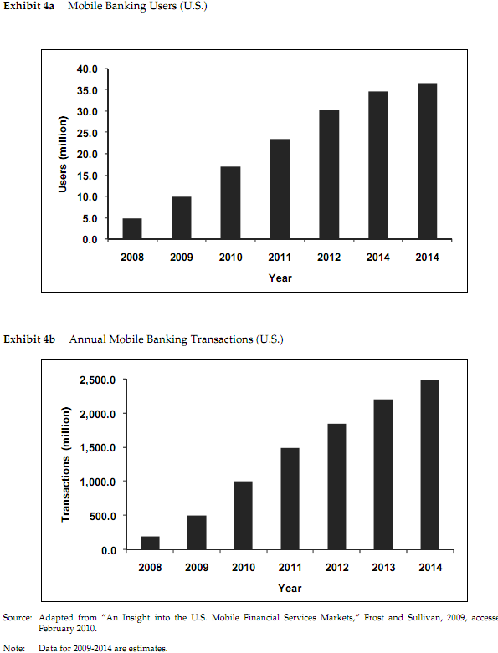

Exhibit 2.
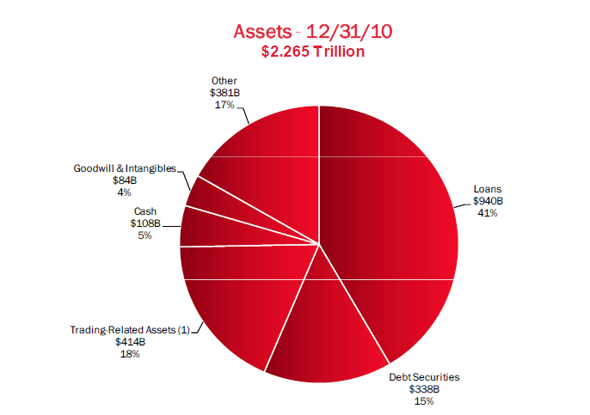
Exhibit 3.
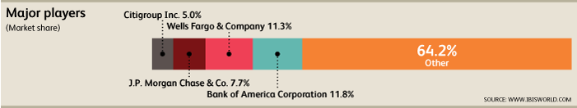

Exhibit 4.
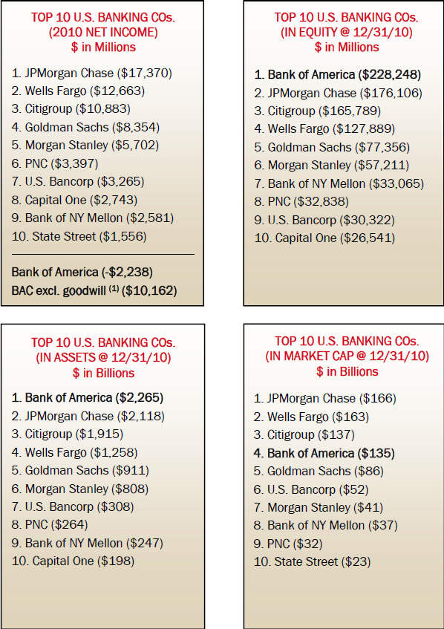

References
Bank of America. (n.d.). Bank of America | Home | Personal. Retrieved August 3, 2011, from https://www.bankofamerica.com/
Bank of America - Wikipedia, the free encyclopedia. (n.d.). Wikipedia, the free encyclopedia. Retrieved August 3, 2011, from http://en.wikipedia.org/wiki/Bank_of_America
Bank of America | Investor Relations | Overview. (n.d.). CCBN is now a part of Thomson Financial. Retrieved August 3, 2011, from http://phx.corporate-ir.net/phoenix.zhtml?c=71595&p=irol-irhome
Chase Quick Deposit Checking Accounts. (n.d.). Mobile Check Deposit iPhone App. Retrieved August 2, 2011, from https://www.chase.com/online/services/check-deposit.htm
Credit Card Processing and Merchant Services - Bank of America Merchant Services. (n.d.). corp.bankofamerica.com. Retrieved August 3, 2011, from http://corp.bankofamerica.com/public/public.portal?_pd_page_label=merchant/index/default
Difficult Market conditions and economic trends. (n.d.). WikiInvest. Retrieved August 3, 2011, from www.wikinvest.com/stock/Encore_Bancshares,_Inc/Difficult_Market_Conditions_Economic_Trends_Adversely_Affected_Banking
Facebook. (n.d.). Facebook. Retrieved August 2, 2011, from http://www.facebook.com/pages/Bank-of-America/32316911614
Financial services - Wikipedia, the free encyclopedia. (n.d.). Wikipedia, the free encyclopedia. Retrieved August 3, 2011, from http://en.wikipedia.org/wiki/Financial_services
Mobile banking - Wikipedia, the free encyclopedia. (n.d.). Wikipedia, the free encyclopedia. Retrieved August 3, 2011, from http://en.wikipedia.org/wiki/Mobile_banking
Online Banking & Money Management. (n.d.). pncvirtualwallet. Retrieved August 2, 2011, from https://www.pncvirtualwallet.com/
Rosencrance, L. (n.d.). Bank of America to launch mobile banking - Computerworld. Computerworld - IT news, features, blogs, tech reviews, career advice. Retrieved August 3, 2011, from http://www.computerworld.com/s/article/9011221/Bank_of_America_to_launch_mobile_banking_
Stock: Bank of America. (n.d.). WikiInvest. Retrieved August 3, 2011, from www.wikinvest.com/stock/Bank_of_America_(BAC)
Stock: Bank of America. (n.d.). WikiInvest. Retrieved July 29, 2011, from www.wikinvest.com/stock/Bank_of_America_(BAC)#Competition
Text Banking: Enroll in SMS Banking from Bank of America. (n.d.). Bank of America. Retrieved August 1, 2011, from www.bankofamerica.com/onlinebanking/index.cfm?template=text_banking
Twitter/User Search. (n.d.). Twitter. Retrieved August 3, 2011, from http://twitter.com/#!/who_to_follow/search/bank%20of%20america
YouTube - Broadcast Yourself.. Retrieved August 2, 2011, from http://www.youtube.com/user/bankofamerica?feature=pvchclk

