254-238-8118 3281 Lomas Rodando Calzada, Kempner, Tx 76539
We accept cash/checks/money orders/credit & debit. For Credit card use, see the photographer. Please No American Express
You and your Team/group will be photographed on __________. All members of your Team/group will be included in the picture. Individuals are personalized w/name, Team Name & year. **Denotes Action Photos Needed
- 2-8x10-Individual
2-5x7-Individual
8-wallets-Individual
$26.00

B. 2-5x7-Individual
8-wallets-Individual
1-5x15 Team Print
(ADD $10.00 for Mounted)
$30.00

B. 1-Memory Mate w/frame
1-Set of 12 Trading Cards
With 3 action photos
$28.00
PKG | Price | QTY | PKG | Price | QTY
A. | $26.00 |  | U.** | $38.00
B. | $30.00 |  | V. | $8.00
C. | $18.00 |  | W. | $6.00
D. | $46.00 |  | X. | $62.00
E. | $30.00 |  | Y. | $82.00
F. | $45.00 |  | Z. | $92.00
G. | $14.00 |  | AA. | $102.00
H. | $14.00 |  | BB. | $122.00
I. | $12.00 |  | CC. | $6.00
J. | $4.00 |  | DD. | $10.00
K. | $4.00 |  | EE. | $20.00
L. | $6.00 |  | FF. | $6.00
M.** | $18.00
N. | $4.00
O. | $5.00
P. | $22.00
Q. | $29.00
R. | $12.00
S. | $12.00
T.** | $28.00
Payment Type: Total:
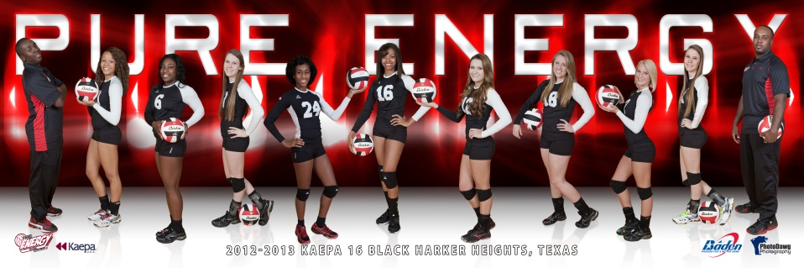
Save $10.
- 2-5x7-Individual
16-wallets-Individual
1-10x30-Team Print
(Add $15-Mounted)
$46.00
Best Buy-You Save $12.00
- 2-5x7-Individual
8-wallets-Individual
$18.00

E. 1-10x30-Team Print-Unmounted
EE. 1-5x15-Team Print-Unmounted (ADD $10-Mounted)
F. 1-10x30-Team Print-Mounted on Gator Board
G. 1-8x10-Individual
H. 1-Magazine Cover or Calendar (circle one)
Use 8 wallets, 5x7 or 8x10 for buddy Pic’s
Please fill in all information and print clearly

Players Name________________________________ Players#____
Team_____________________ Coach _______________________
Parent Name ___________________________________________
Address _______________________________________________
City ___________________________ State __________________
Zip _______ Phone#______________ All orders paid by check must have State ____D/Lic #______________A fee of $35 will be applied to NSF
*Please fill out below for Trading Cards Only*
Position ________________ Hometown______________________

Players #_____Age ____Height: Ft ____ In____ Weight: ________
Action Image# Image#
Add-Ons..You must order PKG A-H to order I-DD.
I. 2-Custom Buttons V. 8 wallets
J. Bag Tag W. 1-5x7
K. Small Key Chain X. 18x12 in
L. Large Key Chain Wall Cling
M. 1-Set of 12 Trading** Y. 36x24 in
Cards w/3 action photos Wall Cling
N. Magnet Z. 48x32 in
O. 5-Game Day Tickets Wall Cling
P. 5x7 Statuette AA. 60x40 in
Q. 8x10 Statuette Wall Cling
R. Insulated Mug BB. 72x48 in
S. Sports Bottle Wall Cling
T. 8x10 Poster** CC. 1-Dog Tags
U. 16x20 Poster** DD. 1-Photo Pen
FF. Flashlight Key Chain

