Selling to
Multi-Generation Customers

By Patricia Haddock

Right now, businesses are serving four generations of customers and the fifth generation is just around the corner. Never before has it been so important to be able to meet the needs of such an age-diverse population. The generation gap today is the greatest and most complex it has ever been. When you understand how generational differences impact your organization and customer communications, you can:

- Communicate more effectively with different generations using preferred media and messaging.
- Convince customers to buy your products and services by understanding their primary motivators.
- Present benefits and address objections in a way that appeals to each generation’s preferences and concerns.
- Educate your sales team on how to approach and long-term relationships with multi-generation customers.

This report can help you understand each generation’s expectations to help you improve the sales process for your multi-generational customers.

Traditionals (1922-1943/1946)
As a generation, Traditionals expect the products and services they purchase to be of high quality and to last over time. They want value for their money.

This generation expects to be treated with a level of formality and courtesy. They respect rules, regulations, and authority and expect the people they do business with to also do so. While they tend to avoid confrontation, if they are unhappy, they will go elsewhere with no explanation.

Traditionals want access to information and expect you to know your products and services extremely well. Slow down interactions, expect decisions to take longer, and always deliver on promises. They prefer communication by phone, in-person, and direct mail.

Baby Boomers (1946-1964)

Baby Boomers think, feel, and act younger than previous generations at the same age, so appealing to their lifestyles, not their age, is the key.

Baby Boomers are collegial and expect you to want to get to know them before doing business with them. Pushing too hard and too fast turns them off. This generation perfected in-person networking and still relies on it for referrals.

Boomers expect to have their questions answered, their problems solved, and their products/services delivered within a reasonable time. While they are willing to pay for superior products and services, they expect you to exceed their expectations! This generation will jump ship if they are disappointed in any way.

Generation X (1964-1980)

Gen X is the “do-it-yourself,” generation and expects the convenience of purchasing online, using self-serve options, scheduling/making payments and opting in/out all online and always 24/7.

Electronic marketing, communications, order taking, and processing systems must be up-to-date, functioning, easy to navigate, and coordinated. Nothing sends this customer packing faster than broken web links, outdated information, or a company’s failure to have even the simplest of electronic tools.

Gen Xs expect compartmentalized offerings and prefer transactions to be menu driven. They tend to avoid product packages and want to choose what meets their unique needs and goals.

Gen X is to-the-point and expects to be treated that way. Their inherent skepticism will kick in if they suspect hype or exaggeration. Once they distrust what you say, they will not do business with you and will tell their friends about it.

Gen Y (1980-2000)

Gen Y consumers expect personalization. They are used to instant gratification and expect up-to-the-minute information across all media channels.

You must be knowledgeable about your offerings and steer Gen Y customers to mobile channels since they love and expect state-of-the-art technology. Many members of Generation Y equate tech savvy with intelligence. It may harm your credibility with a Gen Y customer if you are not technologically savvy.

Community and authenticity are central values to Gen Y consumers. Effective use of social media platforms like Facebook and Twitter are a way businesses can align with these values, but only if social media is treated as a conversation. Gen Y will slam you on social media for service and products perceived as annoying, insulting, or “bad.”

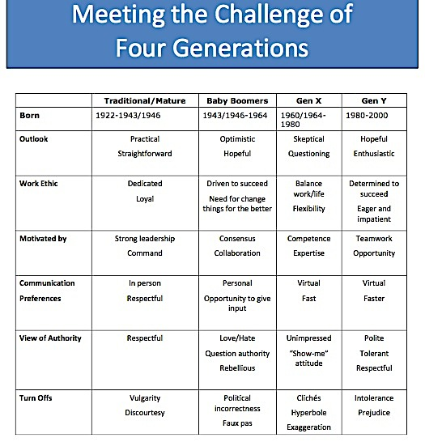

Patricia Haddock is a communication and training consultant who helps her clients attract, retain and develop employees, increase productivity, improve interpersonal skills and drive results. She works with organizations to identify desired outcomes and designs training and communication programs that teach employees skills they can immediately use on the job.

Professional Development Workshops
Time Management and Organization  Delivering Customer Care  Better Workplace Relationships  Bridging the Customer Generation Gap  Developing as a Professional | Leading Multi-Generation Teams  Creativity and Problem Solving  Leadership Skills for Admin Staff  Managing Information Overload  Business Etiquette
Business Writing Workshops
Grammar and Punctuation Review  Writing for the Workplace | Sentences and Composition Review  Writing and Managing Email
Writing Policies and Procedures  Writing Different Business Documents | Editing and Proofreading  Persuasive Writing

Clients (partial list)
Stanford University  Stanford Linear Accelerator  Stanford Office of Technology Licensing  Stanford Management Company  City of Palo Alto  City of Mountain View  County of Santa Clara  City of Sunnyvale | University of California, Santa Cruz  California Public Utilities Commission  Scientific Atlanta  Technology Credit Union  IRS  NASA  County of San Mateo  Cepheid

Connect with Patricia and visit my website for more free professional development information you can share with your staff--
- www.phaddock.com
- pat@phaddock.com
- Blog: http://thesuccessfulprofessionalwithpatriciahaddock.com
- On LinkedIn Patricia Haddock and The Successful Professional in Business
- 415-710-2734

Get More Information about the Onsite Workshop Serving Multi-Generation Customers

