The Successful Professional with Patricia Haddock

Workshops, Consulting & Information for Bottom-line Results

www.phaddock.com pat@phaddock.com

How to Turn Your Passion into Gold™

A How-to Guide from Entrepreneur Academy
By Patricia Haddock

You are sitting on a gold mine and probably don't know it!

That gold mine is your knowledge, experience, and expertise—your message and passion. You have made it. You have put your heart and soul into your business and made your dream of entrepreneurship a reality. But you want more! You deserve more!

Have you heard “Content is king” and “Products = Income,” but you don’t know what that means, why it’s important, and how to do it? I know what it means. It’s called “repurposing, and I know how to do it for your business.

Now is the time to take your business to the next level! Let me show you how to take what you have already created and turn into gold with my Passion into Gold™ System:

- Discover how to take all of your hard work to the next level
- Reach a worldwide audience with your message
- Turn your passion into profits

Turn Your Message into Gold

What you already have and know, your message can be turned it into gold with my system--real, bottom-line profits for the growth and prosperity of your business.

As an experienced branding, content marketing, and product development strategist, I take the content and products you already have and turn them into entire lines of new, profitable products and services.

I make everything you have do double and triple duty to earn income without extra, direct effort on your part—to earn while you are sleeping!

Have you heard “Content is king” and “Products = Income,” but you don’t know what that means, why it’s important, and how to do it? I know what it means. It’s called “repurposing, and I know how to do it for your business.

Content is your message.
A product is how you deliver that message.
It can be a coaching program, an e-book, a webinar, a workshop—
anything you use to communicate your message to your customers and potential customers.

Here’s how it works:

Let’s say you have created an e-book for business coaches on how to build a social media strategy, and you want to repurpose it.

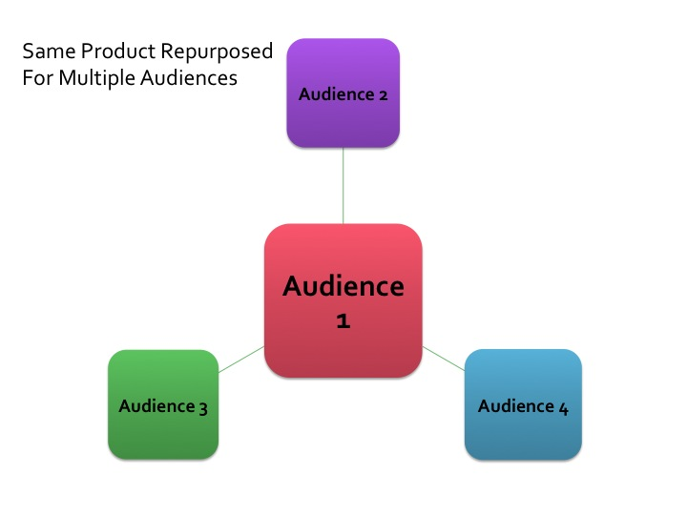
Reach New Audiences—Less Work, Less Profit

When you repurpose an existing product for new audiences, you generally need to make only minor changes to the original to meet the new audience’s needs.

Let’s say the original e-book was targeted to business coaches, and you want to repurpose it for image consultants. Much of the existing content will stay the same.

- Take the existing content from the original e-book.
- Do some light editing to focus it on image consultants.
- Replace existing photos and graphic elements with new ones that are more appropriate for image consultants.

This is the easiest way to repurpose content, and you can repurpose the same product for many different audiences. However, you will not get the most income from this approach. With a little more effort, you can use Option 2 to build an entire line of products that can give you greater rewards, higher visibility, and long-term profits.

Build a Line of Products—More Work, More Profit

Repurpose the existing content into a new format for an existing audience.
- Take the existing e-book and create a new product that complements it.
- Market it to people already in your contact list.

Marketing to people who are already familiar with what you offer is more cost- and time-efficient than selling to a brand new audience. Plus you appeal to people who prefer information in different formats. Some prefer to listen, some like to read, others like to be physically involved in the process.

Leverage Your Content into a Line of Profitable Products

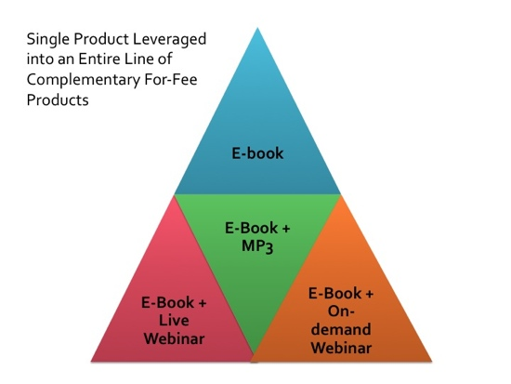
Using our example of an e-book for business coaches:

- Take the original e-book.
- Record an audio version.
- Add new examples and fresh content to the audio.
- Combine the existing e-book and the new MP3 recording to create a for-fee bundled product that you sell on your website and offer it to your contact list.

You can offer the bundle to an even wider audience with an email campaign, through social media, or on a splash page. This lets you reach people who may not have visited your website.

There’s more. You can also:

- Create a dynamic PowerPoint presentation and record a webinar with the original content in the e-book.
- Use the e-book as a free handout when people sign up for the for-fee webinar.
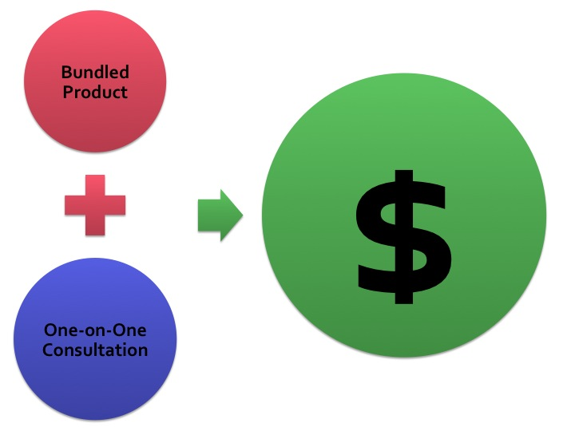
- Record the live webinar and sell the pre-recorded version with the handout as a for-fee, bundled, downloadable product.

Always Add an Upsell

Always add an upsell by offering a one-on-one, for-fee, virtual consultation with you for people who want hands-on instruction and advice. With each free and for-fee product, be sure to add links to your other products and services.

Take Action to turn your Passion into Gold

Sign up for my Passion into Gold System, and I will give you a step-by-step written plan to take one of your existing products and turn it into two, three, or more new product and/or service offerings. Start earning more now using what you already have!

When you sign up for the Passion into Gold System:

- We will have a 45-minute initial phone consultation to choose the content/product to work with and set your goals.
- I will then prepare your customized, written plan to leverage this product for greater results.
- We will meet for another 45-minute phone consultation to go over the plan and answer your questions.

The fee for the Passion into Gold System is $599, but as someone who requested my Special Report, you pay only: Fee: $349 Go here to sign up for the Passion into Gold System™ and start turning your passion into gold!

As an experienced content and brand strategist, I take my clients’ content and products and leverage them into as many new product and service lines as possible. I make everything do double and triple duty. The ultimate goal is to earn income without extra, direct effort on your part—to earn while you are sleeping!
Patricia Haddock is an expert at taking information products and helping you build an empire. She just had a strategy session with me, and I can't wait to share with all of you her recommendations. Patricia is an entrepreneur’s goldmine. I highly recommend working with her! Thank you, Pat!

Joie Gharrity, Brand Strategist, www.113branding.com

- Don’t know where to start?
- Need a guide and mentor to advise you about what steps to take next?
- Want a process to make your business easier to run and more profitable?

I connect the dots between where you are now and where you want to go. Act soon and save $150, using this offer, and start now to leverage what you know by developing new products and services that deliver the profits you want.

Go here to sign up for the Passion into Gold System™ and start turning your passion into gold!

