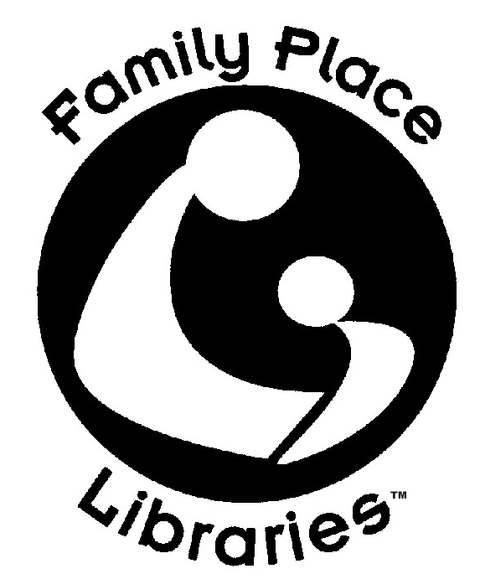
Family Place at the Middletown Free Library
Parent Child Workshop Registration Form

The Parent-Child Workshop is a multi-week series that involves infants & toddlers (ages 0-3 years) and their parents/caregivers; features local professionals who serve as resources for parents; emphasizes the role of parents as the first teachers of their children; facilitates early intervention; and teaches strategies for healthy child development and early literacy.
You must be able to commit to at least 3 weeks of our series.
Participant is registering for the following 4 weekly classes:
Fridays, 10:30-11:45am
November 11, 18
December 2, 9
- Orientation and Early Literacy
- Speech, Hearing and Language Development
- Child Development / Occupational Therapy / Early Intervention
- Nutrition

Please PRINT Names of Participating Family Members: Parents and Children
1._________________________________________________
2._________________________________________________
3._________________________________________________
4._________________________________________________
5._________________________________________________

Address:

Phone: _____________________________________________________________________________________
E-Mail:
_____________________________________________________________________________________

