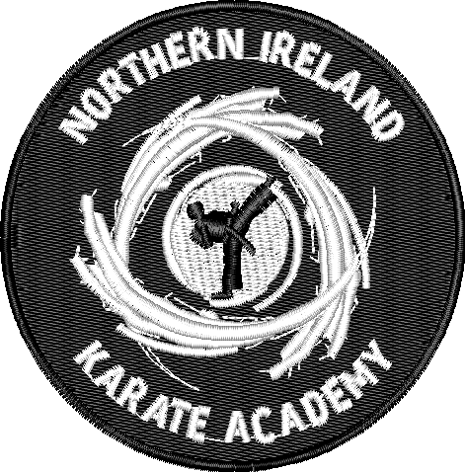

Welcome to
NIKA Northern Ireland Karate Academy

Affiliated to the World Karate Confederation, “Keepers of Karate’s highest traditions”, the club aspires to make it’s mark with it’s own unique training programmes extracted from the strict WKC syllabus.
Our Club squad has twenty members selected from amongst the ranks of our students, they work extremely hard and have reaped the just rewards for their hard training and understanding of Karate-do, it is our aim that all our students achieve the best they can and become model citizens of our society
The club is run by Sensei Cathy McAleer, 3rd Dan and former World Karate Champion and British Kickboxing champion. . As an instructor she uses his wealth of experience and resources to run classes for adults and children on

The Academy that trains at several locations:
Wado-Ryu Karate-Do
- Training Times and Locations
Thursday
4:00pm – 5:00pm:
Queens Leisure Complex,
Holywood
BT18 9QY
Sunday
10:00am – 12:00:
Stormont Pavillion,
stormont
- Contact Us
If you want to get in touch, please contact Cathy Mc Aleer:
Home:
07751465323
E-Mail:
cathymcaleer@yahoo.co.uk
Facebook:
Holywood karate club

Why not come along and join us? Your first lesson is FREE and you can train in just a t-shirt and jogging bottoms. A little unsure? Come watch us train and see the benefits of Karate first-hand.

